IN-YEAR PERFORMANCE AND FINANCIAL REPORT (MID-TERM)

Author : Ms N. Boti
Designation : Acting Chief Executive Officer
Date : 15 January 2025
Attachment : In-year financial and non-financial report
□ For noting 1st Level : Senior Management
□ For recommendation 2nd Level : Audit Committee
□ For consideration and approval 3rd Level : Board
□ For recommendation 4th Level : Mayoral Committee
□ For approval 5th Level : Council
PURPOSE
The purpose of this document is to present the state of the Entity’s performance, budget versus actual income collected and actual expenditure incurred as of 31 December 2025.
LEGISLATIVE PROVISIONS
Municipal Finance Management Act No. 56 of 2003, Municipal Planning & Performance Management Regulations and related.
BACKGROUND

Section 88 of the Municipal Finance Management Act of 2003 requires the Accounting Officer of a Municipal entity to, by 20 January of each year, assess the performance of the entity during the first half of the financial year, taking into account (1) the monthly statements referred to in section 87 for the first half of the financial year and the targets set in the service delivery, business plan or other agreement with the entity’s parent municipality.
This Section further requires the entity to consider the entity’s Annual Report for the past year, and progress on resolving problems identified in the annual report. The accounting officer is required to submit this assessment report to (i) the Board of Directors of the entity and (ii) the Parent Municipality of the entity. This report must also be made public.
The Report encapsulates performance of respective departments for the Period: 1st July 2025 to 31 December 2025. In instances where targets have not been met, reasons for variance are stated and corrective measures are captured. Documentation of areas with positive variances is also a requirement in reporting performance.
INTRODUCTION
The Mid-Year Report: 2025-2026 report provides an authoritative record of the activities and performance of the Entity for the period of the first 6 months of the financial year. It gives a reflection on how the Entity has performed and what areas warrant further attention to ensure that targets are achieved at the end of the financial year.
The Accounting Officer of the Entity is also expected to make recommendations as to whether an adjustment budget is necessary and recommend revised projections for revenue and expenditure to the extent that this may be necessary. The performance assessment on Service Delivery targets and budget implementation on revenue and expenditure has been done through the monitoring of the Service delivery and Budget Implementation Plan on a monthly and quarterly basis.
Any amendments proposed on the Mid-year report are expressed in the Revised SDBIP that will be presented to the Board by the end of January and Council in February 2025.
OVERALL INSTITUTIONAL PERFORMANCE
The organization is responsible for a total of 45 KPIs for Mid-term, of which all were assessed with 39 achieved and 6 not achieved. All the assessed KPIs contribute to the overall performance level of the combined Multi-year Business Plan and SDBIP Scorecards as reflected in this report. Institutional statistics were as follows:
COLOUR CODING
Targets Not Achieved
Targets Achieved

ACHIEVED TARGETS VS NOT ACHIEVED BY DEPARTMENT
Unit | Total No. of targets | Achieved | Not Achieved | Achieved % | Not Achieved %
Programmes | 16 | 14 | 2 | 88% | 13%
Trade & Investment Promotion | 6 | 5 | 1 | 83% | 17%
Finance and Admin | 17 | 16 | 1 | 94% | 6%
Office of the Chief Executive Officer | 6 | 4 | 2 | 67% | 33%
TOTAL | 45 | 39 | 6 | 87% | 13%

Table below depicts 2024/2025 vs 2025/2026 Performance Comparisons
Department | 2024/2025 Mid-term Performance |  |  | 2025/2026 Mid-term Performance |  |  | Improved, Maintained or Declined
Department | Total No. of Targets | % Achieved | % Not Achieved | Total No. of targets | % Achieved | % Not Achieved | Outcome
Chief Executive Officer | 12 | 58% | 42% | 12 | 67% | 33% | Improved
Programmes | 38 | 95% | 5% | 16 | 88% | 13% | Declined
Trade and Investment | 12 | 67% | 33% | 6 | 83% | 17% | Improved
Finance and Administration | 49 | 94% | 6% | 17 | 94% | 6% | Improved
Overall Percentage | 111 | 87% | 13% | 51 | 87% | 13% | Maintained
Detailed Mid-term Institutional Performance for the period 2025/2026 is presented in APPENDIX “A”

Overall Performance Graph per department

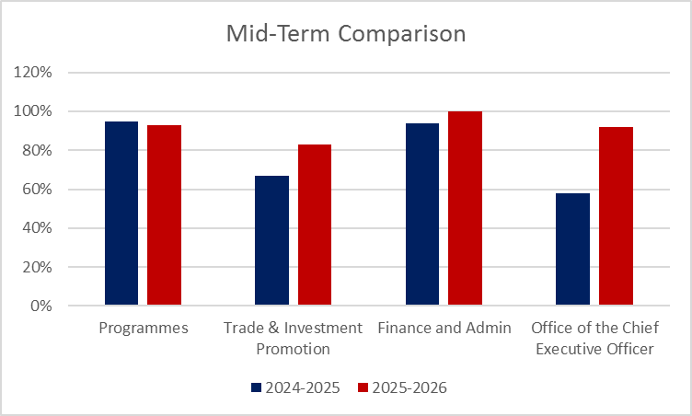
INSTITUTIONAL FINANCIAL PERFORMANCE AND POSITION
For the reporting period, total revenue accrued amounted to R15.8 million, compared to the projected R17.1 million, resulting in a favorable variance of R1.3 million.
Investment revenue earned from interest on call account deposits amounted to R353 thousand, exceeding the projected R75 thousand.
Additional revenue was generated from tender fees amounting to R37 thousand, for which no budget had been provided for.
Operational revenue was projected at R2 million, expected to be realised through project management fees and cost savings estimated at R2.1 million, as well as rollovers amounting to R3.2 million. Of the R1.5 million in expected revenue, R2.0 million was realised; however, this amount relates to a SARS refund rather than operational activities.
In addition, the Agency received R6.5 million in transfers and subsidies from the parent municipality, with qualifying revenue recognised in respect of conditional grants.
On the expenditure side, R12.9 million was spent against a projected R17.1 million, yielding a positive variance of R4.2 million.
Employee-related costs amounted to R4.7 million, below the estimated R6.6 million, mainly due to unfilled vacancies (Executive Manager: Trade and Investment, Human Resources Manager, and Project Coordinator) and pending executive salary adjustments. The recruitment processes are underway and will be finalised in the third quarter.
Board allowances amounted to R443 thousand against a year-to-date budget of R355 thousand, resulting in an over-expenditure of R88 thousand. The variance is mainly attributable to once-off activities, namely the annual general meeting and board induction, which were budgeted to be spread over a twelve-month period instead of being fully recognised in the first quarter when these activities were implemented.
Other operating expenditure, which includes accommodation, utilities, audit fees, and software licences, totalled R7.4 million against the projected R9.7 million. The budget also provides for learnership and internship programmes to support youth skills development across the District.
Overall, the Agency demonstrated prudent expenditure management during the period under review, with underspending primarily driven by vacant positions and timing differences in operational activities. The statement of financial position indicates that the entity's current assets exceed its current liabilities, suggesting a favorable liquidity position. This means the Entity has sufficient short-term resources to meet its short-term obligations, demonstrating its ability to manage immediate financial commitments effectively.
FINANCIAL IMPLICATIONS
The municipal entity ended the mid-term with a positive cash and cash equivalents balance of R6.0 million inclusive of the R1.4-million of the unspent grants portion. This is made up of R2 million refund from SARS, R3,2 for the projects which were rolled over (SETA Accreditation, Macadamia Nuts, Alfred Nzo Industrial Park, Emfundisweni Skills Development Centre), the balance is for employee costs and operations.
From a financial perspective, the entity remains liquid, with current assets exceeding current liabilities. The entity ended the month with a positive cash balance of R6 - million.
The table below reflects the cash flow projections for the period January to June, which indicate a significant cash flow constraint that might face the Agency should the funds not be transferred timeously.

Funds available under investment accounts | 6 067 338.75
Funds available on main account | 77 020.91
Subtotal | 6 144 359.66
Unspent conditional grants | - 1 400 988.04
Commitments | - 3 022 784.54
Employee related costs | - 4 890 000.00
Funds available for disbursements | - 3 169 412.92

The transfer was scheduled to be effected in October; however, disagreements arose regarding the Parent Municipality’s transfer of the funds as stipulated in the Service Delivery Agreement (SDA). As an interim measure, the Agency revised the invoice to reflect a quarterly transfer amount. This revised invoice was also not settled, as the District Municipality requested a report alleging that the Agency had exceeded its approved annual budget for Board fees. This allegation was incorrect.
The above position demonstrates that, notwithstanding the cash held in investment and operational accounts, the Agency is facing a projected funding shortfall, primarily driven by outstanding transfers and unavoidable operating commitments. This situation underscores the urgent need for the settlement of the outstanding District Municipality transfer to ensure liquidity and continuity of operations.
HR IMPLICATIONS
None
LEGAL IMPLICATIONS
The report is prepared in compliance with Section 88 of the MFMA. Non-submission of the report to the Board may lead to an audit query: Non-compliance with applicable legislation.
COMMUNICATION IMPLICATION
The report has been considered and approved by the Board, and it will be uploaded on the Entity’s website.

SERVICE DELIVERY IMPLICATIONS
The Midyear Budget and Performance Assessment Report is a yardstick to measure achievement of indicators and targets as pre-determined in the SDBIP. It gives a reflection of whether or not the Entity is likely to achieve its annual targets and which may trigger revisions to the SDBIP and business re-engineering to achieve targets as set in the SDBIP.
RECOMMENDATIONS
- That the Midyear Budget and Performance Assessment Report for 2025-2026 FY be CONSIDERED and RECOMMENDED by the Audit and Performance Committee.
- That Midyear Budget and Performance Assessment Report for 2025-2026 FY be NOTED and APPROVED by the Board.
- That the Board notes that the second tranche payment from the District was not received.
- That Midyear Budget and Performance Assessment Report for 2025-2026 FY as presented to the Board will be further sent to the Mayoral Committee for NOTING and RECOMMENDATION to Council.
- That Midyear Budget and Performance Assessment Report for 2025-2026 FY as presented to the Mayoral Committee will be further sent to Council for NOTING and ADOPTION.
- Then, after the presentation of the report to Council, Council defer Midyear Budget and Performance Assessment Report for 2025-2026 FY report to the Municipal Public Accounts Committee (MPAC) for further scrutiny in line with its oversight responsibility.
SUBMITTED BY:
Report Generator : Ms N. Boti
Contact No. : 039 492 0011
Email address : botin@anda.org.za
Designation : Acting Chief Executive Officer
Date : 15 January 2025



ANDA IN-YEAR PERFORMANCE REPORT
MID-TERM 2025/2026
Table of Contents
CHAPTER 01: LEADERSHIP AND CORPORATE PROFILE 11
1.1. Chairperson’s foreword 11
1.2. Chief Executive Officer’s Report 13
1.3. Corporate Profile and Overview 15
1.4. Vision 16
1.5. Mission 16
1.7. Strategic Goals and Objectives 17
1.8 Progress in resolving problems identified in the 2024/2025 Annual Report 18
CHAPTER 2: CORPORATE GOVERNANCE 19
SECTION 1: CORPORATE GOVERNANCE STATEMENT 19
SECTION 2: HIGH-LEVEL ORGANISATIONAL STRUCTURE 21
SECTION 3: RISK MANAGEMENT AND INTERNAL AUDIT 21
SECTION 4: ANTI-CORRUPTION AND FRAUD 22
SECTION 5: ICT GOVERNANCE 23
CHAPTER 3: OVERALL PERFORMANCE 23
3.1. Achieved Targets vs. Not Achieved 24
3.2. 2024/2025 VS 2025/2026 MIDTERM PERFORMANCE COMPARISON 24
3.3. Graphical representation of comparison between 2024/2025 & 2025/2026 Midterm performance: 25
3.4 Summary of Performance Achievements Per Directorate 25
Challenges 27
Corrective Measures 28
CHAPTER 4: HUMAN RESOURCES & ORGANISATIONAL DEVELOPMENT 42
Current Status 42
CHAPTER 5: FINANCIAL PERFORMANCE 44
5.1 Operating Revenue 44
5.2 Operating Expenditure 44
5.3 Capital Expenditure 46
5.4 Financial Position 46
5.5 Cash Flows 46
Table F1: Monthly Budget Statement Summary 46
Table F2: Monthly Financial Performance (Revenue and Expenditure) 48
Table F3: Capital Expenditure 48
Table F4: Statement of Financial Position 50
Table F5: Cash flows 51
Table SF3: Aged Debtors 52
Table SF4: Aged Creditors 52
Table SF5: Investment Portfolio Analysis 52
Table SF6: Board member allowances and staff benefits 53
Table SF7: Grants receipts and expenditure 53
CHAPTER 6: IMPLEMENTATION OF SCM POLICY 54
CHAPTER 7: UNAUTHORISED, IRREGULAR, FRUITLESS AND WASTEFUL EXPENDITURE 75
CHAPTER 8: TAX COMPLIANCE REPORT 75
CHAPTER 9: ASSURANCE ESTABLISHMENTS 77
1. Internal Audit 77
2. Risk Management 77

CHAPTER 01: LEADERSHIP AND CORPORATE PROFILE

Chairperson’s foreword
Principle 1 of King IV Code on Corporate Governance requires that the governing body should lead ethically and effectively and of that leadership role is that the governing body should be willing to answer for the execution of their responsibilities, even when these were delegated. The code also further states that the governing body should exercise ongoing oversight of the implementation of strategy and operational plans by management against agreed performance measures and targets.
Section 88 of the Municipal Finance Management Act of 2003 requires the Accounting Officer of a Municipal entity to, by 20 January of each year, assess the performance of the entity during the first half of the financial year, taking into account (1) the monthly statements referred to in section 87 for the first half of the financial year and the targets set in the service delivery, business plan or other agreement with the entity’s parent municipality.
The Entity has made significant strides in strengthening good governance by increasing the number of board members and establishing the sub-committees with their terms of reference.
The Board managed to conclude the signing of the Service Delivery Agreement (SDA) with Alfred Nzo District Municipality (the Shareholder) in compliance with section 76 (b) of the Municipal Systems Act 32 of 2000.
The Entity has made significant progress in revenue enhancement and skills development. All Service Seta and Foodbev SETA funded programmes have been finalised, awaiting payment of final tranches for ultimate closure of the projects. The Entity has received a final tranche for internship vocational which has recently been completed and targeted at 100 graduates. During the period under review, more than R910 121,84 was received from Service SETA as part of tranches for Internship-Vocational and NATED.
The partnership with Sunfarming and the establishment of the Agri-voltaics project at Umzimvubu is proceeding well, marking a strategic move for the district. This initiative combines solar energy generation with agricultural activities, supporting both energy independence and sustainable farming practices.

The Entity through partnership with Eastern Cape Development Corporation have finalized two Business plans for Fresh Produce Packhouses in Matatiele and Umzimvubu Local Municipalities and hosted trade fair at Umzimvubu Local Municipality which aims at giving market opportunity for the SMMEs and local farmers.

The Entity’s performance has also improved in the mid-term for this financial year compared to last financial year’s financial year in the same mid-term which shows that the Entity is moving towards the right direction in stimulating the economy of the District.The Entity also managed to hold its very first Annual General Meeting (AGM) in this mid-term in compliance with section 61 of the Companies Act 71 of 2008.

Chief Executive Officer’s Report

ANDA strictly adheres to principles of professionalism and, in order to keep to good governance, adheres to Governance Risk and Compliance (GRC) model and approach. ANDA does need to strengthen its GRC framework. Accordingly, for the Accounting Officer as per Section 93 of the MFMA, to achieve clean audit and comply with Section 94, 95 of the MFMA and related, management runs an organised machinery, disciplined time management and results oriented guided by a SMART Plan (SDBIP), Board expectations in terms of the Board Annual Work Plan and quarterly reporting thereof, reporting requirements in terms of MFMA, MSA, Public Audit Act, Companies Act and related. ANDA manages and commits to improving organisational performance through achieving its planned objectives and targets in terms of the SDBIP.
This report serves to report the Mid-term Entity’s Performance for the 2025/2026 financial year, reflecting the period from 01 July 2025 ending 31 December 2025. The report details the actual performance and variances of the Agency’s Key Performance Areas in adjusted SDBIP. In the case of under-performance, this report demonstrates mitigations and solutions that will address the challenges that led to under-performance. In instances where quarterly and mid-term targets have not been met, reasons for variance are stated and corrective measures are captured. Documentation of areas with positive variances is also a requirement in reporting of performance.
The overall institutional performance score achieved at mid-term for the 2025/2026 financial year, as at 31 December 2025, is 87%, which is consistent with the mid-term performance achieved in the 2024/2025 financial year.
The report is prepared in compliance with Section 88 of the Municipal Finance Management Act No. 56 of 2003, which provides that:
- The accounting officer of a municipal entity must by 20 January of each year assess the performance of the entity during the first half of the financial year taking into account-
( i ) the monthly statements referred to in section 87 for the first halt of the financial year and the targets set in the service delivery, business plan or other agreement with the entity’s parent municipality: and
( i i ) the entity’s annual report for the past year. and progress on resolving problems identified in the annual report: and
- submit a report on such assessment to-
( i ) the board of directors of the entity: and
( i i ) the parent municipality of the entity.
- A report referred to in subsection (1) must be made public.
In preparation for the mid-term Performance Assessment Report, the Chief Executive Officer must take into account the Section 87 Reports and ensure that reported performance is in line with the Service Delivery and Budget Implementation Plan as approved by the Board in line with Section 53 of the MFMA.
Section 87 subsections (11 to 14) of the MFMA provides that the accounting officer of a municipal entity must days after the end of each month submit to the Municipality Accounting Officer by no later than seven working officer of the parent municipality a statement in the prescribed format on the state of the entity's budget reflecting the following particulars for that month and for the financial year up to the end of that month: (a) Actual revenue, per revenue source: (6) actual borrowings; (c) actual expenditure; (d) actual capital expenditure; (e) the amount of any allocations received; actual expenditure on those allocations, excluding expenditure on allocations exempted by the annual Division of Revenue Act from compliance with this paragraph; and (g) when necessary, an explanation of- (i) any material variances from the entity’s projected revenue by source, and from the entity‘s expenditure projections; (ii) any material variances from the service delivery agreement and business plan: and (iii) any remedial or corrective steps taken or to be taken to ensure the that projected revenue and expenditure remain within the entity’s approved budget. (12) The statement must include a projection of revenue and expenditure for the rest of the financial year. and any revisions from initial projections. (13) The amounts reflected in the statement must in each case be compared with the corresponding amounts budgeted for in the entity’s approved budget. (14) The statement to the accounting officer of the municipality must be in the format of a signed document and in electronic format.
Section 95 of the Local Government Municipal Finance Management Act no. 56 of 2003 states that the Accounting Officer of a municipal entity is responsible for managing the financial administration of the entity, and must for this purpose take all reasonable steps to ensure that the resources of the entity are used effectively, efficiently, economically and transparently.
Section 62 (1) (c) of the MFMA instructs the Accounting Officer to ensure that the Entity maintains an effective, efficient and transparent system of financial and risk management and internal control. The Board has established the Risk Management Committee through shared services with Alfred Nzo District Municipality to assist the Accounting Officer to fulfil her management and control responsibilities in accordance with prescribed legislation and corporate governance responsibilities. However, the risk management committee has not sat to review the progress in the implementation of mitigation plans.
This report therefore complies with the legislated requirements. Overall, the Agency demonstrated prudent expenditure management during the period under review, with underspending primarily driven by vacant positions and timing differences in operational activities. The statement of financial position indicates that the entity's current assets exceed its current liabilities, suggesting a favourable liquidity position. This means the entity has sufficient short-term resources to meet its short-term obligations, demonstrating its ability to manage immediate financial commitments effectively.

Corporate Profile and Overview
Alfred Nzo Development Agency is a “Municipal Entity” of the Alfred Nzo District Municipality (ANDM) which was established through a Council resolution in terms of terms of Section 76 (b) (i) of the Municipal Systems Act 32 of 2000 (MSA), which provides for mechanism by which a municipality may provide a municipal service in its area.
The Municipal Entity was further registered as a State Owned Company with the Registrar of Companies (CIPC) in terms of the Companies Act 71 of 2008, and in line with Section 86 (B) (1) (a) of the MSA in the year of 2000, and was mandated to act as a special purpose vehicle to drive economic development in the entire district, so as to achieve the vision of the Alfred Nzo District Council as articulated in its long term and medium-term strategic planning documents.
The Municipality Entity delivers on its mandate through a Service Delivery Agreement (SDA) that is entered into between the Entity and its parent municipality, for a period of three years and reviewed annually. The purpose of the SDA is to formalise and regulate the working relationship between the parent municipality and its Entity’s, pursuant to the service delivery provisions of the MSA, the Companies Act and the Municipal Finance Management Act 56 of 2003 (MFMA).

The mandate of the Agency therefore is to:
- Act as the operational arm of the Municipality for the purposes of implementing economic, social and environmental policies and projects within ANDM jurisdiction;
- Develop the innovation and entrepreneurial potential and activity which supports and drives economic growth within ANDM jurisdiction;
- To leverage public and private resources and support for development around opportunities which offer economic and development potential;
- Acquire, develop and manage land and buildings necessary to provide public good, generate revenue towards self-sustainability and enable the Agency to achieve its stated aims and objectives;
- Acquire and exercise rights and duties, necessary for the furtherance of its objectives, and generally to perform such further functions as may be delegated or assigned to it by the Municipal Council from time to time.

Vision
“Leading a rapidly growing economy that generates wealth for its people”

Mission
To facilitate inclusive and innovative socio-economic growth through promoting sustainable enterprises development and implementation of high impact initiatives
  - Values
- Innovation
- Partnership
- Integrity
- Accountability and transparency
- Professionalism
- Agility
- Leadership

Strategic Goals and Objectives
Goal | Strategic Objectives | Programmes | Priority Projects | Lead Dept. | KPIs (Examples)
1. Sustainable Inclusive Economic Growth | Promote trade & investment• Support SMEs & rural/township enterprises• Drive green/sustainable development | Investment Promotion- SME & Enterprise Support- Green Economy Initiatives | • Investor Aftercare & Retention• Business Incubators (Rural) Renewable Energy-linked Agro-processing Clusters | Trade & Investment | Number of new investments facilitated and % SMEs supported- green projects implemented
2. Economic Infrastructure Development | Facilitate economic infrastructure• Support catalytic projects | Catalytic Infrastructure Support- Agro-processing & Industrial Park Dev. | Industrial park | Programmes | Number of infrastructure projects initiated, and number of jobs created through projects
3. Sound Financial Management | • Ensure sustainability & compliance• Strengthen revenue & efficiency | Audit opinion with no material findings | • Clean Audit | Finance | Number of clean audits- % budget spent vs allocated
4. Good Governance | • Strengthen accountability & transparency• Enhance board & executive oversight | Governance & Risk Management. Performance reporting | • Governance Charter &Risk Register• Performance reporting | CEO’s Office | Number of board meetings held; % risk mitigation plans implemented; % of targets achieved
5. Human Capabilities & Organisational Efficiency | • Build human capital• Improve systems & culture | - HR Development & Skills- Organisational Efficiency & ICT | • Leadership Development & Mentorship• • Employee Wellness Programme | CEO’s Office | % staff trained- Employee satisfaction index- Process turnaround times

1.8 Progress in resolving problems identified in the 2024/2025 Annual Report
Challenges | Progress to date
The entity’s budget is currently financed generally through a grant transfer from the parent municipality and grants from SETAs. ANDA’s financial instability poses a serious threat to the sustainability of the entity and its business operations. | The entity has embarked on a full-scale resource mobilisation efforts to supplement the grant from ANDM and SETA. The constituted panel of resource mobilisers has also been extended to strengthen these efforts.
Improvement in the nature of initiatives that are implemented | The following catalytic projects are currently being pursued:  - Alfred Nzo Industrial Park is at a feasibility study stage, being implemented in partnership with COEGA, earmarked to be at Winnie Madikizela Mandela  - The entity is also implementing Agro-Voltaic in partnership with Sunfarming
The Agency currently has no IT personnel in the CPS department | The entity has recruited an IT Intern which will work together with ANDM IT on shared services basis

CHAPTER 2: CORPORATE GOVERNANCE

SECTION 1: CORPORATE GOVERNANCE STATEMENT
Governance framework
ANDA’s Board of Directors and executive management team subscribe to the governance principles set out in the Code of Conduct for Directors referred to in section 93L of the Municipal Systems Act, circular 63 of the MFMA. The Entity further applies the governance principles contained in the Companies Act and the entity’s Governance framework. Monitoring the adherence to the above-mentioned governance principles is done through the sub committees of the Board such as the shared Risk Management Committee (RMC) and shared Audit and Performance Committee (APC).
The Board also actively reviews and enhances the systems of internal control and governance procedures in place to ensure that ANDA is managed ethically and within prudently determined risk parameters. During the period under review, the Board exercised oversight to ensure that ANDA complied with the requirements of the Companies Act, the Municipal Systems Act, the MFMA and applicable King Code.

ANDA’s Governance Arrangements
ANDA is accountable to Alfred Nzo District Municipality through the Mayor as per Section 56 Of the Municipal Finance Management. The mayor of a municipality that exercises sole or shared control over a municipal entity is required to direct the municipality in the exercise of its rights and powers over that entity in a manner that reasonably ensures compliance with the Municipal Finance Management Act, does not obstruct the entity’s ability to carry out its operational responsibilities, and ensures that the entity remains accountable to the municipality. In fulfilling this role, the mayor may oversee and monitor the operational activities of the municipal entity, provided that such oversight does not amount to interference in the execution of those functions.
ANDA’s management is accountable for strategic and operational matters to the Board of Directors, which provides strategic direction and oversees its implementation.
Board Of Directors
ANDA adheres to the provision of its memorandum of incorporation (MOI), the Board Charter and the applicable legislation on the nomination, appointment, composition, and remuneration of the Board. The Directors are appointed by the Parent Municipality (Shareholder) in terms of section 93E of the MSA. The composition of the Board is informed by the experience, qualifications and skills mix required to pursue the entity's strategic direction. ANDA has a unitary board, which comprises both executive and non-executive directors. Together, ANDA directors have a range of different skills and experience that they bring to bear for the benefit of the entity. These include accounting, finance, legal, business management, human resources and labour relations, marketing, construction, and development management.
ANDA’s sole shareholder, the Alfred Nzo District Municipality, reviews the term of office for non-executive directors every five (5) years. A service delivery agreement concluded following the provisions of the Municipal Systems Act, govern the entity`s relationship with Alfred Nzo District Municipality.
The Board provides quarterly, biannual, and annual reports on its performance and service delivery to the Alfred Nzo District Municipality as prescribed in the service delivery agreement, the MFMA and the Municipal Systems Act.
Non-executive directors maintain an independent stance to matters under consideration and add to the Board’s depth of experience. The roles of the Chairperson and Chief Executive Officer are separate, with responsibilities divided between them.
Members have unlimited access to the Company Secretary, who acts as an advisor to the Board on matters such as corporate governance, compliance with company rules and procedures, statutory requirements, regulations, and best corporate practices.
The Board or any of its members may, under appropriate circumstances and at the expense of the company, obtain the advice of independent professionals.
Shortcomings will be addressed and areas of strength are consolidated during an annual Board evaluation. The performance of the Board committees will be evaluated against their terms of reference.
As at the Annual General Meeting held on 05th August 2025, the ANDA Board of Directors consist of the following members:
- Mrs N. Mabude (Chairperson)
- Mr Z.D. Qunya (Deputy Chairperson)
- Ms F. Maqwathi
- Ms I. Magaga
- Mr G.N. Vimba
- Mr G.G. Mpumza

SECTION 2: HIGH-LEVEL ORGANISATIONAL STRUCTURE
The Agency operates with an approved organisational structure comprising sixteen (16) positions, of which four (4) are Executive Management positions. These executive roles provide strategic leadership and oversight across the Agency’s core functions and support services. Out of the four executive positions that are in the approved staff establishment, the position of the Chief Executive Officer and Executive Director Trade and Investment are vacant. Recruitment processes towards filling these vacancies are underway.

SECTION 3: RISK MANAGEMENT AND INTERNAL AUDIT
The Agency does not have dedicated personnel or internal capacity for Risk Management and Internal Audit functions. These functions are provided through a shared services arrangement with the parent entity, which ensures that the Agency operates within an established governance and compliance framework.
Through this arrangement, the parent entity provides guidance on risk identification, assessment, and mitigation processes, as well as oversight of internal control systems. The Internal Audit function, facilitated by the parent entity, contributes to the evaluation of governance, risk management, and control processes to ensure that the Agency’s operations remain compliant with applicable legislation and internal policies.
During the reporting period, the Agency continued to participate in the parent entity’s risk management processes, including periodic risk assessments and monitoring of mitigation actions. No material risks outside of the established risk register were identified during mid-term.
The shared services model remains an effective interim measure; however, the absence of dedicated internal capacity limits the Agency’s ability to conduct continuous risk monitoring and implement proactive internal control improvements. The Agency will continue to engage with the parent entity to strengthen these governance functions and ensure effective risk management and assurance practices.

SECTION 4: ANTI-CORRUPTION AND FRAUD
The Agency remains committed to upholding the highest standards of integrity, transparency, and accountability in all its operations. The Agency has adopted an Anti-Corruption and Fraud Prevention Policy, which guides the prevention, detection, and management of fraud and corruption risks within the organisation.
During the reporting period, there were no reported or detected incidents of fraud, corruption, or unethical conduct within the Agency. Employees are continually encouraged to adhere to the Code of Conduct.
Currently, the Agency does not have an established whistle-blowing mechanism for reporting suspected fraud or corruption. In the absence of this mechanism, employees are encouraged to report any suspected irregularities directly to senior management or through the parent entity’s governance structures, where applicable. The Whistle-Blowing policy will be developed with the assistance of the Risk Department as part of the Shared Service.

SECTION 5: ICT GOVERNANCE
The Agency does not currently have a dedicated ICT unit or personnel responsible for the management and governance of Information and Communications Technology. ICT support and governance functions are rendered through a shared services arrangement with the parent entity, which provides assistance in areas such as system administration, network connectivity, data security, and user support.
However, this arrangement does not ensure compliance with the ICT governance framework, policies, and procedures, resulting in non-compliance with applicable corporate governance standards.
The absence of an internal ICT function limits the Agency’s ability to independently plan, implement, and monitor ICT-related initiatives, particularly those that support digital transformation, operational efficiency, and data-driven decision-making.

CHAPTER 3: OVERALL PERFORMANCE
Section 88 of the Municipal Finance Management Act (MFMA), Act 56 of 2003 states that the Accounting Officer of the municipal entity must, within 30 days of the end of each quarter, submit a report to the council on the implementation of the budget and the financial state of affairs of the municipality. Once approved, the report should be placed on the municipal website as stated in section 75 (1) (k) of the MFMA. ANDA is funded by ANDM who is a sole shareholder and a parent Municipality to the Entity. This report aims to facilitate reporting and accountability in relation to municipal funding transferred to the Development Agency for service delivery implementation.
This section provides an outline in terms of the Entity’s midterm performance for 2025/2026 in line with the SDBIP 2025/2026 targets and in relation to the various directorates of the Entity:
- Office of the Chief Executive Officer (OCEO)
- Programmes Department (PD)
- Trade and Investment Promotion
- Finance and Administration

3.1. Achieved Targets vs. Not Achieved
Achieved targets vs not achieved by department 2025-2026
Unit | Total No. of targets | Achieved | Not Achieved | Achieved% | Not Achieved %
Programmes | 16 | 14 | 2 | 88% | 13%
Trade & Investment | 6 | 5 | 1 | 83% | 17%
Finance & Admin | 17 | 16 | 1 | 94% | 6%
Office of the Chief Executive Officer | 6 | 4 | 2 | 67% | 33%
TOTAL | 45 | 39 | 6 | 87% | 13%

3.2. 2024/2025 VS 2025/2026 MIDTERM PERFORMANCE COMPARISON
Department | 2024/2025 Midterm Performance |  |  |  | 2025/2026 Midterm Performance |  |  |  | Improved, Maintained or Declined
Department | Total No. of Targets | Not Achieved | % Achieved | % Not Achieved | Total No. of targets | Not Achieved | % Achieved | % Not Achieved | Outcome
Programmes | 38 | 2 | 95% | 5% | 16 | 2 | 88% | 13% | Declined
Trade and Investment | 12 | 4 | 67% | 33% | 6 | 1 | 83% | 17% | Improved
Finance and Administration | 49 | 3 | 94% | 6% | 17 | 1 | 94% | 6% | Improved
Chief Executive Officer | 12 | 5 | 58% | 42% | 6 | 2 | 67% | 33% | Improved
Overall Percentage | 111 | 14 | 87% | 13% | 90 | 12 | 87% | 13% | Maintained

3.3. Graphical representation of comparison between 2024/2025 & 2025/2026 Midterm performance:

3.4 Summary of Performance Achievements Per Directorate
3.3.1. Directorate: Programmes
PROGRAMMES DEPARTMENT
ACHIEVED TARGETS VS NOT ACHIEVED BY PROJECT
Project Name | Total No. of targets | Achieved | Not Achieved | % Achieved | % Not Achieved
Coffee Plantation | 1 | 1 | 0 | 100 | 0
Amadumbe and Sweet Potato commodity development | 1 | 1 | 0 | 100 | 0
Emfundisweni Skills Development Centre: Business Support | 1 | 1 | 0 | 100 | 0
Fresh Produce Industry Development | 1 | 1 | 0 | 100 | 0
SETA Accreditation | 1 | 1 | 0 | 100 | 0
Services SETA: Learnership (Generic Management) | 1 | 0 | 1 | 0 | 100
Services SETA: Learnership Programme (Business Administration Services) | 1 | 0 | 1 | 0 | 100
Services SETA: Learnership Programme (Clothing Manufacturing processes) | 1 | 1 | 0 | 100 | 0
Foodbev: Learnership Programme | 1 | 1 | 0 | 100 | 0
LGSETA: Learnership Programme Local Economic Development | 1 | 1 | 0 | 100 | 0
LGSETA: Learnership Programme environmental practice | 1 | 1 | 0 | 100 | 0
LGSETA: Artisan Recognition of Prior Learning (ARPL) on Plumbing | 1 | 1 | 0 | 100 | 0
LGSETA: Artisan Recognition of Prior Learning (ARPL) Programme (bricklaying) | 1 | 1 | 0 | 100 | 0
LGSETA: Apprenticeship Programme (Plumbing) | 1 | 1 | 0 | 100 | 0
Services SETA: NATED internship programme | 1 | 1 | 0 | 100 | 0
Construction Seta: Internship Programme | 1 | 1 | 0 | 100 | 0
Total | 16 | 14 | 2 | 88% | 12%

Directorate Overview, Challenges and Successes
Overview
The Programmes Department is the core operational unit of the Entity, responsible for driving local economic development across the district. The Department identifies and implements catalytic projects and facilitates collaboration among public institutions, the private sector, and non-governmental partners to create enabling conditions for inclusive economic growth, employment creation, and improved quality of life for communities.
The Department ensures responsible and sustainable development by promoting SMME development and leading key sectoral initiatives as articulated in the Multi-Year Business Plan. It further advances rural development by designing and implementing targeted strategies aimed at improving economic opportunities and the well-being of rural and marginalised communities, while fostering strategic LED partnerships to support sustained growth of the local economy.
For the reporting period, the directorate set a total of 30 performance targets, of which 28 were achieved, resulting in a 93 % achievement rate and 7 % non-achievement. This reflects strong overall performance, effective implementation of planned activities, and commitment to service delivery excellence.
Key Successes
- Foodbev SETA learnership has been completed successfully, benefiting 68 unemployed youth and individual bakers around the district.
- All service SETA funded programmes have been successfully completed, which targeted clothing manufacturing, project management, business administration and NATED/Vocational internship programmes.

Challenges
- Capacity constraints within the Directorate limit the Department’s ability to fully implement approved targets.
- Although the Programmes Department drives the core business of the Entity, it remains under-resourced, with only three staff members responsible for a wide portfolio of programmes.
- The non-achievement of two performance targets resulted from delays in the issuance of learner certificates by the Services SETA.
- Sustaining high performance levels under current human and financial resource constraints continues to pose operational challenges.
- Insufficient financial capacity limits the Department’s ability to deliver catalytic projects with significant socio-economic impact.

Corrective Measures
- Review and strengthen the organisational structure to incorporate additional capacity, particularly Project Coordinators and administrative support functions.
- Secure additional budget allocations to enable the implementation of high-impact catalytic projects that contribute meaningfully to economic growth and job creation.
The reasons for not achieving 100% in the Mid year are as follows:
Project Name | Challenges/Reason for Variance | Service Delivery implications | Corrective Action
Services SETA: Learnership (Generic Management) | Certificates could not be received due to the backlog that Service Seta is experiencing. As a result of non-receipt of certificates, payment of the last tranche was not processed. | Delays in issuing of certificates will affect learners in securing job opportunities. | Certificates will be received in the 3rd quarter of 2025/26 financial year. Payment to the SDP will then be facilitated thereafter.
Services SETA: Learnership Programme (Business Administration Services) | Certificates could not be received due to the backlog that Service Seta is experiencing. As a result of non-receipt of certificates, payment of the last tranche was not processed. | Delays in issuing of certificates will affect learners in securing job opportunities. | Certificates will be received in the 3rd quarter of 2025/26 financial year. Payment to the SDP will then be facilitated thereafter.

The reasons for variance for the actual expenditure in the Mid-year are as follows:
Project Name | Challenges/Reason for Variance | Corrective Action
Emfundisweni Skills Development Centre: Business Support | The over-expenditure resulted from the payment of casual workers providing cleaning services at the centre. These workers were back paid for services rendered in the previous quarters, which led to the over-expenditure recorded in the current quarter. | None, because the annual budget has not been exceeded. The over-expenditure will be cancelled by a positive annual budget that has not been exceeded.
Fresh Produce Industry Development | The over-expenditure resulted from the payment of activities that were completed in the previous quarter but were only paid in the current quarter following the completion of the verification process | None, because annual budget has not been exceeded. The over-expenditure will be cancelled by a positive annual budget that has not been exceeded.
SETA Accreditation | The under-expenditure resulted from delays in the implementation of the project, which led to certain activities not being fully completed by the end of Quarter 2. Consequently, the entity incurred expenditure only for activities that could be verified in accordance with the Service Level Agreement (SLA). | The variance will be carried forward to the third quarter and will be paid for once all activities have been completed and verified in accordance with the Service Level Agreement (SLA).
Services SETA: Learnership (Generic Management) | Certificates could not be received due to the backlog that Service Seta is experiencing. Due to non-receipt of certificates payment of last tranche was not processed. | Certificates will be received in the 3rd quarter of 2025/26 financial year. Payment of last tranche will be facilitated in Q3 of 2025/26/FY.
Services SETA : Learnership Programme (Business Administration Services) | Certificates could not be received due to the backlog that Service Seta is experiencing. Due to non-receipt of certificates payment of last tranche was not processed. | Certificates will be received in the 2nd quarter of 2025/26 financial year. Payment of last tranche will be facilitated in Q2 of 2025/26/FY.
Services SETA: Learnership Programme (Clothing Manufacturing processes) | The under-expenditure resulted from the closure report not yet being submitted, which delayed the processing of the final payment | The variance will be carried forward to the third quarter and will be paid once the closure report has been submitted and verified.
Foodbev: Learnership Programme | The under-expenditure is due to the non-payment of the service provider, following delays in the receipt of certificates. | The variance will be paid in the third quarter once the outstanding certificates have been received.
LGSETA: Learnership Programme Local Economic Development | The over-expenditure is due to payments for last quarter's activities, which were only fully completed in the current quarter and therefore had to be charged to the current quarter's budget. | The over-expenditure will be addressed in the mid-year budget adjustment.
LGSETA: Learnership Programme enviromental practice | The over-expenditure is due to payments for last quarter's activities, which were only fully completed in the current quarter and therefore had to be charged to the current quarter's budget. | The over-expenditure will be addressed during the mid-year budget adjustment.
LGSETA: Artisan Recognition of Prior Learning (ARPL) on Plumbing | The under-expenditure is due to the non-payment of the service provider. Twenty-four learners have completed trade testing; however, an additional 22 learners were supposed to undergo gap training by December, which was rescheduled to January 2026. | Expenditure will be incurred once the additional 22 learners undergo gap training in the third quarter.
LGSETA: Artisan Recognition of Prior Learning (ARPL) Programme (bricklaying) | The under-expenditure is due to the non-payment of the service provider following delays in the commencement of the project. The entity only makes payments for activities that have been verified in terms of the Service Level Agreement (SLA). | The funds will be paid in Quarter 3 once all necessary activities have been completed in accordance with the SLA.
LGSETA: Apprenticeship Programme (Plumbing) | The under-expenditure is due to the non-payment of the service provider following delays in the completion of certain activities that were scheduled for the second quarter. The entity only makes payments for activities that have been verified in accordance with the SLA. | The funds will be paid in Quarter 3 once all necessary activities have been completed in accordance with the SLA.
Services SETA: NATED internship programme | The under-expenditure is due to the project having been closed and completed | The variance will be addressed in the mid-year adjustment.
Construction Seta: Internship Programme | The over-expenditure is due to payments for learners who were incorrectly reported as having withdrawn from the training but subsequently returned to continue with the programme. | The over expenditure will be addressed in the 3rd Quarter during the midyear budget adjustment process

3.4.2. Directorate: Trade and Investment
TRADE & INVESTMENT
ACHIEVED TARGETS VS NOT ACHIEVED BY PROJECT
Project Name | Total No. of targets | Achieved | Not Achieved | % Achieved | % Not Achieved
Cannabis and Hemp production | 1 | 0 | 1 | 0 | 100
Macadamia Nuts Plantation | 1 | 1 | 0 | 100 | 0
Agri-Voltaic - Sun farming | 1 | 1 | 0 | 100 | 0
Alfred Nzo Industrial Park | 1 | 1 | 0 | 100 | 0
Resource Mobilization | 1 | 1 | 0 | 100 | 0
Partnerships | 1 | 1 | 0 | 100 | 0
Total | 6 | 5 | 1 | 83% | 17%

Departmental Overview, Successes and Challenges
The Trade and Investment Department is responsible for promoting the Alfred Nzo District as a destination for investment and tourism. The Department facilitates and promotes investment into the local economy through strategic partnerships with relevant stakeholders, mobilises resources for the implementation of regional catalytic projects, and implements business retention and expansion programmes in collaboration with local enterprises to support sustainable economic growth and job creation.
During the reporting period, the Directorate set a total of six performance targets, of which five were achieved, resulting in an 83% achievement rate and 17% non-achievement. This performance reflects strong overall delivery, effective implementation of planned activities, and a sustained commitment to service delivery excellence.
Key Successes
- The Entity has secured a partnership with COEGA for the development of a full feasibility study for the Alfred Nzo Industrial Park.
- ANDA is advancing the development of a Master Plan to guide all cannabis-related programmes in the district, ensuring alignment with the regulatory framework.
- Funding proposals have been successfully submitted to WRSETA, Services SETA, and BankSeta.
Challenges
- The department is critically understaffed, operating with only one personnel member.
- Limited financial capacity restricts the department’s ability to deliver catalytic projects with significant socio-economic impact.
Corrective Measures
- Strengthen the organisational structure by incorporating additional capacity, particularly Project Coordinators and administrative support staff.
- Recruit additional human resources to enhance departmental performance and delivery.

The reasons for not achieving 100% in Midyear are as follows:
Project Name | Challenges/Reason for Variance | Service Delivery implications | Corrective Action
Cannabis production | The appointment of the service provider could not be finalised due delays emanating from absence of responsive bidders in the first attempt of recruitment. The first Bid advert was closed on 08 September 2025. | Lack of an integrated efforts towards development of cannabis industry in Alfred Nzo | Readvert was issued in the 2nd quarter of the 2025/2026 financial year as part of sourcing responsive bidders. Appointment of responsive Bidders will be undertaken in the 3rd quarter

The reasons for variance for the actual expenditure in the Mid year are as follows:
Project Name | Challenges/Reason for Variance | Corrective Action
Macadamia Nuts Plantation | The under-expenditure is due to the non-payment of the service provider following delays in the completion of certain activities that were scheduled for the second quarter. The entity only makes payments for activities that have been verified in accordance with the SLA. | The funds will be paid in Quarter 3 once all necessary activities have been completed in accordance with the SLA.
Agri Voltaic – SunFarming | The under-expenditure is due to the non-payment of the service provider following delays in the completion of certain activities that were scheduled for the second quarter. The entity only makes payments for activities that have been verified in accordance with the SLA. The funds will be paid in Quarter 3 once all necessary activities have been completed. | The funds will be paid in Quarter 3 once all necessary activities have been completed in accordance with the SLA.
Alfred Nzo Industrial Park | The under-expenditure is due to the non-payment of the service provider following delays in the completion of certain activities that were scheduled for the second quarter. The entity only makes payments for activities that have been verified in accordance with the SLA. The funds will be paid in Quarter 3 once all necessary activities have been completed. | The funds will be paid in Quarter 3 once all necessary activities have been completed in accordance with the SLA.

3.4.3. Directorate: Finance and Administration
Project Name | Total No. of targets | Achieved | Not Achieved | % Achieved | % Not Achieved
Procurement | 1 | 1 | 0 | 1 | 0
Asset Management | 1 | 1 | 0 | 1 | 0
Fleet Management | 1 | 1 | 0 | 1 | 0
Budget & Reporting | 1 | 1 | 0 | 1 | 0
Financial Information Systems | 1 | 1 | 0 | 1 | 0
Improved audit opinion | 1 | 1 | 0 | 1 | 0
Elimination Irregular Expenditure Project | 1 | 1 | 0 | 1 | 0
Policy Development | 1 | 1 | 0 | 1 | 0
Payroll Management | 1 | 1 | 0 | 1 | 0
Staff Establishment Review | 1 | 1 | 0 | 1 | 0
Skills Development | 1 | 1 | 0 | 1 | 0
ICT Management | 1 | 1 | 0 | 1 | 0
Records Management | 1 | 1 | 0 | 1 | 0
Individual Performance Management | 1 | 0 | 1 | 0 | 1
Cleaning Goods and Services | 1 | 1 | 0 | 1 | 0
Recruitment and Selection | 1 | 1 | 0 | 1 | 0
Health and Safety | 1 | 1 | 0 | 1 | 0
Total | 17 | 16 | 1 | 94% | 6%

Directorate Overview, successes and challenges

Overview
The Finance and Administration Directorate is responsible for ensuring sound financial management, efficient administrative processes, and compliance with governance frameworks and legislative prescripts. The directorate oversees critical functions including procurement, budget and reporting, asset and fleet management, financial information systems, payroll, ICT, records management, and human resources administration.
For the reporting period, the directorate set a total of 17 performance targets, of which 16 were achieved, resulting in a 94% achievement rate and 6% non-achievement. This reflects strong overall performance, effective implementation of planned activities, and commitment to service delivery excellence.

Key Successes
- Achieved full compliance in core financial and administrative functions, including procurement, asset management, budget and reporting, payroll, ICT, and records management.
- Secured an improved audit opinion through strengthened internal controls, effective financial reporting, and improved oversight.
- Eliminated irregular expenditure through enhanced monitoring and stricter compliance with supply chain management prescripts.
- Successfully developed and implemented policies to strengthen governance and operational alignment.
- Implemented target recruitment and skills development initiatives to build internal capacity.
- Enhanced ICT management to support operational efficiency and improve service delivery.
- Although the targets relating to Human Resources, Skills Development, and ICT were achieved, these results were attained under challenging conditions.
- The Directorate currently consists only of finance officials and relies heavily on the parent department for the execution of day-to-day activities in these functional areas. This demonstrates strong commitment and resilience despite limited capacity.

Challenges
- Non-achievement of one target related to Individual Performance Management, due to delays in finalising employee performance assessments within the reporting timeframe and the vacancy in the human resources section.
- ICT governance compliance gaps remain, requiring strengthened oversight, improved alignment with governance frameworks, and stricter enforcement of policies and procedures.
- Capacity constraints within the Directorate limit the ability to fully manage non-financial functions internally, resulting in heavy reliance on the parent department and delays in executing important tasks.
- Sustaining high performance levels under these resource limitations continues to pose operational challenges.

Corrective Measures
- The post of Human Resources Manager is under the process of recruitment.
- Support has been requested from the District for the implementation of the perfomrnace management sytem.
- Formalise the ICT shared services with the District.
- Continue implementing capacity-building initiatives and targeted interventions to maintain and improve performance levels across all functional areas.
The reason for not achieving 100% in Midyear are as follows:
Project Name | Challenges/Reason for Variance | Service Delivery implications | Corrective Action
Performance Management | All employees’ contracts were prepared but could not be signed as the CEO’s performance contract was still being negotiated. | Lack of performance monitoring leading to underperformance going undetected, ineffective use of resources, delayed corrective action, non-compliance with regulatory requirements, and increased operational and reputational risk. | The Board to enter in a performance contract with acting CEO

3.4.4. Directorate: Office of the CEO
OFFICE OF THE CEO
ACHIEVED VS NOT ACHIEVED
Project name | Total No. of Targets | Achieved | Not Achieved | % Achieved | % Not achieved
100% Good Governance Compliance | 1 | 0 | 1 | 0% | 100%
Communications Project | 1 | 1 | 0 | 100% | 0%
Institutional Performance Management | 1 | 1 | 0 | 100% | 0%
Internal Audit | 1 | 1 | 0 | 100% | 0%
Risk Management | 1 | 1 | 0 | 100% | 0%
Legal Services | 1 | 0 | 1 | 0% | 100%
TOTAL | 6 | 4 | 2 | 67% | 33%
Directorate Overview, Successes and Challenges
Overview
The Office of the CEO is responsible for strengthening Governance, reducing risk, increasing performance and efficiency within the Entity. Adding on, it is also responsible for the promotion of stakeholders relations and positive public image of ANDA and the implementation of Performance Management Systems, monitoring and evaluation.
For the reporting period, the directorate set a total of 6 performance targets, of which 4 were achieved, resulting in a 67% achievement rate and 33% non-achievement. This reflects a fairly moderate overall performance; there is room for much more improvement.
Key Successes
- The Entity held a successful and fruitful Induction of the CEO and New Board Members and Annual General Meeting (AGM)
- The OCEO held its first successful and impactful Communications Workshop, and Fraud and Risk Workshop.
Challenges
- The OCEO is currently faced with a challenge of delays in obtaining court dates to achieve litigation reduction.
- The OCEO is also facing challenges with the functionality of the Risk Management Committee (RMC) due to the fact that the Parent Municipality (ANDM) has not yet appointed a new RMC Chairperson, therefore since the new FY started, the RMC still has not sat.
- The OCEO was unable to achieve “100% Good Governance Compliance” because ANDA did not get a Clean Audit Opinion from the Auditor General (AG), instead achieved an Unqualified Opinion.
- The OCEO is currently without a permanent CEO.
Corrective Measures
- The Entity anticipates that the outstanding litigations will be heard by 30 June 2026.
- The Entity will work twice as hard in this current year in order to achieve Clean Audit Opinion.

The reasons for not achieving 100% in midterm are as follows:
Project Name | Challenges/Reason for Variance | Service Delivery implications | Corrective Action
Legal Services | The variance is due to delays in obtaining court dates | The Entity continues to incur legal costs which results in service delivery budget being utilized for legal costs. | The Entity anticipates that the outstanding litigations will be heard by 30 June 2026.
100% Good Governance Compliance | The OCEO was unable to achieve “100% Good Governance Compliance” because ANDA did not get a Clean Audit Opinion from the Auditor General (AG), instead achieved an Unqualified Opinion. | The implications of such lead to lack of credibility to existing and potential investors or partnerships which may impact ANDA quite negatively. | The Entity will work twice as hard in this current year in order to achieve Clean Audit Opinion.

The reasons for variance for the actual expenditure in the Mid year are as follows:
Project Name | Challenges/Reason for Variance | Corrective Action
Legal services | The variance is due to delays in obtaining court dates. The over spending expenditure was due to emerging litigation against ANDA which was not budgeted for. | The outstanding litigations will be heard by 30 June 2026. The Entity will make provision for unforeseen litigation.

CHAPTER 4: HUMAN RESOURCES & ORGANISATIONAL DEVELOPMENT
Overview
Although the entity is committed to enhancing human capabilities and improving organisational efficiency and effectiveness. Currently, the corporate services function, which includes Human Resources, ICT, and related support services is placed under the CFO. However, the CFO’s expertise is primarily financial, with limited technical knowledge and experience in human resource management and corporate services administration.
The entity continues to rely on the District Municipality for recruitment processes. Other critical human resource functions, including individual performance management, workforce planning, employee relations, and skills development, remain underdeveloped due to limited internal capacity and the unfilled HR Manager position.
Furthermore, delays in recruitment processes and administrative errors, stemming from these capacity limitations, have led to the re-advertisement of several critical posts, resulting in further delays in filling key positions. This situation exacerbates the capacity gap and hinders the entity’s ability to implement its human capital strategy effectively. To address this, the HR Manager position has been re-advertised as a key intervention to strengthen internal capabilities and reduce over-reliance on external support.

Current Status
- The Chief Executive Officer’s contract of employment was terminated in November 2025.
- Executive Manager Trade and Investment recruitment processes are underway.
- The HR capacity within the Office of the CFO remains severely constrained, with the HR Manager position vacant and recruitment processes stalled.
- Recruitment processes, currently dependent on the District Municipality, have experienced delays and procedural errors, contributing to the re-advertisement of critical posts and extended vacancy periods.
- Other HR functions such as individual performance management, skills development, and talent retention remain inadequately addressed due to limited internal capacity.
- Skills development resources are minimal, and budgetary limitations further restrict the
implementation of structured training programmes.
- The limited HR and corporate services expertise of the CFO affects strategic decision-making, planning, and the alignment of human capital with organisational objectives.
- As a result, human capital development, organisational efficiency, and performance culture remain below optimal levels.
Implications
- Delayed recruitment processes and errors in administrative procedures prolong vacancy periods, affecting service delivery and operational continuity.
- Re-advertisement of posts leads to increased recruitment costs and slows down the placement of critical staff.
- Delayed or inadequate implementation of performance management and employee development initiatives.
- Limited workforce planning and talent retention strategies, increasing the risk of skills shortages and institutional instability.
- Over-reliance on the District Municipality reduces responsiveness and control over internal HR processes.
- Potential misalignment of corporate services functions with the entity’s strategic objectives due to the CFO’s limited expertise in these areas.
Proposed Solutions and Corrective Measures
- Realign the organisational structure to ensure that the corporate services function is led or supported by personnel with appropriate human resource and organisational development expertise.
- Formalise collaboration with the District Municipality through service-level agreements (SLAs) to improve accountability and responsiveness.
- Additional budget allocations for capacity-building programmes to address skills shortages.
- Implement a performance management system to improve planning, talent retention, and organisational accountability.
Summary:
The placement of corporate services under the CFO, coupled with limited HR expertise, has resulted in capacity constraints, delays in recruitment, and administrative errors, including the re-advertisement of critical posts. This has negatively affected the entity’s ability to fill key positions timeously and deliver on its strategic objectives. Addressing these challenges through structural realignment, targeted recruitment, strengthened governance, and capacity-building will enhance organisational efficiency and human capital management.

CHAPTER 5: FINANCIAL PERFORMANCE

5.1 Operating Revenue
In the statement of financial performance, revenue accrued is R15,8-million out of the projected R17,1-million giving rise to an unfavorable variance of R1,3-million.
Investment Revenue
This relates to interests received in the call account deposits. Interest received since July amounts to R353-thousand out of the expected R75-thousand.
Other Revenue
Tender fees –R37-thousand accrued however there was no budgeted for the fees
Operational revenue – The Agency estimated an annual budget of R6.2-million that would be realized on the following: -
- Project management fees
- Savings on unfilled posts
- Savings on last year’s projects
No revenue has been realised on project management fees as yet.
Transfers and subsidies
An amount of R12-million was accrued as revenue from the parent municipality, and qualifying revenues have been recognized for conditional grants.

5.2 Operating Expenditure
On operating expenditure, R12,9-million was spent against the estimated budget of R17,1-million giving rise to a positive variance of more than R4,2-million.

Employee Costs
R4,8-million has been spent to date on employee-related costs against the estimated budget of R6,6-million as projected, giving rise to a variance of R1.9-million. This has been due to the vacancy of the Executive Manager Trade & investment, Manager Human Resources, Supply Chain Practitioner and project coordinator posts that have not been filled together with executive manager’s salary increment that has yet not been paid out.
Board member allowance
Expenditure incurred since July amounts to R443 thousand, compared to an estimated year-to-date expenditure of R355 thousand, resulting in an unfavourable variance of R88 thousand. This variance is primarily attributable to once-off costs related to the induction of new board members and expenses associated with the annual general meeting.
Other expenditure
Contracted Services - Expenditure is R2,3 - million against the expected budget of R2.9 - million.
- This line item includes all the other operating expenses like accommodation, telephone, electricity, audit fees, and software licenses.
- Included in the operational costs’ budget are learnership and internship programmes aimed at assisting the unemployed youth of the district to acquire workplace experiential training and skills. Total expenditure since July totals to R5,0 million against the projected R6.8-million. Variance contributing factors are as follows:
- The delays in receipt of trench payments from LG SETA affected the projected budget and expenditure from the following projects: Apprenticeship in Plumbing, ARPL plumbing & Bricklaying, Learnership in Environmental practise and Local Economic Development (LED).
- Services SETA programmes both internship and learnership have completed, and the Entity is waiting for issuing certificates and the payment of last tranches in order to fulfil some of the outstanding expenditures including payment of providers
- Construction SETA internship has recorded 1 dropout due to a learner obtaining employment elsewhere
- Foodbev Learnership programme has been completed, the entity is awaiting the issuing of certificates and the payment of last tranches to fulfil some of the outstanding expenditures including payment of providers
Contracted Services - Expenditure is R2,3 million against the expected budget of R2,9-million.

5.3 Capital Expenditure
Additions were made in respect of air conditioners amounting to R139-thousand

5.4 Financial Position
The entity’s current assets exceed its current liabilities, indicating an ability to meet short-term obligations. This is assessed by calculating the current ratio, which is determined by dividing total current assets by total current liabilities. The ratio provides an indication of the municipality’s capacity to settle its short-term liabilities using available current assets. However, the financial position may deteriorate if transfers from the parent municipality are not received, as the second tranche payment has been withheld.

5.5 Cash Flows
The municipality ended the month with a positive cash and cash equivalents balance of R6-million.

Table F1: Monthly Budget Statement Summary
The table below reflects on the summary of the total municipality’s budget against year-to-date collections or expenditures.
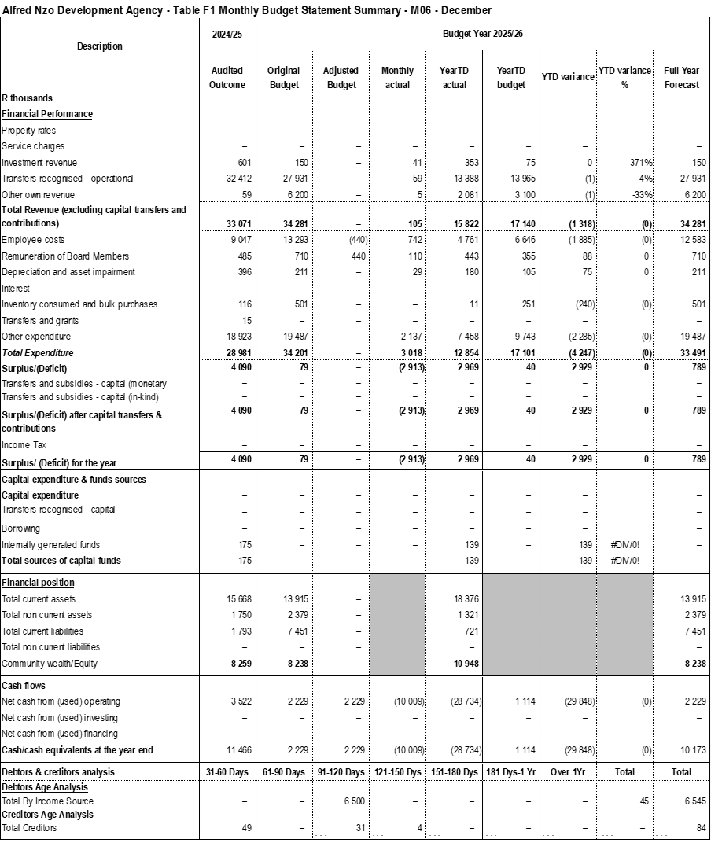

Table F2: Monthly Financial Performance (Revenue and Expenditure)
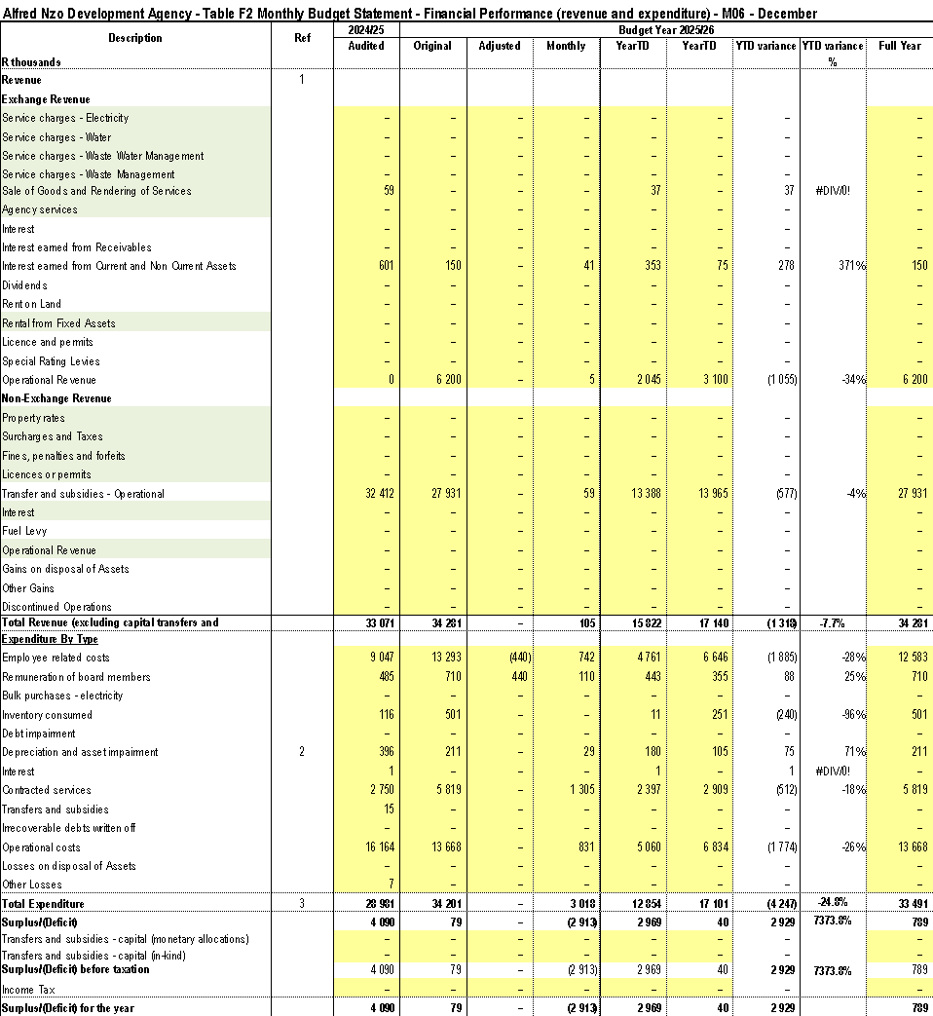

Table F3: Capital Expenditure
Capital acquisitions were made with respect to air conditioners in the current year.
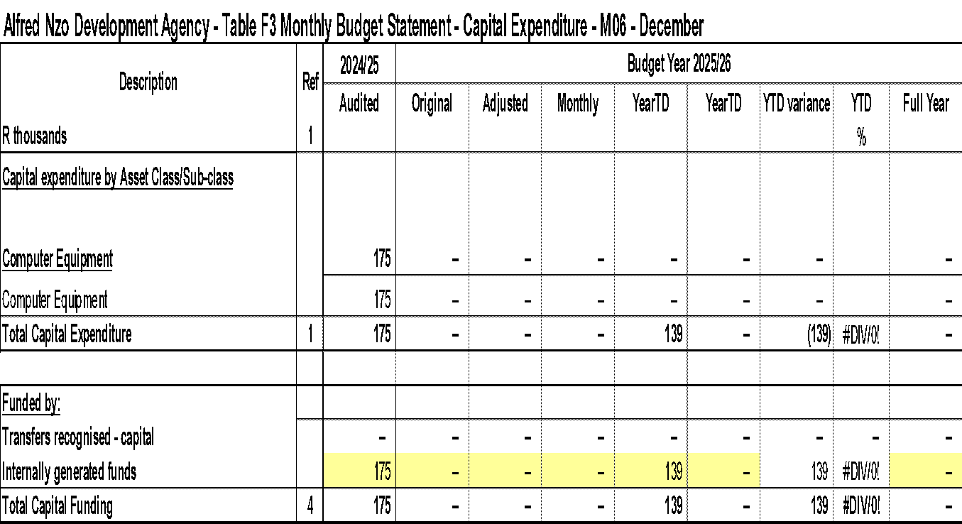

Table F4: Statement of Financial Position
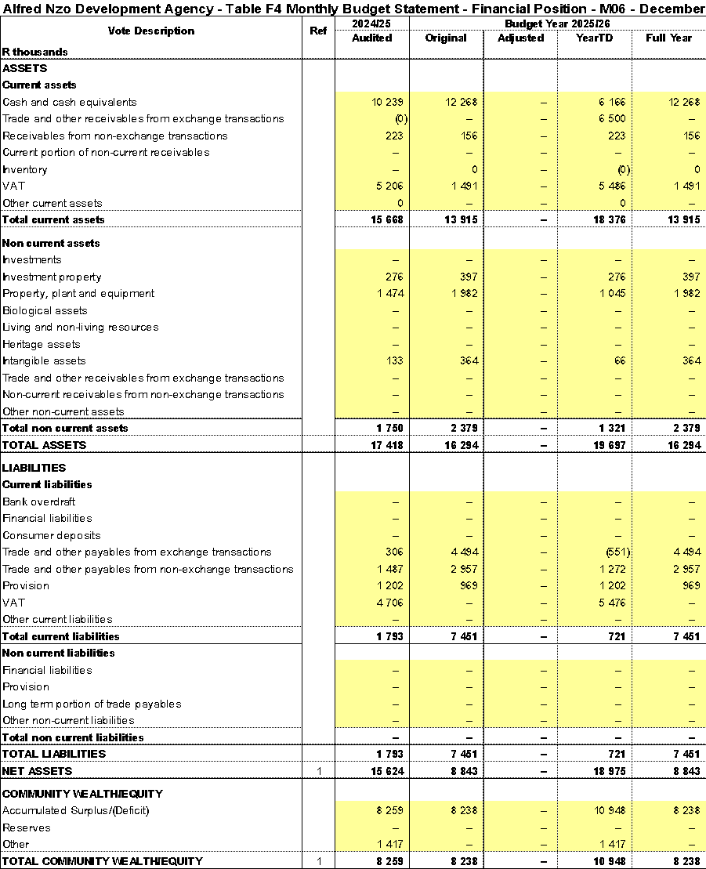

Table F5: Cash flows
The table below reflects on cash flows of the institution.
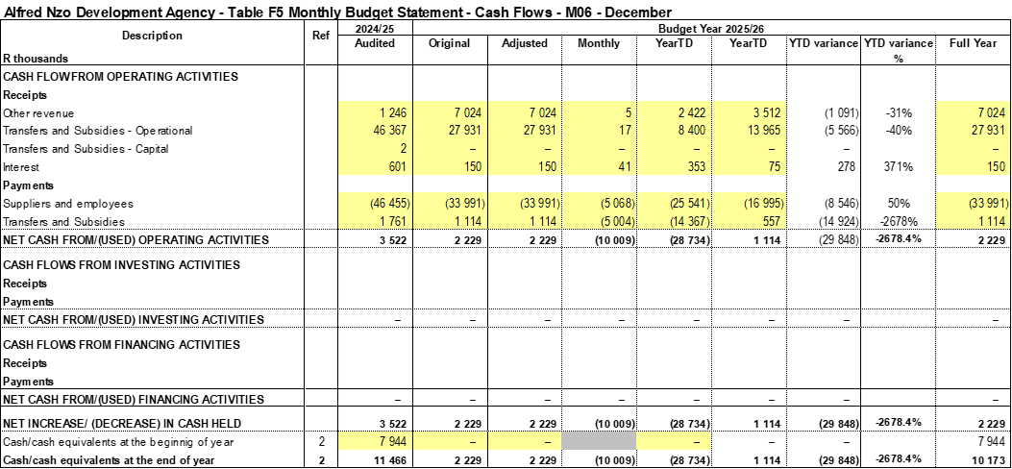
PART 2 – SUPPORTING DOCUMENTATION
Table SF1: Material variances and explanations
Description | Ref | Variance | Reasons for material deviations | Remedial or corrective steps / remarks
R thousands
Revenue items
Sale of Goods and Rendering of Services |  | 21 | There was no budget provision from the sale of tenders | Adjust in an adjustments budget
Interest earned |  | 156 | Savings on projects not yet implemented yielding interest on investments | N/A
Operational Revenue |  | 484 | Misallocated SARS refund | Corrective adjustments in the second quarter
Transfers and subsidies - Operational |  | 600 | Variance is not material | N/A
Expenditure items
Employee related costs |  | (916) | Savings from vacancies and increment not yet implemented | Fast track the recruitment process
Remuneration of board members |  | 71 | Special meeting sittings and new board members ‘induction
inventory consumed |  | (115) | Consumables will be procured in the second quarter | N/A
Depreciation and impairment |  | 41 | Under budgeting | Correct in an adjustments budget
Interest |  | –
Contracted services |  | (686) | Appointment letters issued in the third month of the quarter. | N/A
Operational Costs |  | (753) | Appointment letters issued in the third month of the quarter for operations | N/A
Total variance |  | (2 258)

Table SF3: Aged Debtors
The second tranche transfer from the District municipality was not received in the second quarter.
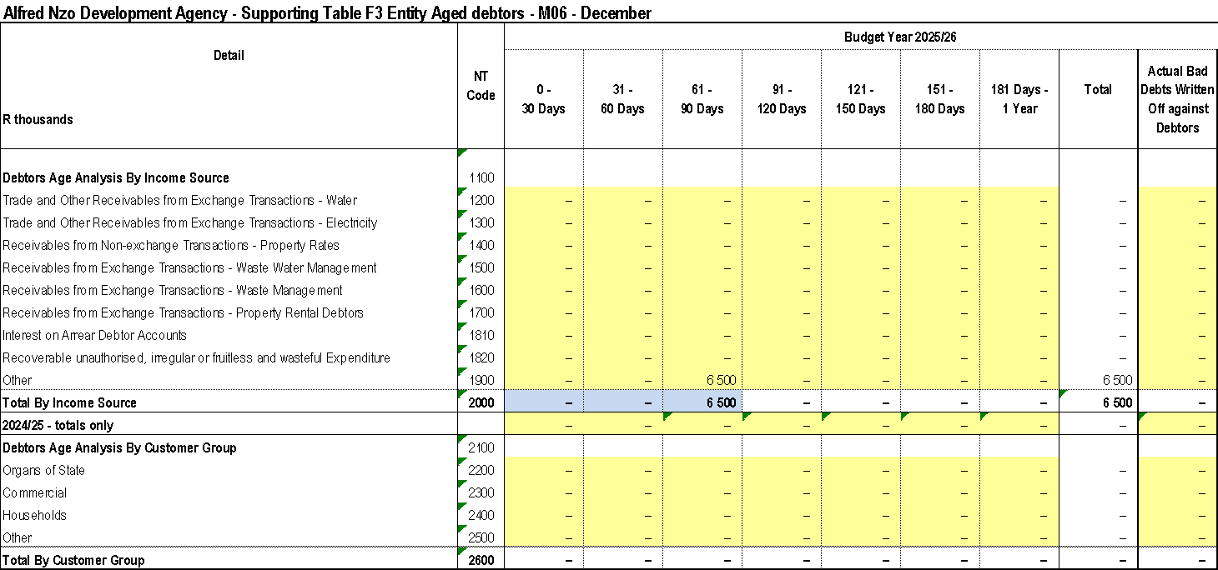

Table SF4: Aged Creditors
As at the reporting date, the entity had an outstanding trade creditor obligations of R84 thousand.
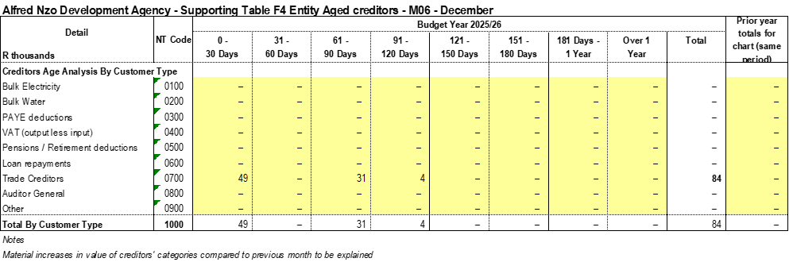

Table SF5: Investment Portfolio Analysis
All call deposit balances are classified as highly liquid short-term investments, maintained with the primary objective of meeting the entity’s short-term commitments, rather than for the purpose of earning interest income.
As detailed in the table below, the total call deposit balance amounts to R6.0 million, of which R1.4-million pertains to unspent conditional grants. The remaining R4.6- million represents the entity’s own funds invested in for liquidity management purposes
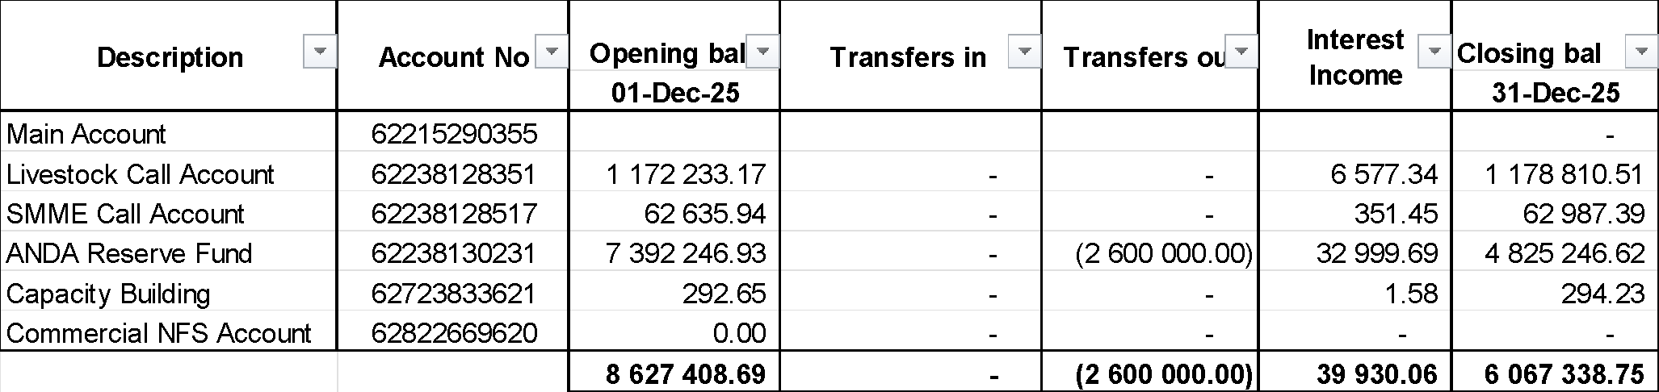

Table SF6: Board member allowances and staff benefits
The table below is a reflection of the board sittings and travelling expenses.
Name | No of sittings | Sitting Allowance | Total sitting allowances paid | Local Travel | Total Amount
M Mabude | 14 | 5 500.00 | 77 000 | 28 371 .86 | 105 371.86
Maqwathi | 9 | 4 500.00 | 40 500 | 8 228.07 | 48 728.07
Vimba | 9 | 4 500.00 | 40 500 | 28 174.87 | 68 674.87
Magaga | 13 | 4 500.00 | 58 500 | 10 004.34 | 68 504.34
Mpumza | 9 | 4 500.00 | 40 500 | 14 333.00 | 54 833.00
Qunya | 11 | 4 500.00 | 49 500 | 5 790.11 | 55 290.11
Annual General Meeting- venue hire |  |  |  |  | 30 000.00
Physical Board Meeting - venue hire |  |  |  |  | 10 650.00
Total |  |  | 306 500 | 94 902.27 | 442 052.25

Table SF7: Grants receipts and expenditure
Unspent conditional grants’ total is R1.4 – million, and R519-thousand and R201-thousand being owed by construction ceta and foodbev seta.
- LGSETA – The projects are still under implementation. The SDP has to complete certain training activities and unit standards before the payments can be made to the training provider.
- SERVICES SETA – The shortfall is due to pending tranche payments from Service Seta relating to various programmes that have been closed.
- FOODBEV SETA – The programme has been completed, awaiting the final monitoring and certification by the SETA, after which a last tranche payment will be made to cover the shortfall.
- CONSTRUCTION SETA- The shortfall is due to pending tranche invoices which have been submitted to Construction SETA but have not yet been paid.
- ECDC- The surplus is due to the Service provider who has been appointed for development of business plans. The work will only be completed in Quarter 2 -thereafter payment will be made.
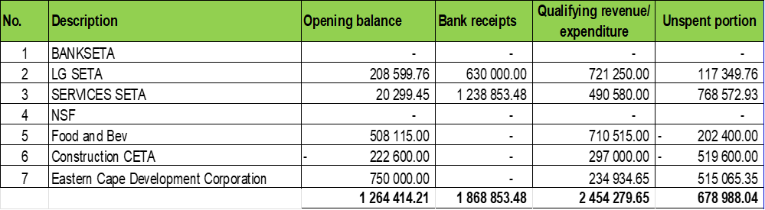

CHAPTER 6: IMPLEMENTATION OF SCM POLICY
BACKGROUND
The implementation of Supply Chain Management in the municipal entity is continuously improving its procedures in order to ensure that the Board of Directors receives value for money in terms of demand and acquisition management. Projects and procurement are being planned with cognisance of the requirements of the Supply Chain Management legislative framework.

The current shortcomings in the implementation of the Supply Chain Management Policy are constantly being addressed. The SCM policy fully complies with the requirements of the SCM Regulations, and is ideally set to ensure that procurement processes of the Entity are fair, equitable, transparent, competitive, cost effective and comply with the prescriptions of the Municipal Finance Management Act.

In accordance with the Municipal Finance Management Act SCM Regulations Section 6 (2)(a)(ii) states that the accounting officer must, within 20 days of the end of each financial year, submit a report on the implementation of the municipal entity’s supply chain management policy to the board of directors of the municipal entity, who must then submit the report to the accounting officer of the parent entity for submission to the council.
In terms of Section (111) of the MFMA, the Municipal Entity must have and implement a supply chain management policy that;
- gives effect to;
- section 217 of the Constitution; and
- Part 1 of chapter 11 and other applicable provisions of the Act;
- Is fair, equitable, transparent, competitive and cost effective
- Complies with;
- The regulatory framework prescribed in Chapter 2 of these Regulations and
- Any minimum norms and standards that may be prescribed in terms of section 168 of the Act
- Is consistent with other applicable legislation;
- Does not undermine the objective for uniformity in supply chain management system between organs of state in all spheres; and
- Is consistent with national economic policy concerning the promotion of investments and doing business with the public sector.

ANDA’s SCM Policy requires that the conditions for the procurement of goods or services through formal written price quotations are followed:
- At least 1 Quotation for procurement of a transaction value of between R300 to R2 000 (Vat Included)
- Formal written quotations for procurement of a transaction value over R2 000.00 up to R30 000.00 (Vat included)
- At least 3 Formal written price quotations for procurements of a transaction value over R30 000.00 up to R200 000.00 Vat included, and shall be advertised for at least 7 days on the website.
- Competitive bidding process to be followed for procurements above a transaction value of R200 000 (Vat Included)
DEVIATIONS
There are no deviations implemented during the 2025/26 mid-year financial year thus far.
CONTRACTS REGISTER
The Contracts Register has been developed according to Contract Management Guide and the active number of contracts is 21 .
Table 6.1.

 | Appointed Bidder Name | Bid Reference Number | Description | Contract Duration | User - Department | HOD | Appointment date | Start Date | End of The Contract Date | Extension Y/N - Reason for Extension | Extension period | Contract Value | Extension Value | Comments | Contract after Extension Amount | 2025/2026 Expenditure | Paid to Date | Invoices Due At Hand | Remaining Commitment for 2025/2026 | Commitment for 2026/2027
 | Munsoft | REGULATION 36 | Financial System and ICT Server | 36 Months | BTO | Ms Boti | 20-Dec-19 | 10-Jun-20 | 09-Jun-23 | Y | 36 months | R2 556 872.80 | R4 009 920.98 | Extension of contract for 36 months | R6 566 793.78 | R151 119.55 | R6 210 823.17 | R291.00 | R1 238 240.07 | R1 334 450.48
 | Silalele Skills Academy | ANDA 06/2020/2021 | Panel of Training Providers | 36 Months | Programmes | Ms Maloi | 15-Mar-22 | Awaiting conception letter from SETA | 14-Mar-25 | N/A | N/A | R678 500.00 | R0.00 | Silalele appointed to conduct learnership on Generic management L04 on 28/03/2023 for 12 months | N/A |  | R628 875.00 | N/A | R49 625.00 | N/A
 | VODACOM PTY LTD | ANDA 14/2022/2023 | Provision of Internet,VPN,WIFI and VOIP | 36 Months | Finance and Admin | CFO | 12-Jul-23 | 01-Aug-23 | 31-Jul-26 | N/A | N/A | R713 665.31 | N/A | N/A | N/A | R117 826.60 | R829 451.69 | N/A | R214 393.66 | R237 888.44
 | Silalele Skills Academy | ANDA 06/2020/2021 | Panel of Training Providers | 36 Months | Programmes | Ms Maloi | 15-Mar-22 | Learnership programme on Sewing: Clothing Manufacturing Processes NQF L1 for 12 months | 14-Mar-25 | N/A | N/A | R504 000.00 | R0.00 | N/A | N/A | R278 000.00 | R252 000.00 | N/A | R137 047.00 | N/A
 | Reflections Development Institute (Pty) Ltd | ANDA 06/2020/2021 | Panel of Training Providers | 36 Months | Programmes | Ms Maloi | 15-Mar-22 | Learnership programme on General EducationTraining: Business Administration Services NQF L4 for 12 months | 14-Mar-25 | N/A | N/A | R1 200 000.00 | R0.00 | N/A | N/A | R113 000.00 | R1 062 953.00 | N/A | #REF! | N/A
 | Artisan Development Academy (Pty) Ltd | ANDA 01/2023/2024 | Panel of Training Providers | 36 Months | Programmes | Ms Maloi | 16-Jan-24 | Appointed to conduct an Apprenticeship and ARPL Pogramme on Plumbing and Bricklaying for 36 months | 15-Jan-27 | N/A | N/A | N/A | R0.00 | N/A | N/A | R0.00 | R0.00 | N/A | -R19 332.83 | N/A
 | Kunene Makopo Risk Solutions | ANDA 08/2023/2024 | Provision of Insurance Services | 36 months | Finance and Admin | Ms Boti | 29-Feb-24 | 01-Apr-24 | 01-Apr-27 | N/A | N/A | R159 907.86 | R0.00 | N/A | N/A | R45 242.90 | R72 635.16 | N/A | N/A | R53 302.33
 | Silalele Skills Academy | ANDA 06/2020/2021 | Panel of Training Providers: Appointed to conduct a learnership on Bread and Confectionary Baking for 12 months | 12 Months | Programmes | Ms Maloi | 15-Mar-24 | 04-Sept-24 | 03-Sept-25 | N/A | N/A | R1 656 000.00 | R0.00 | N/A | N/A | R539 275.00 | R1 716 725.00 | R170 000.00 | N/A | R1 656 000.00
 | Artisan Development Academy (Pty) Ltd | ANDA 01/2023/2024 | Panel of Training Providers: Appointed to conduct an Apprenticeship and ARPL Pogramme on Plumbing and Bricklaying for 36 months | 36 Months | Programmes | Ms Maloi | 16-Jan-24 | 15-Aug-24 | 14-Aug-27 | N/A | N/A | R4 999 796.00 | R0.00 | N/A | N/A | R582 750.00 | R1 925 766.36 | N/A |  | R4 999 796.00
 | Umzimvubu Leather Craft | ANDA 08/2024/2025 | Provision of Cleaning Services | 12 Months | Finance and Admin | Ms Boti | 28-Aug-24 | 1-Sep-24 | 31-Aug-25 | N/A | N/A | R180 000.00 | R0.00 | N/A | N/A | R75 000.00 | R150 000.00 | N/A |  | R30 000.00
 | Silalele Skills Academy | ANDA 06/2020/2021 | Panel of Training Providers | 36 Months | Programmes | Ms Maloi | 25-Nov-24 | Appointed to conduct a learnership on Environmental Practice for 12 months | 24-Mar-26 | N/A | N/A | R273 700.00 | R0.00 | N/A | N/A |  | R178 565.00 | N/A | R95 135.00 | N/A
 | Silalele Skills Academy | ANDA 06/2020/2021 | Panel of Training Providers | 36 Months | Programmes | Ms Maloi | 25-Nov-24 | Appointed to conduct a learnership on Local Economic Development for 12 months | 24-Mar-26 | N/A | N/A | R391 000.00 | R0.00 | N/A | N/A |  | R179 975.00 | N/A | R211 025.00 | N/A
 | Zanla Consulting | ANDA 17/2024/2025 | Appointment of a Social Facilitator for Emfundisweni Skills Development Centre Project | 05 months | Programmes | Ms Maloi | 31-Mar-25 |  |  | N/A | N/A | R300 000.00 | R0.00 | N/A | N/A | R65 163.70 | R0.00 | N/A | R300 000.00 | R300 000.00
 | Iqhayiya Design Workshop | ANDA 18/2024/2025 | Development of of Business Plans for Fresh Produce Pack Houses at WMMLM and MLM | 05 months | Programmes | Ms Maloi | 31-Mar-25 |  |  | N/A | N/A | R499 936.05 | R0.00 | N/A | N/A | R499 936.05 | R234 934.65 | N/A | R265 001.40
 | MTN (PTY) LTD | ANDA 32/2024/2025 | Provision of Cell-Phone Contracts for Alfred Nzo Development Agency Officials. | 24 months | Finance & Admin | Ms Boti | 30-Jun-25 | 1-Jul-25 | 30-Jun-27 | N/A | N/A | R687 307.92 | R0.00 | N/A | N/A | R113 000.08 | R132 191.64 | N/A | R0.00 | R343 653.96
 | SMELOKUHLE |  | ANDA Accreditation | 6 Months | Programmes | Ms Maloi | 25-May-25 |  | 31-Dec-25 | N/A | N/A | R 105 000.00 | R - | N/A | N/A | R60 000.00
 | Boqwana Burns |  | Legal Services | 36 Months | CEO's Office | Mr Gentse | 17-Jul-25 | 01-Aug-25 | 31-Jul-28 | N/A | N/A | N/A | R - | N/A | N/A | R408 765.02 | R408 765.02
 | Mbhekwa Business | ANDA 06/2025/2026 | The Appointment of Service Provider for The Development of Feasibility Study for Taro (Amadumbe)And Sweet Potato | 4 Months | Progrmmes | Ms Maloi | 26-Sept-25 | 05-Nov-25 | 28-Feb-26 | N/A | N/A | R 550 000.00 | R - | N/A | N/A | R110 000.00 | R110 000.00 |  | R 440 000.00
 | Mbhekwa Business | ANDA 08/2025/2027 | Appointment of Service Provider to conduct feasibility study for Coffee Plantation in Alfred Nzo. | 04 Months | Progrmmes | Ms Maloi | 26-Sept-25 | 05-Nov-25 | 28-Feb-26 | N/A | N/A | R 550 000.00 | R - | N/A | N/A | R110 000.00 | R110 000.00 |  | R 440 000.00
 | Solanga Sydney Projects | ANDA 06/2025/2028 | Professional Land Surveyor for Facilitating the Sub-Divisional Diagram, Rezoning of Agricultural Land and Produce A Valuation Report for Toleni Area Situated at Umzimvubu Local Municipality | 04 Months | Progrmmes | Ms Maloi | 01-Nov-25 | 28-Oct-25 | 31-Jul-28 | N/A | N/A | R 400 000.00 | R - | N/A | N/A | R158 003.00 | R158 003.00 |  | R 241 997.00
 | ZanlaConsulting Jv GIBBS AFRICA PEALE CORPS | ANDA 03/2025/2029 | Appointment Of Service Provider To Conduct Social Facilitation For Macadamia Nuts Plantation | 4 Months | Progrmmes | Ms Maloi | 01-Nov-25 | 28-Oct-25 | 31-Jul-28 | N/A | N/A | R 276 500.00 | R - | N/A | N/A |  | R0.00 |  | R 276 500.00

ORDERS ISSUED FOR THE FINANCIAL YEAR 2025/2026
Orders issued for the Mid-Term amounted to R849 549.62 including VAT for VAT vendors and are as follows:

Table 6.2.
Sequence | Creditor Name | Creditor Address | Order No. | Order Date | Value
1 | SIBUWELE | BETSHWANA A/A; MOUNT AYLIFF;47 BETSHWANA A/A; MOUNT AYLIFF; 4 4735 | 28878 | 2025/12/15 | R4 500.00
2 | Wild Coast Sun | PO BOX 23 PORT EDWARD 4295 | 28877 | 2025/12/11 | R2 060.00
3 | Allenio Travel | 10 KENNINGTON ROAD NAHOON 5201 | 28876 | 2025/12/11 | R3 003.00
4 | Garden Court Umhlanga | Cnr Aurora & Centenary Blvd Umhlanga Ridge | 28875 | 2025/12/09 | R1 700.00
5 | Garden Court Umhlanga | Cnr Aurora & Centenary Blvd Umhlanga Ridge | 28874 | 2025/12/09 | R1 700.00
6 | Allenio Travel | 10 KENNINGTON ROAD NAHOON 5201 | 28873 | 2025/12/05 | R5 940.00
7 | Travelstart Online Travel oper | P.O.BOX 32285 CAMPSBAY Cape Town 8040 | 28872 | 2025/12/04 | R17 196.00
8 | Garden Court East London | CNR JOHN BAILLIE ROAD AND MOOR EAST LONDON 5210 | 28871 | 2025/12/03 | R1 630.00
9 | Garden Court East London | CNR JOHN BAILLIE ROAD AND MOOR EAST LONDON 5210 | 28870 | 2025/12/03 | R3 260.00
10 | Kellys Beachfront Apartments | 3 GANNET ROAD PORT ALFRED 6170 | 28869 | 2025/11/25 | R4 650.00
11 | Kellys Beachfront Apartments | 3 GANNET ROAD PORT ALFRED 6170 | 28868 | 2025/11/25 | R4 650.00
12 | PREMIER HOTEL ELICC | MARINE PARK COMPLEX 22 ESPLANADE BEACHFRONT East London 5201 | 28867 | 2025/11/24 | R7 485.00
13 | Garden Court Mthatha | NELSON MANDELA DRIVE MTHATHA 5100 | 28866 | 2025/11/17 | R1 845.00
14 | Garden Court Mthatha | NELSON MANDELA DRIVE MTHATHA 5100 | 28865 | 2025/11/17 | R3 690.00
15 | Southern Sun Hemmingways | CNR WESTERN BYPASS & TWO RIVER CAMBRIDGE 5200 | 28864 | 2025/11/06 | R4 890.00
16 | Garden Court East London | CNR JOHN BAILLIE ROAD AND MOOR EAST LONDON 5210 | 28863 | 2025/11/06 | R4 890.00
17 | Allenio Travel | 10 KENNINGTON ROAD NAHOON 5201 | 28862 | 2025/11/06 | R9 860.25
18 | Allenio Travel | 10 KENNINGTON ROAD NAHOON 5201 | 28861 | 2025/11/05 | R5 940.00
19 | Allenio Travel | 10 KENNINGTON ROAD NAHOON 5201 | 28860 | 2025/11/05 | R7 969.00
20 | Allenio Travel | 10 KENNINGTON ROAD NAHOON 5201 | 28859 | 2025/11/05 | R10 626.00
21 | Allenio Travel | 10 KENNINGTON ROAD NAHOON 5201 | 28858 | 2025/11/05 | R9 865.14
22 | Allenio Travel | 10 KENNINGTON ROAD NAHOON 5201 | 28857 | 2025/11/05 | R7 969.00
23 | Allenio Travel | 10 KENNINGTON ROAD NAHOON 5201 | 28856 | 2025/11/05 | R9 860.25
24 | Southern Sun Hemmingways | CNR WESTERN BYPASS & TWO RIVER CAMBRIDGE 5200 | 28855 | 2025/11/05 | R3 330.00
25 | LISOMMA LODGE | 19 MAZIZI NKANYUZA STREETLY MO P.O.BOX 285. MOUNT AYLIFF 4735 | 28854 | 2025/10/24 | R29 870.00
26 | MAIL AND GUARDIAN ONLINE | GROSVENOR CORNER; 195 JAN SMUT PARKTOWN NORTH Johannesburg 2193 | 28853 | 2025/10/24 | R2 645.00
27 | ARENA HOLDINGS | P O BOX 408 MHLUZI Johannesburg 1053 | 28852 | 2025/10/24 | R7 452.00
28 | INGELI FOREST LODGE CC | 3792 MACKTON FARM; R56 WEZA OFF N2 BETWEEN HARDING AND KOK KwaZulu- Natal 4680 | 28851 | 2025/10/23 | R5 100.00
29 | TB AND YN TRADING | RHODE AA MOUNT AYLIFF 4735 | 28850 | 2025/09/30 | R28 990.00
30 | THE OAK TREEHOUSE BNB | 37 FOCH AVENUE TOP TOWN 5320 | 28849 | 2025/09/30 | R3 220.00
31 | Allenio Travel | 10 KENNINGTON ROAD NAHOON 5201 | 28848 | 2025/09/29 | R15 849.85
32 | Allenio Travel | 10 KENNINGTON ROAD NAHOON 5201 | 28847 | 2025/09/29 | R6 890.00
33 | Allenio Travel | 10 KENNINGTON ROAD NAHOON 5201 | 28846 | 2025/09/29 | R6 600.00
34 | IMBALI BOUTIQUE HOTEL | NO.137 HOPE STREET BHONGWENI; KOKSTAD 4700 | 28845 | 2025/09/25 | R1 620.00
35 | Pondoland Times | P O BOX 127 NTSINGIZI A SP; NTSINGIZI A 4800 | 28844 | 2025/09/18 | R1 800.00
36 | Pondoland Times | P O BOX 127 NTSINGIZI A SP; NTSINGIZI A 4800 |  | 2025/09/18 | R1 800.00
37 | Allenio Travel | 10 KENNINGTON ROAD NAHOON 5201 | 28843 | 2025/09/16 | R5 830.00
38 | VERI-SOURCE CONSULTING | P O BOX 9324 WELTEVREDENPARK 1715 | 28842 | 2025/09/16 | R853.00
39 | Town Lodge Gqeberha | 50 BEACH ROAD CORNER BEACH AND LODGE ROADS 6001 | 28841 | 2025/09/15 | R4 545.00
40 | Wild Coast Sun | PO BOX 23 PORT EDWARD 4295 | 28840 | 2025/09/15 | R5 610.00
41 | FISC ENTERPRISE (PTY) LTD | CHITHWA VILLAGE CHITHWA A/A 4735 | 28839 | 2025/09/11 | R5 550.00
42 | VERI-SOURCE CONSULTING | P O BOX 9324 WELTEVREDENPARK 1715 | 28838 | 2025/09/11 | R1 362.75
43 | Garden Court Umhlanga | Cnr Aurora & Centenary Blvd Umhlanga Ridge | 28837 | 2025/09/11 | R10 650.00
44 | Garden Court Umhlanga | Cnr Aurora & Centenary Blvd Umhlanga Ridge | 28836 | 2025/09/11 | R3 330.00
45 | Garden Court Umhlanga | Cnr Aurora & Centenary Blvd Umhlanga Ridge | 28835 | 2025/09/11 | R3 330.00
46 | Garden Court Umhlanga | Cnr Aurora & Centenary Blvd Umhlanga Ridge | 28834 | 2025/09/11 | R3 330.00
47 | Garden Court Umhlanga | Cnr Aurora & Centenary Blvd Umhlanga Ridge | 28833 | 2025/09/11 | R3 330.00
48 | Allenio Travel | 10 KENNINGTON ROAD NAHOON 5201 | 28832 | 2025/09/11 | R2 151.14
49 | Garden Court Umhlanga | Cnr Aurora & Centenary Blvd Umhlanga Ridge | 28831 | 2025/09/11 | R1 630.00
50 | Allenio Travel | 10 KENNINGTON ROAD NAHOON 5201 | 28830 | 2025/09/10 | R7 772.25
51 | Allenio Travel | 10 KENNINGTON ROAD NAHOON 5201 | 28829 | 2025/09/10 | R4 044.70
52 | Allenio Travel | 10 KENNINGTON ROAD NAHOON 5201 | 28828 | 2025/09/10 | R6 100.00
53 | Allenio Travel | 10 KENNINGTON ROAD NAHOON 5201 | 28827 | 2025/09/10 | R4 630.00
54 | Allenio Travel | 10 KENNINGTON ROAD NAHOON 5201 | 28826 | 2025/09/10 | R3 880.00
55 | Southern Sun Pretoria | CNR PRETORIUS AND BIKO STREETS PRETORIA 0007 | 28825 | 2025/09/10 | R3 260.00
56 | Allenio Travel | 10 KENNINGTON ROAD NAHOON 5201 | 28824 | 2025/09/09 | R4 485.00
57 | Allenio Travel | 10 KENNINGTON ROAD NAHOON 5201 | 28823 | 2025/09/09 | R3 709.43
58 | RALAKE CONSTRUCTION AND SERVIC | ERF 194 MALUTI TOWNSHIP MATATIELE 4730 Matatiele 4740 | 28822 | 2025/09/02 | R11 500.00
59 | VILO SECURITY SERVICES | 126 WINNIE MADIKIZELA MANDELA BIZANA 4800 | 28821 | 2025/09/02 | R2 000.00
60 | ANGELA LIFE EVENTS | ERF 913 MALUTI SP; MALUTI 4730 | 28820 | 2025/09/01 | R19 180.00
61 | Harvey World Travel East Londo | 77 DEVEREUX AVENUE VINCENT; EAST LONDON East London 5247 | 28819 | 2025/08/29 | R11 880.00
62 | AWETHU EVENTS MANAGEMENT AND C | MZINTO ADMINISTRATIVE AREA MOUNT FRERE 5090 | 28818 | 2025/08/29 | R13 500.00
63 | 4ZZKAZI TRADING AND PROJECTS | ERF 291 WHITECITY 3297 | 28817 | 2025/08/28 | R19 500.00
64 | 4 K PROTECTION | MATHWEBU LOCATION BIZANA 4800 | 28815 | 2025/08/28 | R20 475.00
65 | MIDTOWN DREAM | ERF 1511 HIGHLAND VIEW 4800 | 28816 | 2025/08/28 | R22 500.00
66 | OWOLWAZI | ERF 1981 MAIN STREET BIZANA SP; BIZANA 4800 | 28814 | 2025/08/28 | R11 850.00
67 | ZODIAC TRADING | 103 MAIN STREET 4730 | 28813 | 2025/08/28 | R1 630.00
68 | IMVOMVO COUNTRY LODGE AND OTHE | MBANGWENI A/A NTABANKULU 5130 | 28812 | 2025/08/28 | R1 450.00
69 | TAMAC CONSULTING | 16A EMPIRE AVE CAMBRIDGE 5201 | 28811 | 2025/08/26 | R187 673.91
70 | Garden Court Mthatha | NELSON MANDELA DRIVE MTHATHA 5100 | 28810 | 2025/08/25 | R3 360.00
71 | Mayfair Hotel | 35 ERROL SPRING AVENUE VULINDLELA HEIGHTS Southernwood 5099 | 28809 | 2025/08/08 | R3 360.00
72 | Garden Court East London | CNR JOHN BAILLIE ROAD AND MOOR EAST LONDON 5210 | 28808 | 2025/08/07 | R8 150.00
73 | Garden Court East London | CNR JOHN BAILLIE ROAD AND MOOR EAST LONDON 5210 | 28807 | 2025/08/07 | R8 150.00
74 | Garden Court East London | CNR JOHN BAILLIE ROAD AND MOOR EAST LONDON 5210 | 28806 | 2025/08/07 | R8 150.00
75 | Garden Court East London | CNR JOHN BAILLIE ROAD AND MOOR EAST LONDON 5210 | 28806 | 2025/08/07 | R8 150.00
76 | Garden Court East London | CNR JOHN BAILLIE ROAD AND MOOR EAST LONDON 5210 | 28805 | 2025/08/07 | R8 150.00
77 | PONDO NEWS | 58 HOPE STREET 4700 | 28804 | 2025/08/07 | R3 588.00
78 | MAIL AND GUARDIAN ONLINE | GROSVENOR CORNER; 195 JAN SMUT PARKTOWN NORTH Johannesburg 2193 | 28803 | 2025/08/05 | R2 753.10
79 | Savoy Shopping Centre + Hotel | NELSON MANDELA DRIVE MTHATHA 5200 | 28802 | 2025/08/05 | R1 830.00
80 | ARENA HOLDINGS | P O BOX 408 MHLUZI 1053 | 28801 | 2025/08/05 | R9 315.00
81 | Allenio Travel | 10 KENNINGTON ROAD NAHOON 5201 | 28800 | 2025/08/04 | R5 280.00
82 | SWIFT TRAVEL AND TOURS | 10 MILLER STREET MTHATHA Mthatha 5099 | 28799 | 2025/08/04 | R7 920.00
83 | Travelstart Online Travel oper | P.O.BOX 32285 CAMPSBAY Cape Town 8040 | 28798 | 2025/08/04 | R605.00
84 | SWIFT TRAVEL AND TOURS | 10 MILLER STREET MTHATHA Mthatha 5099 | 28797 | 2025/08/04 | R6 733.00
85 | INGELI FOREST LODGE CC | 3792 MACKTON FARM; R56 WEZA OFF N2 BETWEEN HARDING AND KOK KwaZulu- Natal 4680 | 28796 | 2025/08/01 | R1 950.00
86 | Travelstart Online Travel oper | P.O.BOX 32285 CAMPSBAY Cape Town 8040 | 28795 | 2025/08/01 | R1 977.00
87 | Travelstart Online Travel oper | P.O.BOX 32285 CAMPSBAY Cape Town 8040 | 28794 | 2025/07/30 | R1 932.08
88 | Garden Court Mthatha | NELSON MANDELA DRIVE MTHATHA 5100 | 28793 | 2025/07/30 | R3 690.00
89 | INGELI FOREST LODGE CC | 3792 MACKTON FARM; R56 WEZA OFF N2 BETWEEN HARDING AND KOK KwaZulu- Natal 4680 | 28792 | 2025/07/29 | R22 100.00
90 | INGELI FOREST LODGE CC | 3792 MACKTON FARM; R56 WEZA OFF N2 BETWEEN HARDING AND KOK KwaZulu- Natal 4680 | 28791 | 2025/07/29 | R30 000.00
91 | Pondoland Times | P O BOX 127 NTSINGIZI A SP; NTSINGIZI A 4800 | 28790 | 2025/07/24 | R1 000.00
92 | LWALWA EVENTS AND PROJECTS | ERF 308 NO.09 NGQALUTYANA SEKU MOUNT AYLIFF 4735 | 28789 | 2025/07/22 | R4 975.00
93 | IMVELISO HOLDINGS | 58526 HUTCHINSON ROAD REESTON; EAST LONDON 5247 | 28788 | 2025/07/16 | R18 000.00
94 | Konica Minolta SA Ado Bidvest | 35 MODULUS ROAD ORMONDE Ormonde 2091 | 28787 | 2025/07/16 | R11 870.42
95 | ZODIAC TRADING | 103 MAIN STREET 4730 | 28786 | 2025/07/10 | R1 160.00
96 | Pondoland Times | P O BOX 127 NTSINGIZI A SP; NTSINGIZI A 4800 | 28785 | 2025/07/08 | R1 000.00
97 | MAIL AND GUARDIAN ONLINE | GROSVENOR CORNER; 195 JAN SMUT PARKTOWN NORTH Johannesburg 2193 | 28784 | 2025/07/08 | R1 955.00
98 | ARENA HOLDINGS | P O BOX 408 MHLUZI Johannesburg 1053 | 28783 | 2025/07/08 | R4 978.35

Table 6.3.

PROVINCE | AMOUNT | % | Number of orders | %
Eastern Cape | R661 926.92 | 78.33458 | 65 | 67.70833
KwaZulu Natal | R114 918.00 | 13.59977 | 16 | 16.66667
Gauteng | R63 640.62 | 7.531438 | 12 | 12.5
Western Cape | R4 514.08 | 0.534211 | 3 | 3.125
Total | R849 549.62 | 100 | 96 | 100

Pie Chart 6..2

Table 6.3.

Local Municipality | Amount | % | No. of orders | %
Umzimvubu | R87 385.00 | 10.28603838 | 6 | 6.25
WMMLM | R59 625.00 | 7.018424657 | 6 | 6.25
Ntabankulu | R1 450.00 | 0.170678671 | 1 | 1.041666667
Matatiele | R33 470.00 | 3.939734562 | 4 | 4.166666667
Outside Alfred Nzo | R667 619.62 | 78.58512373 | 79 | 82.29166667
Total | R849 549.62 | 100 | 96 | 100

Pie Chart 6.3.

List of Bids Awarded
Table 6.4
BID NUMBER | PROJECT DESCRIPTION | AMOUNT | SERVICE PROVIDER | Municipality
ANDA 03/2025/2026 | Appointment of Service Provider to Conduct Social Facilitation for Macadamia Nuts Plantation | R276 500 | Gibbs Africa Peale Corps JV Zanla Consulting | Ntabankulu
ANDA 06/2025/2026 | The Appointment of Service Provider for The Development of Feasibility Study for Taro (Amadumbe)And Sweet Potato | R550 000 | Mbhekwa Business Solutions | Winnie Madikizela Mandela
ANDA 07/2025/2026 | Professional Land Surveyor for Facilitating the Sub-Divisional Diagram, Rezoning of Agricultural Land and Produce A Valuation Report for Toleni Area Situated at Umzimvubu Local Municipality | R400 000 | Solanga Sydney Projects | EmaXesibeni
ANDA 08/2025/2026 | Appointment of Service Provider to conduct feasibility study for Coffee Plantation in Alfred Nzo. | R550 000 | Mbhekwa Business Solutions | Winnie Madikizela Mandela
ANDA 05/2025/2026 | Provision of Cleaning Services for a Period of Two (2) Years | R540 000 | Umzimvubu Leather Craft and Multipurpose | Umzimvubu

PROCUREMENT PLAN
ANDA developed an annual procurement plan in line with the SDBIP

Table 6.5.
Directorate / Unit | Vote | Bid Description | Date of Submission of Specification / TOR's | Budgeted Amount | Source of Funding | Envisaged Date of Award | Actual date of award | Comments
Trade and Investment | Research and Development :Cannibas | 1.Develop 1 x Cannabis Master Plan by 30 June 2026 | 14 October 2025 | R 600 000.00 | ANDM GRANT | 10 February 2026 |  | Bid Evaluation Committee has recommended for appointment
Trade and Investment | Research and Development :Cannibas | 1. Conduct 1x social facilitation for the development of Macadamia Nuts Plantation by 30 June 2026 | 11-Aug-25 | R300 000.00 | ANDM GRANT | 05-Sept-25 | 25-Sept-25 | Appointment has been made
Trade and Investment | Research and Development :Cannibas | 1 x land survey at Tholeni Administrative Area by June 2026 | 11-Aug-25 | R400 000.00 | ANDM GRANT | 08-Sept-25 | 25-Sept-25 | Appointment has been made
Programmes | Research and Development :Cannibas | 1. Conduct 1 x feasibility study for the development of coffee plantations in 4 local municipalities by 30 June 2026 | 11-Aug-25 | R 600 000.00 | ANDM GRANT | 03-Sept-25 | 25-Sept-25 | Appointment has been made
Programmes | Research and Development :Cannibas | 1. Conduct 1x feasibility study for the development of Amadumbe and Sweet Potato by 30 June 2026 | 11-Aug-25 | R600 000.00 | ANDM GRANT | 05-Oct-25 | 25-Sept-25 | Appointment has been made
Finance and Admin | Administrative and Corporate Support:Admin & Corporate Services | Provision of Cleaning Services | 11-Aug-25 | R217 000.00 | ANDM GRANT | 28-Aug-25 |  | Appointment has been made
Office of the CEO | Legal Fees | The appointment of the panel of service providers for handling of legal matters for Alfred Nzo Development Agency (ANDA) | 18-Jul-25 | R150 000.00 | ANDM GRANT | 05-Oct-25 |  | The Tender period has lapsed will need to readvertised.

SITTINGS OF BIT COMMITTEES
All bid committees were appointed in line with the applicable legislation during the 2025/2026 financial year. All sittings for the financial year are reflected on the following table;
Table 6.6
BID COMMITTEE SITTING 2025/26 MIDTERM
BID NO. | DESCRIPTION | BID COMMITTEE | DATE OF SITTING
02/2025/2026 | Provision of cellphone contracts for 2 years: The Appointment of Service Provider for the Development of Alfred Nzo District Cannabis Master Plan. | Bid Specification Committee | 14-Jul-25
03/2025/2026 | The Appointment of Service Provider to Conduct Social Facilitation for Macadamia Nuts Plantation | Bid Specification Committee | 14-Jul-25
04/2025/2026 | The Appointment of a Panel for The Handling of Legal Matters for Alfred Nzo Development Agency for A Period Of 36 Months | Bid Specification Committee | 14-Jul-25
05/2025/2026 | The Appointment of a Service Provider for the Provision Cleaning Services for a period of 3 years. | Bid Specification Committee | 14-Jul-25
06/2025/2026 | The Appointment of Service Provider for The Development of Feasibility Study for Taro (Amadumbe)And Sweet Potato | Bid Specification Committee | 14-Jul-25
07/2025/2026 | Appointment of a Professional Land Surveyor for Facilitating the Sub-Divisional Diagram, Rezoning of Agricultural Land and Produce A Valuation Report for Toleni Area Situated at Umzimvubu Local Municipality. | Bid Specification Committee | 14-Jul-25
08/2025/2026 | Appointment of Service Provider to conduct feasibility study for Coffee Plantation in Alfred Nzo. | Bid Specification Committee | 14-Jul-25
02/2025/2026 | Provision of cellphone contracts for 2 years: The Appointment of Service Provider for the Development of Alfred Nzo District Cannabis Master Plan. | Bid Evaluation Committee | 11-Sept-25
03/2025/2026 | The Appointment of Service Provider to Conduct Social Facilitation for Macadamia Nuts Plantation | Bid Evaluation Committee | 11-Sept-25
04/2025/2026 | The Appointment of a Panel for The Handling of Legal Matters for Alfred Nzo Development Agency for A Period Of 36 Months | Bid Evaluation Committee | 11-Sept-25
05/2025/2026 | The Appointment of a Service Provider for the Provision Cleaning Services for a period of 3 years. | Bid Evaluation Committee | 11-Sept-25
06/2025/2026 | The Appointment of Service Provider for The Development of Feasibility Study for Taro (Amadumbe)And Sweet Potato | Bid Evaluation Committee | 11-Sept-25
07/2025/2026 | Appointment of a Professional Land Surveyor for Facilitating the Sub-Divisional Diagram, Rezoning of Agricultural Land and Produce A Valuation Report for Toleni Area Situated at Umzimvubu Local Municipality. | Bid Evaluation Committee | 11-Sept-25
08/2025/2026 | Appointment of Service Provider to conduct feasibility study for Coffee Plantation in Alfred Nzo. | Bid Evaluation Committee | 11-Sept-25
02/2025/2026 | Provision of cellphone contracts for 2 years: The Appointment of Service Provider for the Development of Alfred Nzo District Cannabis Master Plan. | Bid Adjudication Committee | 17-Sept-25
03/2025/2026 | The Appointment of Service Provider to Conduct Social Facilitation for Macadamia Nuts Plantation | Bid Adjudication Committee | 17-Sept-25
04/2025/2026 | The Appointment of a Panel for The Handling of Legal Matters for Alfred Nzo Development Agency for A Period Of 36 Months | Bid Adjudication Committee | 17-Sept-25
05/2025/2026 | The Appointment of a Service Provider for the Provision Cleaning Services for a period of 3 years. | Bid Adjudication Committee | 17-Sept-25
06/2025/2026 | The Appointment of Service Provider for The Development of Feasibility Study for Taro (Amadumbe)And Sweet Potato | Bid Adjudication Committee | 17-Sept-25
07/2025/2026 | Appointment of a Professional Land Surveyor for Facilitating the Sub-Divisional Diagram, Rezoning of Agricultural Land and Produce A Valuation Report for Toleni Area Situated at Umzimvubu Local Municipality. | Bid Adjudication Committee | 17-Sept-25
08/2025/2026 | Appointment of Service Provider to conduct feasibility study for Coffee Plantation in Alfred Nzo. | Bid Adjudication Committee | 17-Sept-25
04/2025/2026 | The Appointment of a Panel for Training Providers for Alfred Nzo Development Agency for A Period Of 36 Months | Bid Specification Committee | 16-Oct-25
09/2025/2026 | The Appointment of Service Provider for the Development of Alfred Nzo District Cannabis Master Plan. | Bid Specification Committee | 15-Oct-25
09/2025/2026 | The Appointment of Service Provider for the Development of Alfred Nzo District Cannabis Master Plan. | Bid Evaluation Committee | 20-Nov-25
04/2025/2026 | The Appointment of a Panel for The Handling of Legal Matters for Alfred Nzo Development Agency for A Period Of 36 Months | Bid Evaluation Committee | 17-Nov-25
05/2025/2026 | The Appointment of a Service Provider for the Provision Cleaning Services for a period of 3 years. | Bid Evaluation Committee | 17-Nov-25
04/2025/2026 | The Appointment of a Panel for The Handling of Legal Matters for Alfred Nzo Development Agency for A Period Of 36 Months | Bid Adjudication Committee | 05-Dec-25
05/2025/2026 | The Appointment of a Service Provider for the Provision Cleaning Services for a period of 3 years. | Bid Adjudication Committee | 05-Dec-25

PERFORMANCE OF EXTERNAL SERVICE PROVIDERS FOR MID TERM OF 2025/2026 FY
Table 6.7.
LEGEND:
1 – Not meeting the standards (0-30%)
2 – Meet some of the standards (30-50%)
3 – Meet most of the standards (50-70%)
4 – Meet all the standards (70-100%)
NAME OF SERVICE PROVIDER | SERVICE RENDERED | SET TARGET OF PERFORMANCE (2025/2026) | PERFORMANCE | RATING FOR CURRENT FINANCIAL YEAR | COMMENTS /RECOMMENDATIONS
MUNSOFT | Financial System | Provision of municipal financial system for transacting | Good | 3 | The interaction with Munsoft has improved after an email was sent to management. The system still has gaps that need to be attended to.
Vodacom | Business Contract Phones and Internet | Phones and internet are provided as specified. | Poor | 2 | Contract is in place and monitored monthly but overall service is poor
Umzimvubu Leather Craft | Provision of cleaning services | Cleaning services | Good | 3 | The service provider is performing as expected.
MTN | Provision of Cellphone contracts for 24 months | Cellphone Contracts | Poor | 3 | Service Provider performance is fair though the MTN coverage is a problem.
Silale Skills Academy | Silalele appointed to conduct learnership on Generic management L04 | Learnership on Generic Management NQF L4 | Good | 4 | Contract ongoing with no challenges.
Silale Skills Academy | Silalele appointed to conduct learnership on Sewing General Education Training (GET) Certificate Clothing Manufacturing Processes | Learnership on Clothing Manufacturing Processes NQF L1 | Good | 4 | Contract ongoing with no challenges.
Silalele Skills Solutions | Silalele appointed to conduct learnership on Bread and Confectionary baking for 12 months | Learnership on Bread and Confectionary Baking for 12 months | Good | 4 | Contract ongoing with no challenges
Artisan Development Academy | ADA appointed to conduct an apprenticeship and ARPL Programme on Plumbing and Bricklaying for 36 months | Apprenticeship and ARPL Programme on Plumbing and Bricklaying | Good | 4 | Contract ongoing with no challenges
Iqhayiya Design Workshop Architects | Service Provider for Development of Business Plans, Conceptual Designs and Costing of Fresh Produce Packhouses At Winnie Madikizela Mandela And Matatiele Local Municipalities | Service Provider for Development of Business Plans, Conceptual Designs and Costing of Fresh Produce Packhouses At Winnie Madikizela Mandela And Matatiele Local Municipalities | Good | 4 | Contract on-going with no challenges
ZANLA | Social Facilitator for Emfundisweni | Social Facilitator for Emfundisweni | Good | 4 | Contract on-going with no challenges
SMELOKUHLE | ANDA SETA Accreditation | ANDA SETA Accreditation | Good | 4 | Contract on-going with no challenges
Boqwana Burns | Legal Services | Legal Services | Good | 4 | The Service Provider received instruction and prosecuted as requested .
Mbhekwa Business | The Appointment of Service Provider for The Development of Feasibility Study for Taro (Amadumbe)And Sweet Potato | The Appointment of Service Provider for The Development of Feasibility Study for Taro (Amadumbe)And Sweet Potato | Good | 4 | Contract ongoing with no challenges
Mbhekwa Business | Appointment of Service Provider to conduct feasibility study for Coffee Plantation in Alfred Nzo. | Appointment of Service Provider to conduct feasibility study for Coffee Plantation in Alfred Nzo. | Good | 4 | Contract ongoing with no challenges
Solanga Sydney Projects | Professional Land Surveyor for Facilitating the Sub-Divisional Diagram, Rezoning of Agricultural Land and Produce A Valuation Report for Toleni Area Situated at Umzimvubu Local Municipality | Professional Land Surveyor for Facilitating the Sub-Divisional Diagram, Rezoning of Agricultural Land and Produce A Valuation Report for Toleni Area Situated at Umzimvubu Local Municipality | Good | 4 | Contract ongoing with no challenges

CHAPTER 7: UNAUTHORISED, IRREGULAR, FRUITLESS AND WASTEFUL EXPENDITURE
The Irregular Expenditure report is prepared according to MFMA circular number 68, the Irregular Expenditure Register is attached.
There has been no irregular expenditure recorded for the current financial year.
There has been no fruitless and wasteful expenditure recorded for the current financial year.

CHAPTER 8: TAX COMPLIANCE REPORT
This report serves as a summary of the entity's tax obligations and compliance schedule. It is essential for the entity to maintain accurate records and ensure timely submissions to avoid penalties or interest.
1. Types of Taxes Applicable to the Entity: The entity is required to comply with the following types of taxes:
- Provisional Tax: This tax is applicable to the entity and must be paid twice a year. It serves as a method of pre-paying the annual tax liability in advance to avoid a large lump sum at year-end.
- Value-Added Tax (VAT): The entity is registered for VAT and submits VAT returns every two months. This tax is applicable on the sale of goods and services, and the entity is eligible to claim input VAT on expenses incurred in the course of its business.
- Annual Income Tax: The entity is required to file an annual income tax return based on the taxable income derived during the financial year.
- Employees’ Tax (PAYE): The entity deducts employees' tax (PAYE) from salaries and submits these payments monthly to the tax authority. This tax is withheld as part of the employees' remuneration process.
2. Tax Submission Frequency:
- VAT: Every two months.
- Employees’ Tax (PAYE): Monthly.
- Provisional Tax: Twice a year.
- Annual Income Tax: Once a year.
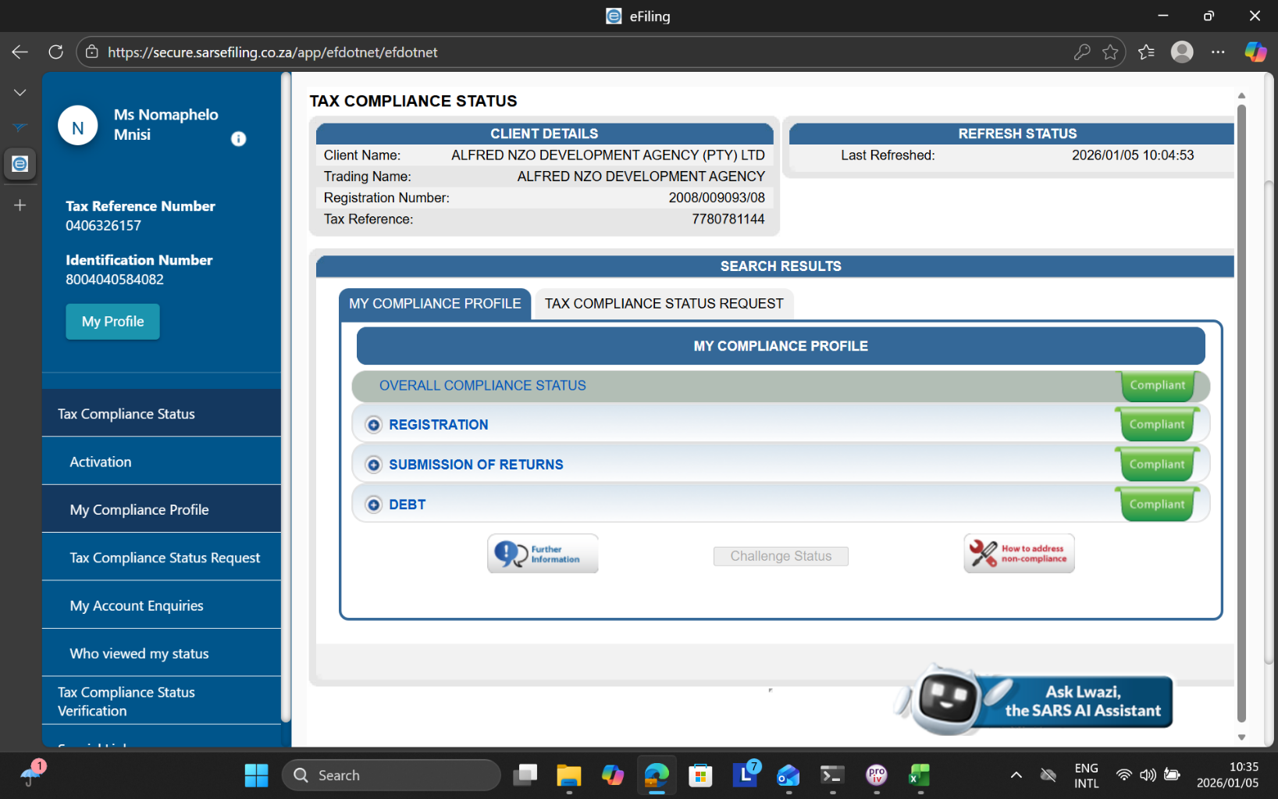
3. Tax Audit Communication:
No tax audits have been communicated to the entity to date.

CHAPTER 9: ASSURANCE ESTABLISHMENTS

1. Internal Audit
The Entity does not have an Internal Audit Unit; however, the Alfred Nzo District Municipality’s Internal Audit Unit is assisting with internal audit services. The District’s Internal Audit has prepared and implemented the Risk Based Internal Audit Coverage Plan 2025/2026. The internal audit plan has been prepared to direct internal audit unit’s efforts, based on available and envisaged resources, in terms of a risk-based methodology.
The preparation of an operational plan is required in terms of the provisions of the MFMA, and is also regarded as current internal audit “Best Practice”. The update of the risk profile of the Entity would be conducted where management participates. The risk assessment constitutes an integral phase in the preparation of the audit plan, as the results thereof form its basis. The following is a diagrammatical overview of the process by which the internal audit plans were formulated:
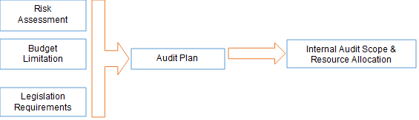

Risk Management
In fulfilling the requirement of section 62 (1) (c) of the MFMA which instructs the Accounting Officer to ensure that the Entity maintains effective, efficient and transparent system of financial and risk management and internal control, the Board has established the Risk Management Committee through shared services with Alfred Nzo District Municipality to assist the Accounting Officer to fulfil her management and control responsibilities in accordance with prescribed legislation and corporate governance responsibilities.
The Committee sat in Quarter one to monitor the institution’s risk profile as part of executing its functions as outlined in the charter which amongst other things include the following:
- Reviewed the risk management policy and strategy and recommended for approval by the Board.
- Reviewed the risk appetite and tolerance and recommended for approval by the Accounting Officer.
- Reviewed the Entity’s risk identification and assessment methodologies to obtain reasonable assurance of the completeness and accuracy of the risk register.
- Evaluated the effectiveness of mitigating strategies to address the material risks of the institution.
- Reported to the Accounting Officer any material changes to the risk profile of the institution.
- Evaluated the effectiveness of the implementation of the fraud prevention policy.
- Review any material findings and recommendations by assurance providers on the system of risk management and monitor that appropriate action is instituted to address the identified weaknesses.
- Oversee the performance of the risk management function.
- Provided proper and timely reports to the Accounting Officer on the state of risk management, together with aspects requiring improvement accompanied by the Committees recommendations to address such issues.
2.1. Organisational synopsis of quarterly risk management dashboard
The risk management committee did not sit.

