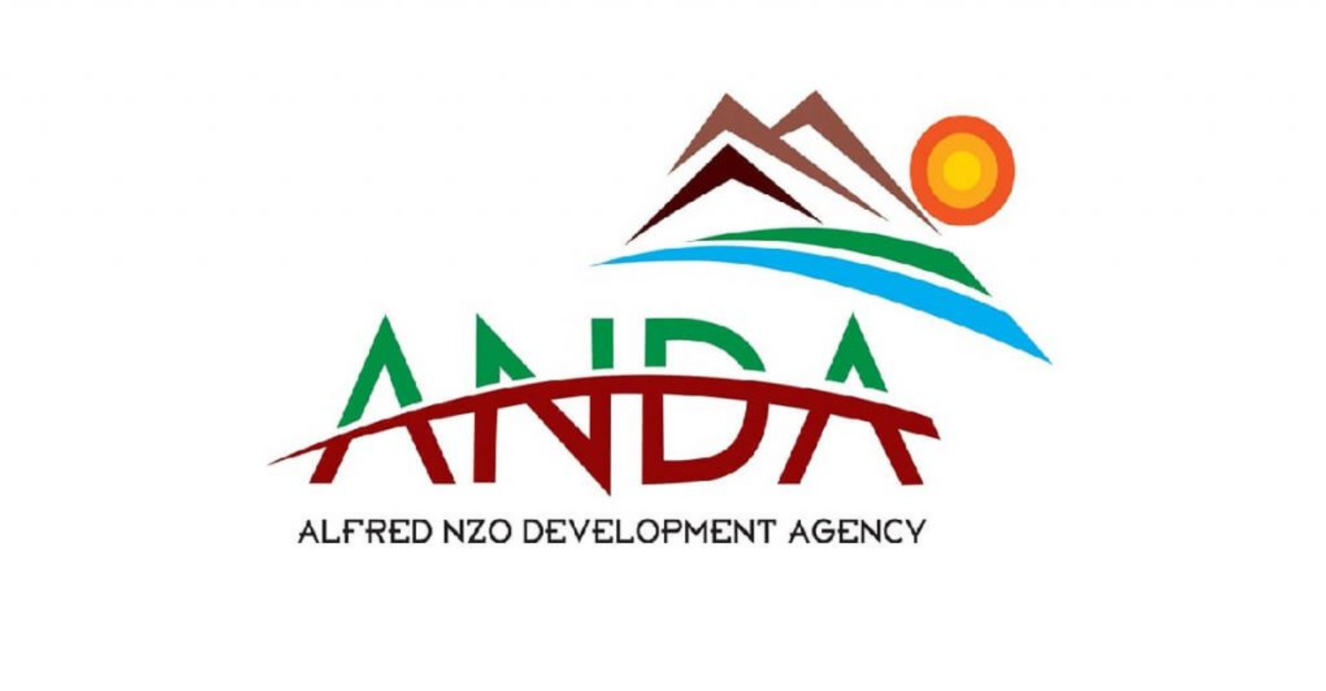

ALFRED NZO DEVEOPLEMNT AGENCY ADJUSTMENTS BUDGET 2025/2026

Notice Is hereby given in terms section 75(1)-(2) of the Local Municipal Finance Management Act No.56 of 2003, that the adjustment budget must be placed on website not later than five days after its tabling in the council
The table below indicates the adjustment budget that was tabled to Alfred Nzo Development Agency Board on 12 February 2026 for consideration and approval and further tabled to the Council for approval on 27 February 2026

