**IN-YEAR PERFORMANCE AND FINANCIAL REPORT (QUARTER )4**

**Author : Lumko Mtimde**

**Designation : Chief Executive Officer**

**Date : 15 July 2025**

**Attachment : In-year financial and non-financial report**

□ For noting 1st Level : Senior Management

□ For information 2nd Level : Audit Committee

□ For consideration 3rd Level : Board

□ For recommendation 4th Level : Mayoral Committee

□ For approval 5th Level : Council

1. **PURPOSE**

The purpose of this document is to present the state of the Entity’s performance, budget versus actual income collected and actual expenditure incurred as of 30 June 2025.

1. **LEGISLATIVE PROVISIONS**

Municipal Finance Management Act No. 56 of 2003

Municipal Planning & Performance Management Regulations

1. **BACKGROUND**

The report is prepared in compliance with Section 52 (d) of the Municipal Finance Management Act No. 56 of 2003, which provides that:

The mayor of a municipality must, within 30 days of the end of each quarter, submit a report to the Council on the implementation of the budget and the financial state of affairs of the municipality.

In preparation of the Quarterly Performance Assessment Report, the Chief Executive Officer must consider the Section 87 Reports and ensure that reported performance is in line with the Service Delivery and Budget Implementation Plan as approved by the Board in line with Section 53 of the MFMA.

The Report encapsulates the performance of respective departments for the Period: 1st April 2025 to 30 June 2025. In instances where quarterly targets have not been met, reasons for variance are stated and corrective measures are captured. Documentation of areas with positive variances is also a requirement in reporting performance.

**OVERALL INSTITUTIONAL PERFORMANCE**

The organization is responsible for a total of 43 KPIs for quarter four (4), of which all were assessed with 36 achieved and 7 not achieved. All the assessed KPIs contribute to the overall performance level of the combined Multi-year Business Plan and SDBIP Scorecards as reflected in this report. Institutional statistics were as follows:

**COLOUR CODING**

|  |  |
| --- | --- |
|  | **Targets Not Achieved** |
|  | **Targets Achieved** |

|  |  |  |  |  |  |
| --- | --- | --- | --- | --- | --- |
| **ACHIEVED TARGETS VS NOT ACHIEVED BY DEPARTMENT** | | | | | |
| **Department** | **Total No. of targets** | **Achieved** | **Not Achieved** | **Achieved%** | **% Not Achieved** |
|  |
| Programmes | 17 | 14 | 3 | 82% | 18% |  |
| Trade & Investment Promotion | 4 | 2 | 2 | 50% | 50% |  |
| Finance and Administration | 16 | 15 | 1 | 94% | 6% |  |
| Office of the Chief Executive Officer | 6 | 5 | 1 | 83% | 17% |  |
| **TOTAL** | **43** | **36** | **7** | **84%** | **16%** |  |

|  |  |  |  |  |  |  |  |
| --- | --- | --- | --- | --- | --- | --- | --- |
| **Department** | **2023/2024 Quarter Four (4) Performance** | | | **2024/2025 Quarter Four (4) Performance** | | | **Improved, Maintained or Declined** |
| Total No. of Targets | % Achieved | % Not Achieved | Total No. of targets | % Achieved | % Not Achieved | **Outcome** |
| Chief Executive Officer | **6** | 100% | 0% | **6** | 83% | 17% |  |
| Programmes | **14** | 93% | 7% | **17** | 82% | 18% |  |
| Trade and Investment | **6** | 100% | 0% | **4** | 50% | 50% |  |
| Finance and Administration | **16** | 88% | 12% | **16** | 94% | 6% |  |
| **Overall Percentage** | **42** | **93%** | **7%** | **43** | **84%** | **16%** |  |

Detailed **Quarter Four (4)** Institutional Performance for the period 2024/25 is presented in **APPENDIX “A”**

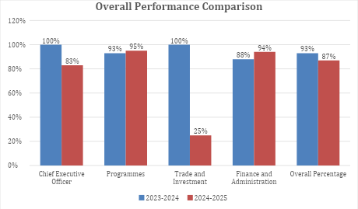

1. **INSTITUTIONAL FINANCIAL PERFORMANCE AND POSITION**

For the period under review, the Entity accrued total revenue of R31.7 million against a projected R40.0 million, resulting in a negative variance of R8.2 million. The shortfall is primarily attributed to under-collection from SETA funding, which amounted to R11.6 million against a projection of R15.9 million. This variance is largely due to delays in disbursements by the respective SETAs.

Investment revenue amounted to R601 thousand (against R621 thousand projected), while tender fees slightly exceeded expectations. At first glance, operational revenue appears to have significantly underperformed, with only R750,000 recorded against the R2.5 million projected for the period. However, this is not a true reflection of performance, as an amount of R1.5 million was already available at the beginning of the financial period.

When this amount is taken into account, the actual revenue aligns more closely with the projection, indicating that **operational revenue is on track** and there is **no material underperformance**.

Transfers and subsidies amounted to R31.6 million, comprising R20 million from the parent municipality and R11.6 million from various SETAs.

On the expenditure side, the entity spent R28.3 million of the projected R39.5 million, resulting in a positive variance of R11.1 million. The variance is largely driven by the delayed implementation of SETA programmes, which only commenced in the fourth quarter.

Key expenditure highlights:

Employee-related costs amounted to R8.6 million (R1.1 million under budget), driven by vacancies in critical posts and pending salary adjustments for senior management.

Board allowances totalled R463 thousand, yielding savings of R96 thousand.

Contracted services incurred R2.8 million, below the R4.9 million budgeted.

Operational costs, including youth development programmes, totalled R12.6 million against a projected R15.9 million. Underspending was due to programme delays, learner dropouts, and external moderation lags.

Capital expenditure amounted to R175 thousand for asset procurement.

From a financial position perspective, the entity remains solvent, with current assets exceeding current liabilities. The entity ended the month with a positive cash balance of R10.2 million.

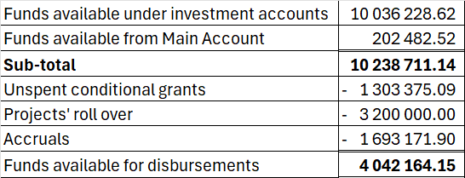

**FINANCIAL IMPLICATIONS**

None

**HR IMPLICATIONS**

None

**LEGAL IMPLICATIONS**

The report is prepared in compliance with Section 52d read with section 88 of the MFMA. Non-submission of the report to Council may lead to an audit query: Non-compliance with applicable legislation.

**COMMUNICATION IMPLICATION**

The report has to be uploaded on the Entity’s website.

**SERVICE DELIVERY IMPLICATIONS**

The Quarter Four (4) Budget and Performance Assessment Report is a yardstick to measure achievement of indicators and targets as pre-determined in the SDBIP. It gives a reflection of whether or not the Entity is likely to achieve its annual targets and which may trigger revisions to the SDBIP and business re-engineering to achieve targets as set in the SDBIP.

**RECOMMENDATIONS**

1. That the **Quarter Four (4)** Budget and Performance Assessment Report for 2024-2025 FY be **NOTED** and **APPROVED** considered by the Mayoral Committee.

2. That the **Quarter Four (4)** Budget and Performance Assessment report for 2024-2025 FY as presented to the Mayoral Committee will be further sent to Council for **NOTING** and **ADOPTION**.

3. Thereafter presentation of the report to Council, Council defers the **Quarter Four (4)** Budget and Performance Assessment Report for 2024-2025 FY report to the Municipal Public Accounts Committee (MPAC) for further scrutiny in line with its oversight responsibility.

**SUBMITTED BY:**

|  |
| --- |
| Report Generator : L. Mtimde  Contact No. : 039 492 0011  Email address : mtimdel@andm.gov.za  Designation : Chief Executive Officer  Date : 15 July 2025 |



**ANDA IN-YEAR PERFORMANCE REPORT-**

**QUARTER FOUR (4) 2024/2025**

**Table of Contents**

PART 01: CHAIRPERSON REPORT 10

1.1 Link between the budget and service delivery agreement 10

1.2 Skills Development, Revenue enhancement strategies and partnerships 11

1.3 Overview of the Financial Performance 11

1.4 Financial risks faced by the agency 12

1.5 Interventions to mitigate the challenges 13

**1.6** Legal framework 13

1.7 Executive summary 14

PART 2: OVERALL PERFORMANCE 14

2.1 Achieved Targets vs. Not Achieved 15

2.2. SUMMARY OF PERFORMANCE ACHIEVEMENTS PER DIRECTORATE 16

PART 3 – QUARTERLY BUDGET STATEMENT 23

Introduction 23

Financial performance 25

Operating Revenue 25

Operating Expenditure 25

Capital Expenditure 28

Financial Position 28

Cash Flows 28

Table F1: Monthly Budget Statement Summary 29

Table F2: Monthly Financial Performance (Revenue and Expenditure) 30

Table F3: Capital Expenditure 30

Table F4: Statement of Financial Position 31

Table F5: Cash flows 32

PART 2 – SUPPORTING DOCUMENTATION 32

Table SF1: Material variance explanations 32

Table SF2: Financial and non-financial indicators 33

Table SF3: Aged Debtors 33

Table SF4: Aged Creditors 33

Table SF5: Investment Portfolio Analysis 34

Table SF6: Board member allowances and staff benefits 34

Grants receipts and expenditure 35

PART 4: IMPLEMENTATION OF SCM POLICY 36

PART 5: UNAUTHORISED, IRREGULAR, FRUITLESS AND WASTEFUL EXPENDITURE 51

PART 6: TAX COMPLIANCE REPORT 51

PART 7: STATUS ON IMPLEMENTATION OF RISK MITIGATING PLANS 53

**Chief Executive Officer’s Quality Certification** 54

# PART 01: CHAIRPERSON REPORT

## Link between the budget and service delivery agreement

The extract below is from the Development Agency’s Multi – Year Business Plan 2024/2025 (MYBP) and shows the link between the MYBP 2024/2025 and the Service Delivery Agreement (SDA) between ANDM and ANDA.

In conforming to the mandate of the organization as defined in the shareholder agreement between the ANDM and ANDA, the Board is committed to working with management and the municipality to promote economic development initiatives that aim to better the district and to better the lives of its inhabitants. As defined in the SDA the Board has further translated the ANDA mandate into the MYBP 2024/2025 whilst also keeping in mind goals of the shareholder expressed in the IDP.

The Service Delivery and Budget Implementation Plan 2024/2025 (SDBIP) is developed from the Multi – Year Business Plan and is essentially management and implementation tool which sets in-year information, such as quarterly service delivery and monthly budget targets, and links each service delivery output to the budget of the Agency, thus providing credible management information and a detailed plan for how the Agency will provide such services and the inputs and financial resources to be used.

The Annual Budget in line with the SDBIP 2024/2025 sets the yearly service delivery and budget targets (revenue and expenditure), it is imperative that in-year mechanisms are able to measure performance and progress on a continuous basis. Hence, the end-of-year targets must be based on quarterly and monthly targets, and the CEO must ensure that the budget is built around quarterly and monthly information. Being a start- of-year planning and target tool, the SDBIP 2024/2025 gives meaning to both in-year reporting in terms of section 87 (monthly reporting), section 52d (in-year report) and end-of-year annual reports. The in-year reporting is an illustration of the implementation of the budget.

## Skills Development, Revenue enhancement strategies and partnerships

The Entity has made significant progress in revenue enhancement and skills development. By securing R23 million from Construction SETA and partnering with the Department of Public Works and Infrastructure, the entity aims to revitalize the Emfundisweni Skills Development Centre. Additionally, the R17.5 million secured from various SETAs will support youth training programs, enhancing their employability and entrepreneurial skills.

The partnership with Sunfarming and the establishment of the Agri-voltec project at Umzimvubu marks a strategic move for the district. This initiative combines solar energy generation with agricultural activities, supporting both energy independence and sustainable farming practices.

The Entity has partnered with the Eastern Cape Development Corporation and the local municipalities in the hosting of trade fairs which gives market opportunity for the SMMEs. The trade fair was successfully hosted at Matatiele Municipality due the period under review.

## Overview of the Financial Performance

The financial viability of the institution has been identified as organizational and strategic risk. It is worth highlighting that although efforts are underway to forge relations with strategic stakeholders that should ideally yield revenue enhancement through new investment and through ANDA’s existing property profile.

Financial sustainability and clean governance remain one of the critical areas in steering the Entity towards achieving its objectives. A revenue shortfall was experienced during the period under review because of SETA grant transfers that were not realized as planned due to continuous learner dropouts and delays in receipt of tranche payments.

At quarter four (4), the Entity had not spent R11,1-million of its projected annual budget. The underspending is a result of the LGSETA trench payment delays; Services SETA learner dropouts and challenges experienced in constituting a quorum for the bid adjudication committee meetings. Despite the shortfalls, the Board is committed to ensuring that it works with Management to continue to explore strategies to increase value creation for the benefit of the Alfred Nzo District community.

The board notes that there are strategic programmes that the entity needs to gain attraction in the short to midterm, to turn around the state of the Entity. This would require mobilization of financial resources and securing land parcels with specific focus in unlocking investment attraction opportunities.

## Financial risks faced by the agency

The Alfred Nzo Development Agency operates under financial constraints that limit its capacity to fully implement its mandate, with the budget mainly covering operational expenses and leaving little for capital expenditure. It is recognized that there are strides internally to mobilize more funds in the form of grants and related funding models. Critical financial challenges facing the Development Agency include the following:

* Non availability of land parcels that are ready for development
* There are challenges in leveraging the LED opportunities due to limited financial resources to attract investors which leads to a limited ability to implement and sustain the entity's programmes and projects effectively.
* The packaging and sourcing of funding to implement high impact projects.
* Inability to attract investors.
* The incompleteness of TFC processes has adversely affected our planning.

These challenges expose the Agency to the following Strategic Risks:

* Non – Achievement of strategic objectives like financial viability of the Agency.
* Non–Achievement of annual performance targets translates to non–achievement of strategic objectives.
* Failure to effectively implement the Development Agency’s mandate as outlined in the service delivery agreement (SDA) with the parent municipality.

## Interventions to mitigate the challenges

* SETAs including LG & FoodBev SETA have made trench payments for the projects being implemented and this demonstrates that the cash inflow of the entity is slowly beginning to improve.
* ANDA is intensifying its resource mobilization efforts, it is anticipated that this will assist in attracting prospective funders to the Development Agency. A Memorandum of Understanding has been entered into between ANDA and the Department of Labour. Funding proposals have been submitted to Construction SETA and WR SETA.
* The Entity through its attorneys is in the process of registering two properties under ANDA assets.

## Legal framework

This report is in line with the statutes governing local government.

1. Section 52d read with section 88 of Local Government: Municipal Finance Management Act 53 of 2003, provides that the mayor of a municipality must, within 30 days of the end of each quarter, submit a report to Council on the implementation of the budget and the financial state of the municipality. Additionally, it also provides a monitoring tool for Council on the non-financial indicators which is part of the Service Delivery and Budget Implementation Plan (SDBIP).

1. Local Government: Municipal Planning and Performance Regulations (2001), prescribes that a municipality must develop a performance management system and determine continuous review of performance based on the predetermined objectives. This process encompasses review of Indicators as per set targets in the SDBIP.
2. Alfred Nzo Development Agency is in compliance with the Performance Regulations and adopted its Performance Management System Policy Framework which gives an indication of the approach by the entity towards performance management.

## Executive summary

This report serves to report the **Quarter Four Performance** for the **2024/2025** financial year **ending 30 June 2025**. This report details the actual performance and variances of the Agency’s Key Performance Areas in adjusted SDBIP. In the case of under-performance, this report demonstrates mitigations and solutions that will address the challenges that led to under-performance.

The overall institutional performance score for the **fourth quarter of the 2024/2025 financial year**, ending **30 June 2025**, is **87%**. This represents a **slight decrease** compared to the **93%** achieved in the corresponding quarter of the **2023/2024 financial year**. The variance is noted and will be analysed further to inform improvement strategies for the upcoming financial year.

# PART 2: OVERALL PERFORMANCE

Section 52 (d) of the Municipal Finance Management Act (MFMA), Act 56 of 2003 states that the mayor of the municipality must, within 30 days of the end of each quarter, submit a report to the council on the implementation of the budget and the financial state of affairs of the municipality. Once approved, the report should be placed on the municipal website as stated in section 75 (1) (k) of the MFMA. ANDA is funded by ANDM which is a sole shareholder and a parent Municipality to the Entity. This report aims to facilitate reporting and accountability in relation to municipal funding transferred to the Development Agency for service delivery implementation.

This section provides an outline in terms of the Entity’s Quarter four performance for 2024/2025 in line with the SDBIP 2024/2025 targets and in relation to the various directorates of the Entity:

1. Office Of the Chief Executive Officer (OCEO)
2. Programmes Department (PD)
3. Trade and Investment Promotion
4. Finance and Admin

## Achieved Targets vs. Not Achieved

|  |  |  |  |  |  |
| --- | --- | --- | --- | --- | --- |
| **ACHIEVED TARGETS VS NOT ACHIEVED BY DEPARTMENT** | | | | | |
| **Department** | **Total No. of targets** | **Achieved** | **Not Achieved** | **Achieved%** | **% Not Achieved** |
|  |
| Programmes | 17 | 14 | 3 | 82% | 18% |  |
| Trade & Investment Promotion | 4 | 2 | 2 | 50% | 50% |  |
| Finance and Administration | 16 | 15 | 1 | 94% | 6% |  |
| Office of the Chief Executive Officer | 6 | 5 | 1 | 83% | 17% |  |
| **TOTAL** | **43** | **36** | **7** | **84%** | **18%** |  |

**Performance Comparison**

|  |  |  |  |  |  |  |  |
| --- | --- | --- | --- | --- | --- | --- | --- |
| **Department** | **2023/2024 Quarter Four (4) Performance** | | | **2024/2025 Quarter Four (4) Performance** | | | **Improved, Maintained or Declined** |
| Total No. of Targets | % Achieved | % Not Achieved | Total No. of targets | % Achieved | % Not Achieved | **Outcome** |
| Chief Executive Officer | **6** | 100% | 0% | **6** | 83% | 17% |  |
| Programmes | **14** | 93% | 7% | **17** | 82% | 18% |  |
| Trade and Investment | **6** | 100% | 0% | **4** | 50% | 50% |  |
| Finance and Administration | **16** | 88% | 12% | **16** | 94% | 6% |  |
| **Overall Percentage** | **42** | **93%** | **7%** | **43** | **84%** | **16%** |  |

**2.1.1 Graphical representation of performance**



## 2.2. SUMMARY OF PERFORMANCE ACHIEVEMENTS PER DIRECTORATE

**2.2.1. Directorate: Programmes**

|  |  |  |  |  |  |
| --- | --- | --- | --- | --- | --- |
| **PROGRAMMES DEPARTMENT** | | | | | |
| **ACHIEVED TARGETS VS NOT ACHIEVED BY PROJECT** | | | | | |
| **Project Name** | **Total No. of targets** | **Achieved** | **Not Achieved** | **% Achieved** | **% Not Achieved** |
| Sheep Farming Programme | 1 | 1 | 0 | 100 | 0 |
| Fresh Produce Industry Development | 1 | 1 | 0 | 100 | 0 |
| Emfundisweni Skills Development Centre: Business Support | 1 | 1 | 0 | 100 | 0 |
| Enterprise Development | 1 | 1 | 0 | 100 | 0 |
| SETA Accreditation | 1 | 1 | 0 | 100 | 0 |
| FoodBev Learnership | 1 | 0 | 1 | 0 | 100 |
| LG SETA Learnership (LED) | 1 | 1 | 0 | 100 | 0 |
| LG SETA Learnership (Environmental Practice) | 1 | 1 | 0 | 100 | 0 |
| LG SETA ARPL (Plumbing) | 1 | 1 | 0 | 100 | 0 |
| LG SETA ARPL (Bricklaying) | 1 | 0 | 1 | 0 | 100 |
| LG SETA Apprenticeship (Plumbing) | 1 | 0 | 1 | 0 | 100 |
| Services SETA: Learnership Programme (Business Administration) | 1 | 1 | 0 | 100 | 0 |
| Services SETA: Learnership Programme (Sewing) | 1 | 1 | 0 | 100 | 0 |
| Services SETA: NATED Internship Program | 1 | 1 | 0 | 100 | 0 |
| Services SETA: Vocational Internship | 1 | 1 | 0 | 100 | 0 |
| Construction SETA: Internship Programmes | 1 | 1 | 0 | 100 | 0 |
| **Total** | **17** | **14** | **3** | **82%** | **18%** |

**Directorate Overview, Challenges and Successes**

* The Programmes Department is a very crucial but under-resourced department in terms of the staff complement as it has only 3 Employees.
* During the period under review, the Programmes Department had a total of 17 targets, 14 of the total targets were achieved successfully and 3 targets not achieved.
* The entity has successfully constructed 2 shearing sheds in Winnie Madikizela Mandela LM, and Umzimvubu LM and refurbished one in Matatiele LM targeted at total of 3 Wool grower associations accounting for 10 000 heads of sheep for 108 beneficiaries
* A 2-day Agricultural Show and Trade Fair took place in Umzimvubu LM on 08-09 April 2025 aimed at showcasing agricultural produce and other sectors. Fresh produce SMMEs secured markets.
* The Entity conducted an MSME Training initiative for local contractors, entrepreneurs and SMMEs with the intention to provide capacity building on SCM compliance requirements, financial management etc. A total of 40 SMMEs attended and further received certificates.
* 305 learners are enrolled in various skills programmes that are undertaken by the Entity across the District. Over 200 learners receive monthly stipends ranging from R3000 -R4000. Through the experience gained, learners are exposed to business opportunities.
* On the internship programme, over 30 learners have confirmed to have secured full-time employment.
* The skills offerings range from plumbing, bakery and baking confectionery, clothing manufacturing, project management etc.

**The reasons for not achieving 100% in Quarter four(4) are as follows:**

|  |  |  |  |
| --- | --- | --- | --- |
| **Project Name** | **Challenges/Reason for Variance** | **Service Delivery implications** | **Corrective Action** |
| LG SETA ARPL (Bricklaying) | Progress on bricklaying could not be monitored due to the late start of the programme which was caused by failure of the recruited learners to meet the required programme standards. | The construction industry in Alfred Nzo which relies heavily on bricklayers will be negatively affected resulting in outsourcing of critical skills into the District. | Appointment has been set for 5 learners who meet the requirements to go to Durban for Trade Testing . The 5 learners will be Trade tested in September 2025. |
| Foodbev: Learnership Programme | The close up report could not be faciliated because the programme is still continuing and expected to be completed in August 2025. | Delays in the receipt of the certificates | The closure report will be achieved by 30 September 2025 |
| LGSETA Apprenticeship Programme (Plumbing) | Implementation of the programme could not be monitored as the project has not yet commenced due to ANDM concerns over releasing key employees to a training far from their work stations, since the training was planned to take place in Durban. | Delays in the receipt of the certificates. | ANDA has requested a bilateral meeting with ANDM Corporate Services to discuss the way forward regarding the programme. |

**2.2.2. Directorate: Trade and Investment**

|  |  |  |  |  |  |
| --- | --- | --- | --- | --- | --- |
| **TRADE & INVESTMENT** | | | | | |
| **ACHIEVED TARGETS VS NOT ACHIEVED BY PROJECT** | | | | | |
| **Project Name** | **Total No. of targets** | **Achieved** | **Not Achieved** | **% Achieved** | **% Not Achieved** |
| Macadamia Nuts Plantation | 1 | 0 | 1 | 0 | 100 |
| Agri-Voltaic - Sun farming | 1 | 1 | 0 | 100 | 0 |
| Alfred Nzo Industrial Park | 1 | 0 | 1 | 0 | 100 |
| Resource Mobilization | 1 | 1 | 0 | 100 | 0 |
| **Total** | **4** | **2** | **2** | **50%** | **50%** |

**Departmental Overview and Challenges**

* The department operates with only one personnel.
* During the period under review, the Trade and Investment Promotion Department had a total of 04 targets and only 1 target was achieved successfully.
* Funding proposal has been submitted to WRSETA for apprenticeship programmes

**The reasons for not achieving 100% in quarter four(4) are as follows:**

|  |  |  |  |
| --- | --- | --- | --- |
| **Project Name** | **Challenges/Reason for Variance** | **Service Delivery implications** | **Corrective Action** |
| Macadamia Nuts Plantation | The Entity issued a call to secure strategic partnerships, however could not get a responsive bidder | Delays in the development of new industries in the District  Escalating unemployment  Bulk Infrastructure shortages | Identify strategic partners and invite them to submit partnership proposals for the implementation of the project by 30 September 2025. Preliminary engagements have commenced with potential partners. |
| Alfred Nzo Industrial Pack | Signing of the MOU/SLA could not be finalised due to consultation delays on the legislative regularity of the partnership between government entities. | Escalating unemployment  Bulk Infrastructure shortages | Upon finalisation of the consultation process, MOU and SLA between ANDA and COEGA will be signed by 30 September 2025. |

**2.2.3. Directorate: Finance and Admin**

|  |  |  |  |  |  |
| --- | --- | --- | --- | --- | --- |
| **FINANCE AND ADMIN** | | | | | |
| **ACHIEVED TARGETS VS NOT ACHIEVED BY PROJECT** | | | | | |
| **Project Name** | **Total No. of targets** | **Achieved** | **Not Achieved** | **% Achieved** | **% Not Achieved** |
| Procurement Projects | 1 | 1 | 0 | 100% | 0% |
| Asset Management | 1 | 1 | 0 | 100% | 0% |
| Fleet Management | 1 | 1 | 0 | 100% | 0% |
| Budget & Reporting | 1 | 1 | 0 | 100% | 0% |
| Financial Information Systems | 1 | 1 | 0 | 100% | 0% |
| Improved Audit Opinion | 1 | 1 | 0 | 100% | 0% |
| Irregular Expenditure | 1 | 1 | 0 | 100% | 0% |
| Policy Development | 1 | 1 | 0 | 100% | 0% |
| VIP Payroll | 1 | 1 | 0 | 100% | 0% |
| Staff Establishment Review | 1 | 1 | 0 | 100% | 0% |
| Skills Development | 1 | 1 | 0 | 100% | 100% |
| ICT Management | 1 | 1 | 0 | 100% | 0% |
| Records Management | 1 | 1 | 0 | 100% | 100% |
| Individual Performance Management | 1 | 0 | 1 | 0% | 100% |
| Cleaning Goods & Services | 1 | 1 | 0 | 100% | 0% |
| Recruitment and selection | 0 | 0 | 0 | 0% | 0% |
| Occupational Health and Safety | 1 | 1 | 0 | 100% | 0% |
| **Total** | **16** | **15** | **1** | **94%** | **6%** |

**Directorate Overview, Challenges and Successes**

* The Finance and Admin Department had an overall of 16 targets at quarter four (4) for the 2024/2025 financial year
* 15 targets were achieved successfully whilst 1 target was not achieved.
* The financial management system currently in use consumes approximately 10% of the Entity’s total budget, representing a significant financial burden. Given the high cost and the entity’s constrained financial position, a formal request will be submitted to the parent municipality to consider funding the system through the Treasury grant**,** as the entity is no longer in a position to sustain this expense from its own budget.
* The Entity is currently unable to provide skills development for its employees due to financial constraints. The LGSETA mandatory grant is unable to fund the programme as the Entity only received R2-thousand the Entity has applied for alternative funding through SETAs, however no responses have been received.
* The Entity is struggling to retain employees due to concerns about job security and the lack of employee benefits. Management is applying the prudence principle in budget implementation, acknowledging the constraints and uncertainties regarding potential increases in operational funding allocations.

**2.2.4. Directorate: Office of the CEO**

|  |  |  |  |  |  |
| --- | --- | --- | --- | --- | --- |
| **OFFICE OF THE CEO** | | | | | |
| **ACHIEVED VS NOT ACHIEVED** | | | | | |
| **Project name** | **Total No. of Targets** | **Achieved** | **Not Achieved** | **% Achieved** | **% Not achieved** |
| Sitting of Board Meetings | 1 | 0 | 1 | 0% | 100% |
| Communications Project | 1 | 1 | 0 | 100% | 0% |
| Institutional Performance Management | 1 | 1 | 0 | 100% | 0% |
| Internal Audit | 1 | 1 | 0 | 100% | 0% |
| Risk Management | 1 | 1 | 0 | 100% | 0% |
| Legal Services | 1 | 1 | 0 | 100% | 0% |
| **TOTAL** | **6** | **5** | **1** | **83%** | **17%** |

**Directorate Overview, Challenges and Successes**

* The OCEO had an overall of 06 targets in Quarter four (4) for the 2024/2025 financial year.
* Out of the 06 targets, 05 targets were achieved successfully and only 01 was not achieved.
* The OCEO was not able to hold the Annual General Meeting (AGM) in Q4 due to the unavailability of the Shareholder Representative. However, it has been postponed to quarter one of the 2025-26 financial year.

# PART 3 – QUARTERLY BUDGET STATEMENT

## Introduction

This financial report aims to provide a regular update on indicators critical to the Entity’s viability and serve as an early warning indicator where remedial action is required.

The consolidated report is a high-level overview of the Entity’s financial viability and sustainability.

This report is a summary of the main budget issues arising from the monitoring process. It compares the progress of the budget to the projections contained in the Service Delivery and Budget Implementation Plan (SDBIP).

Section 87 (11) to (14) of the MFMA 56 of 2003 states that the accounting officer of the municipal entity must not later than seven working days after the end of each month submit to the accounting officer of the parent municipality **a** **statement in the prescribed format** on the state of the entity’s budget reflecting the following particulars for that month and for the financial year up to the end of that month:

1. Actual revenue, per revenue source
2. Actual borrowings
3. Actual expenditure
4. Actual capital expenditure
5. The amount of any allocations received
6. Actual expenditure on those allocations excluding expenditure on allocations exempted by the annual revenue act from compliance with this paragraph, and
7. When necessary, an explanation of:
8. Any material variances from the entity’s projected revenue by source and from the entity’s expenditure projects
9. Any material variance from the service delivery agreement and the business plan, and
10. Any remedial or corrective steps taken or to be taken to ensure that projects revenue and expenditure remains within the entity’s approved budget.

The statement must include -

1. Projections of the Entity’s revenue and expenditure for the rest of the financial year, and any revisions from initial projections;
2. The amounts reflected in the statement must in each case be compared with corresponding amounts budgeted for in the entity’s approved budget.

This report has been prepared using the accrual method of accounting. The general idea is that economic events are recognised by matching revenues to expenses (the matching principle) at the time in which the transaction occurs rather than when payment is received or made.

This method allows the current cash inflows/outflows to be combined with future expected cash inflows/outflows to give a more accurate picture of the Entity’s current financial position.

## Financial performance

### Operating Revenue

In the statement of financial performance, revenue accrued is R31,7-million out of the projected R40,0-million giving rise to a variance of R8,2-million. The variance-contributing factors are explained below.

Investment Revenue

This relates to interests received in the call account deposits. Interest received since July amounts to R601-thousand out of the expected R621-thousand.

Other Revenue

Tender fees –R59-thousand accrued compared to the estimated R45-thousand.

Operational revenue – R750 - thousand accrued compared to the annual estimated R2,5 - million. At first glance, operational revenue appears to have significantly underperformed, with only R750,000 recorded against the R2.5 million projected for the period. However, this is not a true reflection of performance, as an amount of R1.5 million was already available at the beginning of the financial period.

Transfers and subsidies

An amount of R20 million was received from the parent municipality during the period. In addition, the entity received R11.6 million in funding from Sector Education and Training Authorities (SETAs) since July 2024, broken down as follows:

* LG SETA R949 360
* Services SETA R6 627 179
* Food and Bev R4 052 160

This is against projected SETA revenues of R15.9 million, resulting in an under-collection of R4.3 million. The shortfall is primarily attributed to delays in disbursements by the respective SETAs.

### Operating Expenditure

On operating expenditure, R28.3-million was spent against the estimated budget of R39.5-million giving rise to a positive variance of more than R11.1-million. The contributing factor to such a huge variance is the Services Seta programmes that commenced in the fourth quarter.

Employee Costs

To date, R8.6 million has been spent on employee-related costs against a projected budget of R9.7 million, resulting in a favourable variance of R1.1 million. The underspending is primarily due to the continued vacancies in key positions during the financial year, including the Chief Executive Officer, Executive Manager: Trade and Investment, Asset Officer, Human Resources Practitioner, and Trade and Investment Coordinator. Additionally, the 2025 financial year salary adjustments for senior management have not been implemented, as the relevant upper limits gazette has not yet been published. While recruitment processes for the Chief Executive Officer position have been concluded, recruitment for other roles is currently underway and is expected to be finalised in the first quarter of the 2026 financial year.

Board member allowance

Amount spent since July totals to R463-thousand, when the expected expenditure to date was estimated at R559-thousand, giving rise to a favorable variance of R96-thousand.

Other Expenditure

Contracted Services - Expenditure is R2,8-million against the expected budget of R4,9-million.

Operational Costs

Included in the operational costs’ budget are learnership and internship programmes aimed at assisting the unemployed youth of the district to acquire workplace experiential training and skills. Total expenditure since July totals to R12,6-million against the projected R15,9-million. Variance contributing factors are as follows:

* The delays in receipt of tranche payments from LG SETA affected the projected budget because the Learnership in Environmental Practice had to start later than the anticipated date.
* Dropouts of learners in various programmes include the following:

|  |  |  |  |
| --- | --- | --- | --- |
| **Project** | **Initial No. of learners** | **Current No. of learners** | **Reasons for underspending** |
| Learnership (Generic Management) | 40 | 29 | 8 learners obtained full time employment. |
| Learnership (Project Management) | 31 | 26 | Only 2 learners obtained full time employment, the rest just absconded |
| Learnership (Clothing manufacturing processes) | 15 | 14 | The 1 Learner that dropped out relocated from where the training took place |
| Vocational Internship | 100 | 84 | 10 Interns confirmed to have obtained full time employment; others relocated due to other opportunities |
| Internship – NATED | 70 | 58 | 04 Interns confirmed to have obtained full time employment; others relocated due to other opportunities, and 2 learners passed on. |
| Business Administration Service | 70 | 46 | 7 learners confirmed to have obtained full time employment; 11 learners went back to school in January, and 6 learners relocated for other opportunities |
| Food and Bev | 80 | 68 | 12 learners have relocated for other opportunities |
| Construction CETA | 16 | 15 | Reimbursement model used by the CETA and 1 learner dropout due to health reasons. |

## Capital Expenditure

The Entity incurred expenditure amounting to R175-thousands on the procurement of assets during the reporting period.

## Financial Position

The municipality’s current assets exceed the current liabilities. The municipality’s ability to pay its short-term liabilities is tested by taking the total current assets and dividing them by current liabilities. This test is mainly used to give an idea of the entity’s ability to pay back its short-term liabilities using the current assets.

## Cash Flows

The municipal entity ended the month with a positive cash and cash equivalents balance of R10,2-million. The total balance will be broken down as per the table below:



## Table F1: Monthly Budget Statement Summary

The table below reflects on the summary of the total municipality’s budget against year-to-date collections and expenditures.

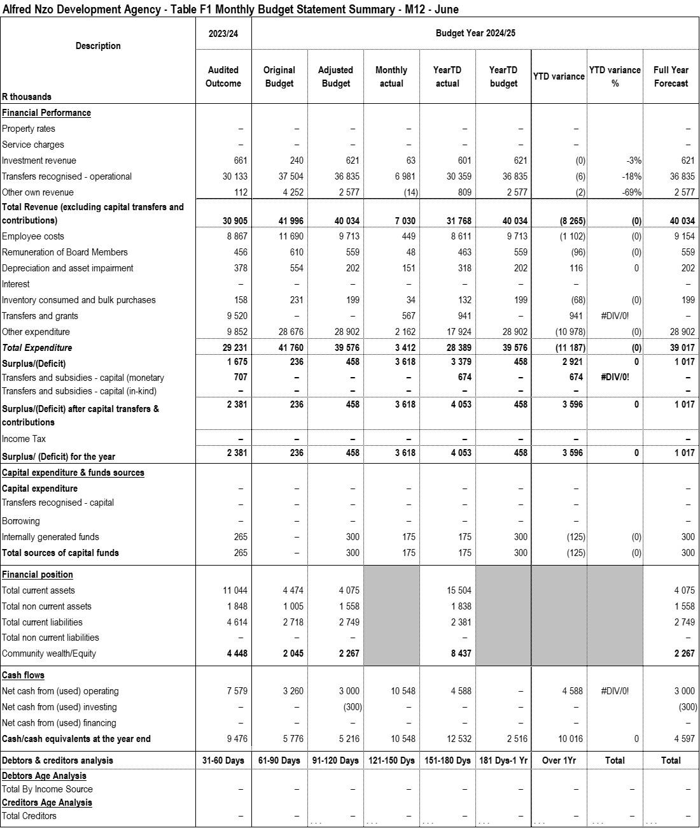

## Table F2: Monthly Financial Performance (Revenue and Expenditure)

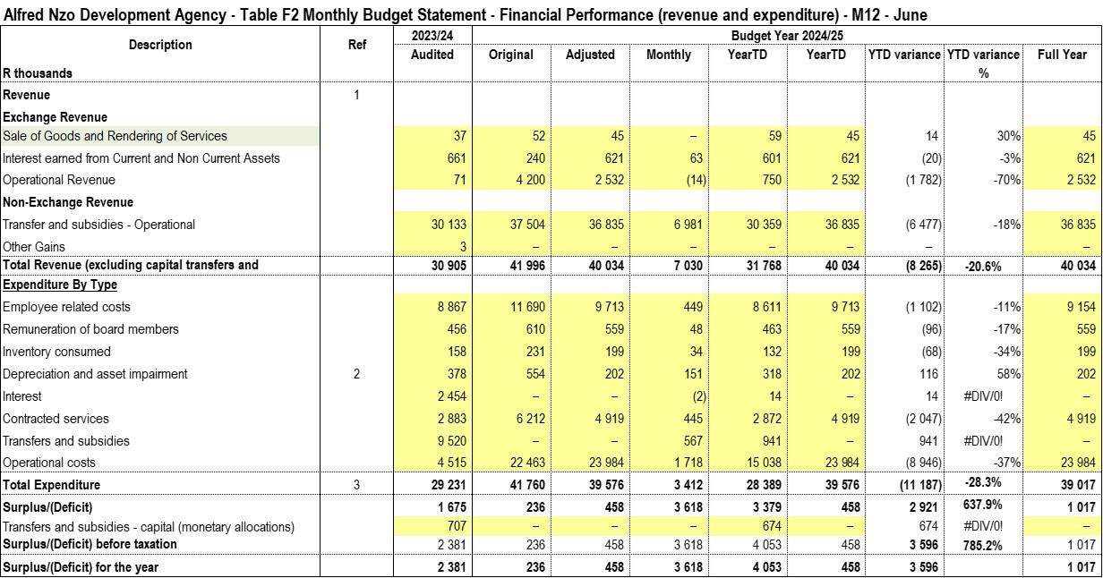

## Table F3: Capital Expenditure

The table below reflects on capital expenditure since July 2024.

## Table F4: Statement of Financial Position

## Table F5: Cash flows

The table below reflects the cash flows of the institution.

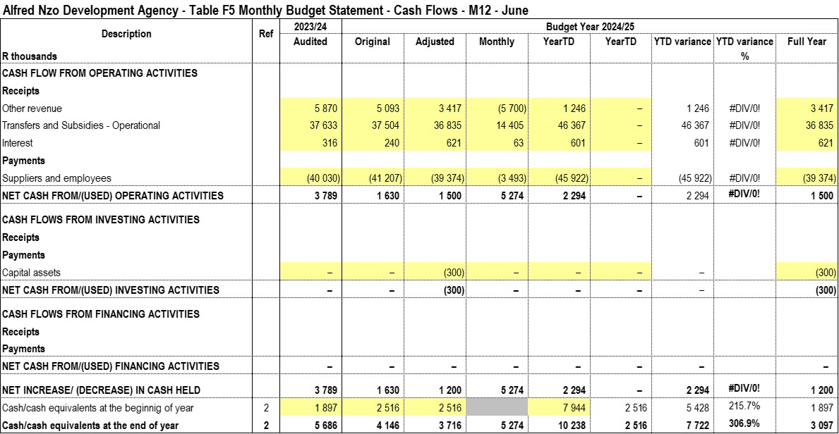

# PART 2 – SUPPORTING DOCUMENTATION

## Table SF1: Material variance explanations

|  |  |  |  |  |
| --- | --- | --- | --- | --- |
| **Description** | **Ref** | **Variance** | **Reasons for material deviations** | **Remedial or corrective steps / remarks** |
|  |
| **R thousands** |  |  |  |  |  |
| **Revenue items** |  |  |  |  |  |
| Sale of rendering goods/services |  | 14 | N/A | N/A |  |
| Intererst earned on investments |  | (20) | N/A | N/A |  |
| Operational Revenue |  | (1 782) | The entity's savings from last year were included as other income | N/A |  |
| Grants and subsidies |  | (6 477) | There were delays in the commencement of SETAs. The programmes are still in progress. |  |  |
| **Expenditure items** |  |  |  |  |  |
| Employee related costs |  | (1 102) | Unfilled posts | Fasttrack the recruitment process |  |
| Remuneration of Board members |  | (96) | Board vacancies | Recruitment of additional Board members is underway. |  |
| Consumables |  | (68) |  |  |  |
| Depreciation |  | 116 |  |  |  |
| Interest paid |  | – |  |  |  |
| Contracted Services |  | (2 047) | Delays in the bid committee sittings | Continuous requests to the Local Municipalities to release senior managers for BAC sittings, and put pressure on SETAs |  |
| Transfers and subsidies |  | 941 | The entity does not give out transfers | Correct through a journal |  |
| Operational Costs |  | (8 946) | Delays in the bid committee sittings | Continuous requests to the Local Municipalities to release senior managers for BAC sittings, and put pressure on SETAs |  |
|  |  |  |  |  |  |
| **Total variance** |  |  |  |  |  |

## Table SF2: Financial and non-financial indicators

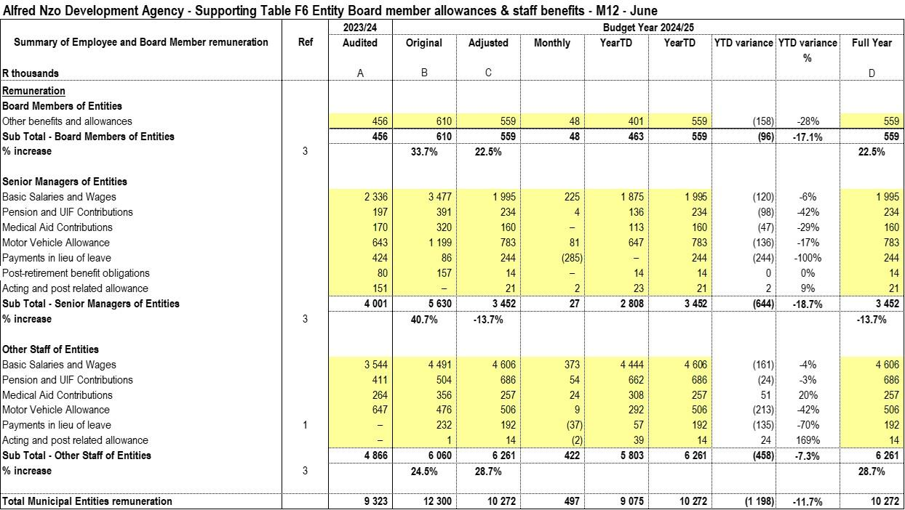

## Table SF3: Aged Debtors

No debtors

## Table SF4: Aged Creditors

As at the reporting date, the Entity has outstanding trade creditor obligations amounting to R939,171.95.

|  |  |  |  |  |  |  |  |
| --- | --- | --- | --- | --- | --- | --- | --- |
| **Creditor Name** | **Ageing :** | **0days** | **30days** | **60days** | **90days** | **120days** | **Total** |
| Allenio Travel | Current | 4 785.00 |  |  |  |  | 4 785.00 |
| E G Fire Services | Current | 1 386.90 |  |  |  |  | 1 386.90 |
| MBEWU CONSULTANTS AND MAINTENANCE | Current | 390 000.00 |  |  |  |  | 390 000.00 |
| Reflections Development Institute | Current | 113 000.00 |  |  |  |  | 113 000.00 |
| SIBUWELE | Current | 4 000.00 |  |  |  |  | 4 000.00 |
| SILALELE SKILLS ACADEMY | Current | 426 000.00 |  |  |  |  | 426 000.00 |
| Southern Sun Hemmingways | Current |  |  |  |  | 0.01 | 0.01 |
| Travelstart Online Travel operations | Current |  |  |  |  | 0.04 | 0.04 |
|  | **Ageing :** | **0days** | **30days** | **60days** | **90days** | **120days** | **Total** |
| **Company Total** | **Current** | **939 171.90** |  |  |  |  | **939 171.95** |

## Table SF5: Investment Portfolio Analysis

All call deposit balances are classified as highly liquid short-term investments, maintained with the primary objective of meeting the entity’s short-term commitments, rather than for the purpose of earning interest income.

As detailed in the table below, the total call deposit balance amounts to **R10 million**, of which **R1.3 million** pertains to **unspent conditional grants**. The remaining **R8.7 million** represents the entity’s own funds invested for liquidity management purposes.

|  |  |  |  |  |  |  |
| --- | --- | --- | --- | --- | --- | --- |
| **Description** | **Account No** | **Opening bal** | **Transfers in** | **Transfers out** | **Interest Income** | **Closing bal** |
| **01-Jul-24** | **30-Jun-25** |
| Livestock Call Account | 62238128351 | 1 056 377.11 | - | - | 83 717.22 | 1 140 094.33 |
| SMME Call Account | 62238128517 | 56 445.43 | - | - | 4 473.26 | 60 918.69 |
| ANDA Reserve Fund | 62238130231 | 5 868 694.79 | 20 250 000.00 | (17 726 535.36) | 442 771.95 | 8 834 931.38 |
| Capacity Building | 62723833621 | 45 977.64 | - | (47 232.05) | 1 538.63 | 284.22 |
| Commercial NFS Account | 62822669620 | 306 864.05 | - | (315 236.21) | 8 372.16 | 0.00 |
|  |  | **7 334 359.02** | **20 250 000.00** | **(18 089 003.62)** | **540 873.22** | **10 036 228.62** |

## Table SF6: Board member allowances and staff benefits



## 

## Grants receipts and expenditure

The table below reflects the Entity’s grants as of 30 June 2025.

|  |  |  |  |  |  |
| --- | --- | --- | --- | --- | --- |
| **No.** | **Description** | **Opening balance** | **Bank receipts** | **Qualifying revenue/ expenditure** | **Unspent portion** |
| 1 | BANKSETA | 891 600.00 | - | 891 600.00 | - |
| 2 | LG SETA | - 1 290.00 | 949 360.00 | 632 689.36 | 315 380.64 |
| 3 | SERVICES SETA | 391 880.68 | 6 627 178.77 | 6 839 180.00 | 179 879.45 |
| 4 | NSF | 824 138.85 | - | 824 138.85 | - |
| 5 | Food and Bev | - | 4 052 160.00 | 3 244 045.00 | 808 115.00 |
| 6 | Construction CETA | - |  | 222 600.00 | - 222 600.00 |
|  |  | **2 106 329.53** | **11 628 698.77** | **12 654 253.21** | **1 080 775.09** |
|  |  |  | **Construction CETA Receivable** | | **222 600.00** |
|  |  |  | **Unspent grants** |  | **1 303 375.09** |

* **LGSETA –** The project has been completed however the Entity is waiting for the project closure confirmation letter from LGSETA in order to realise the project management fees due to ANDA.
* **SERVICES SETA –** The outstanding balance portion is for the projects that are still currently in progress as elaborated above.
* **FOOD AND BEV SETA –** The project is in-progress.
* **CONSTRUCTION CETA –** The project is in progress. Construction SETA utilizes the reimbursement model unlike other SETAs. Therefore ANDA needed to make payments before claiming from the SETA. ANDA has submitted all outstanding tranches to CETA for payment. Follow up is constantly being made to the CETA.

# PART 4: IMPLEMENTATION OF SCM POLICY

In terms of Municipal Finance Management Act SCM Regulations Section 6 (3) states that the accounting officer must, within 10 days of the end of each quarter, submit a report on the implementation of the supply chain management policy to the board of directors of the municipal Entity.

In terms of Section (111) of the MFMA, the Municipal Entity must have and implement a supply chain management policy that:

1. gives effect to:
2. section 217 of the Constitution; and
3. Part 1 of chapter 11 and other applicable provisions of the Act;
4. Is fair, equitable, transparent, competitive, and cost effective
5. Complies with;
6. The regulatory framework prescribed in Chapter 2 of these Regulations and
7. Any minimum norms and standards that may be prescribed in terms of section 168 of the Act
8. Is consistent with other applicable legislation;
9. Does not undermine the objective for uniformity in supply chain management system between organs of state in all spheres; and
10. It is consistent with national economic policy concerning the promotion of investments and doing business with the public sector.

ANDA SCM Policy required that the conditions for the procurement of goods or services through formal written price quotations are followed:

* At least 1 Quotation for procurement of a transaction value of between R300 to R2 000 (VAT Included)
* Formal written quotations for procurement of a transaction value over R2 000.00 up to R30 000.00 (VAT included)
* At least 3 Formal written price quotations for procurements of a transaction value over R30 000.00 up to R200 000.00 VAT included and shall be advertised for at least 7 days on the website.
* Competitive bidding process to be followed for procurements above a transaction value of R200 000 (VAT Included)

Legislative provisions

* Municipal Finance Management Act 56 of 2003
* Supply Chain Management Regulations
* Preferential Procurement Policy Framework Act and its Regulations
* 2024/2025 Supply Chain Management Policy

Deviations Report

The Deviations report is prepared according to MFMA circular 68

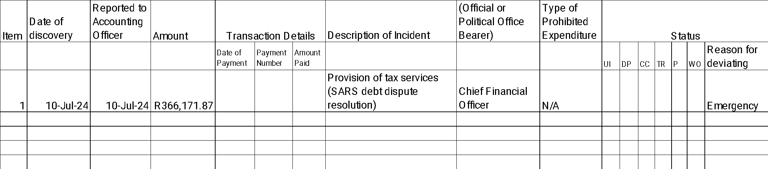

Contracts Register

The Contracts Register has been developed according to the Contract Management Guide and is attached as an annexure.

Performance of External Suppliers

| **LEGEND:**  **1 – Not meeting the standards (0-30%)**  **2 – Meet some of the standards (30-50%)**  **3 – Meet most of the standards (50-70%)**  **4 – Meet all the standards (70-100%)** | | | | | |
| --- | --- | --- | --- | --- | --- |
| **NAME OF SERVICE PROVIDER** | **SERVICE RENDERED** | **SET TARGET OF PERFORMANCE (2024/2025)** | **PERFORMANCE** | **RATING FOR CURRENT FINANCIAL YEAR** | **COMMENTS /RECOMMENDATIONS** |
| MUNSOFT | Financial System | Provision of municipal financial system for transacting | Good | 3 | The interaction with Munsoft has improved after an email was sent to management. The system still has gaps that need to be attended to. |
| Vodacom | Business Contract Phones and Internet | Phones and internet are provided as specified. | Poor | 2 | Contract is in place and monitored monthly but overall service is poor |
| Umzimvubu Leather Craft | Provision of cleaning services | Cleaning services | Good | 3 | Service provider is performing as expected. |
| MTN | Provision of Cellphone contracts for 24 months | Cellphone Contracts | Poor | 3 | Service Provider performance is fair though the MTN coverage is a problem. |
| Taleni Godi Attorneys | Provision of Legal Services | Provision of Legal Services | Good | 4 | Contract ongoing with no challenges. |
| Mvana and Associates | Provision of Legal Services | Provision of Legal Services | Good | 4 | Meets Expected Standards |
| Tonise Attorneys | Provision of Legal Services | Provision of Legal Services | Good | 3 | Meets most of the standards |
| Magqabi Seth Zitha Attorneys | Provision of Legal Services | Provision of Legal Services | Good | 4 | Meets Expected Standards |
| Silale Skills Academy | Silalele appointed to conduct learnership on Generic management L04 | Learnership on Generic Management NQF L4 | Good | 4 | Contract ongoing with no challenges. |
| Silale Skills Academy | Silalele appointed to conduct learnership on Sewing General Education Training (GET) Certificate Clothing Manufacturing Processes | Learnership on Clothing Manufacturing Processes NQF L1 | Good | 4 | Contract ongoing with no challenges. |
| Reflections Development Institute | Reflections appointed to conduct learnership programme on General Education Training Certificate: Business Administration NQF L4 | Learnership programme on Business Administration | Good | 4 | Contract ongoing with no challenges. |
| Kunene Makopo Risk Solutions | Provision of Insurance Services | Provision of Insurance Services | Good | 3 | Contract ongoing |
| Silalele Skills Solutions | Silalele appointed to conduct learnership on Bread and Confectionary baking for 12 months | Learnership on Bread and Confectionary Baking for 12 months | Good | 4 | Contract ongoing with no challenges |
| Artisan Development Academy | ADA appointed to conduct an apprenticeship and ARPL Programme on Plumbing and Bricklaying for 36 months | Apprenticeship and ARPL Programme on Plumbing and Bricklaying | Good | 4 | Contract ongoing with no challenges |
| Extreme Auto Wash & Chillaz | Construction of a Sheep Shearing Shed at WMMLM | Construction of a Sheep Shearing Shed at WMMLM | Good | 4 | Contract Completed |
| Ooketshe Trading and Transport | Construction of a Sheep Shearing Shed at ULM | Construction of a Sheep Shearing Shed at ULM | Good | 4 | Contract Completed |
| Xolweni Trading & Projects | Fencing and Refurbishment of Ephifane Shearing Shed | Fencing and Refurbishment of Ephifane Shearing Shed | Good | 4 | Contract on-going with no challenges |
| Iqhayiya Design Workshop Architects | Service Provider for Development of Business Plans, Conceptual Designs and Costing of Fresh Produce Packhouses At Winnie Madikizela Mandela And Matatiele Local Municipalities | Service Provider for Development of Business Plans, Conceptual Designs and Costing of Fresh Produce Packhouses At Winnie Madikizela Mandela And Matatiele Local Municipalities | Good | 4 | Project has been finalised |
| ZANLA | Social Facilitator for Emfundisweni | Social Facilitator for Emfundisweni | Goode | 4 | Contract on-going with no challenges |

Orders issued less than R30 000.00

Orders issued in quarter 4 of 2024/2025 amounted to R239 780.21 including VAT for VAT vendors and are as follows:

**Table A: Orders issued in Q4 of 2024/2025**

|  |  |  |  |  |  |  |
| --- | --- | --- | --- | --- | --- | --- |
| **NO.** | **Creditor Name** | **Order No.** | **Order Date** | **Value** | **Specifications** | **Creditor Address** |
| 1 | SIBUWELE | 28782 | 2025/06/26 | R4 000.00 | Catering lunch for Wellness Programme for 20 people Steamed Bread; Pork; Beef; Beef Sausage; Chicken; 3x salads 20x Soft drinks | BETSHWANA A/A; MOUNT AYLIFF;47 BETSHWANA A/A; MOUNT AYLIFF; 4 4735 |
| 2 | Garden Court East London | 28781 | 2025/06/24 | R4 890.00 | Accommodation and meals for Ms M. Mhlelembana attending WSP at EL Check in on 25/06/2025 and out on 28/06/2025 | CNR JOHN BAILLIE ROAD AND MOOR EAST LONDON 5210 |
| 3 | Garden Court East London | 28780 | 2025/06/24 | R4 890.00 | Accommodation and meals for Ms F. Nketshisa attending WSP at EL Check in 25/06/2025 and out on 28/06/2025 | CNR JOHN BAILLIE ROAD AND MOOR EAST LONDON 5210 |
| 4 | Allenio Travel | 28779 | 2025/06/20 | R4 785.00 | Car hire for Ms Boti attending the Munsoft year-end w/shop on the 23-24 June 2025. pick up at OR Tambo on 22/06/2025 and drop off on 25/06/2025 | 10 KENNINGTON ROAD NAHOON 5201 |
| 5 | Travelstart Online Travel oper | 28778 | 2025/06/19 | R5 201.00 | Flight tickets for Ms Boti and Mr Stulo attending Munsoft year-end workshop. DUR - JHB on 22/06/2025 | P.O.BOX 32285 CAMPS BAY Cape Town 8040 |
| 6 | Garden Court Sandton City | 28777 | 2025/06/19 | R4 890.00 | Accommodation and meals for Mr Stulo at JHB attending Munsoft year-end workshop on the 23-24 June 2025 | CORNER WEST STREET AND MAUDE A SANDTON 2146 |
| 7 | Garden Court Sandton City | 28776 | 2025/06/19 | R4 890.00 | Accommodation and meals for Ms Boti at JHB; attending Munoft year-end workshop on the 23-24 June 2025 | CORNER WEST STREET AND MAUDE A SANDTON 2146 |
| 8 | SWIFT TRAVEL AND TOURS | 28775 | 2025/06/18 | R2 000.00 | Accommodation for CEO (Mtimde) attending ECSECC Capacity Building on the 19th June 2025 Check in 18/06/2025 and out 19/06/2025 | 10 MILLER STREET MTHATHA Mthatha 5099 |
| 9 | E G Fire Services | 28774 | 2025/06/17 | R1 386.90 | this is to request your good office to assist us with the service prov will help our institution for servicing of six(6) fire Extinguisher | LOT 986; RETHMAN DRIVE UMTENTWINI |
| 10 | LISOMMA LODGE | 28773 | 2025/06/11 | R28 500.00 | Accommodation and meals for Mr Mtimde in Mt Ayliff; check in 10/06/202 on 10/07/2025 for relocation. Dinner; bed & breakfast. | 19 MAZIZI NKANYUZA STREETLY MO P.O.BOX 285. MOUNT AYLIFF 4735 |
| 11 | NOT THE BOOK TRADING CC | 28772 | 2025/06/04 | R24 770.91 | this is to request your good office to assist with the following stati A4 white paper ream 1x20 box; Gel pens ( box of 12) 1x1; retractable b box of 50) 1x1; highlighter ( pack of 4) 1x9; A4 Matte coated inject p | MBANGWENI A/A NTABANKULU NU; NTABANKULU NU 5130 |
| 12 | KHAYALAM DEVELOPMENT | 28771 | 2025/06/04 | R4 756.00 | This is to request your office to assist with the procurement of general electrical connectors . | NO. 20 BIGGAR STREET GLENCOE 2930 |
| 13 | ALUTHA HOLDINGS 82 | 28770 | 2025/05/27 | R9 257.50 | Replacement of 2x restroom doors and plastering at ANDA | Bizana |
| 15 | Bora Trading and Projects (PTY | 28768 | 2025/05/23 | R2 900.00 | This serves to request your good office to assist us with the procure cleaning material ; two ply of toilet paper 1x 4 pack of 50 and 1 pac cloth soft touch heavy duty 38L x 65W three in a pack. 1 pack of dis | ERF 1270 CHITHWA VILLAGE MOUNT AYLIFF 4735 |
| 16 | Garden Court Umhlanga | 28767 | 2025/05/22 | R6 520.00 | Accommodation and meals for Mr Gentse attending ANDM Policy Review w/s check in 25/05/2025 and out 29/05/2025 | Cnr Aurora & Centenary Blvd Umhlanga Ridge |
| 17 | Garden Court Umhlanga | 28766 | 2025/05/22 | R6 520.00 | Accommodation and meals for Ms Maloi attending ANDM Policy Review w/sh check in 25/05/2025 and out 29/05/2025 | Cnr Aurora & Centenary Blvd Umhlanga Ridge |
| 18 | Garden Court Umhlanga | 28765 | 2025/05/22 | R6 520.00 | Accommodation and meals for Ms Boti attending ANDM Policy Review w/sho check in 25/05/2025 and out 29/05/2025 | Cnr Aurora & Centenary Blvd Umhlanga Ridge |
| 19 | Garden Court Sandton City | 28764 | 2025/05/15 | R6 120.00 | Accommodation and meals for Ms Gixane; attending Munsoft Control Balancing w/shop. Check in 18/05/2025 and out 22/05/2025 | CORNER WEST STREET AND MAUDE A SANDTON 2146 |
| 20 | Garden Court Sandton City | 28763 | 2025/05/15 | R6 120.00 | Accommodation and meals for Ms Boti; attending Munsoft Control Balanci w/shop. Check in 18/05/2025 and out 19/05/2025 | CORNER WEST STREET AND MAUDE A SANDTON 2146 |
| 21 | Harvey World Travel East Londo | 28762 | 2025/05/15 | R5 799.40 | Car hire for Ms Boti in JHB; attending Munsoft Control Balancing w/sho Pick up 18/05/2025 and drop off 22/05/2025 Group B | 77 DEVEREUX AVENUE VINCENT; EAST LONDON East London 5247 |
| 22 | Travelstart Online Travel oper | 28761 | 2025/05/14 | R6 077.00 | flight tickets for Ms Boti and Ms Gixane attending Munsoft w/shop on control balancing. Durban - Jhb | P.O.BOX 32285 CAMPS BAY Cape Town 8040 |
| 24 | CHMD Estuary Hotel and Spa | 28759 | 2025/05/08 | R6 850.00 | Extension of venue hire for ANDA Strat Plan 09 May 2025 | ESTUARY HOTEL AND SPA R61 NATIONAL ROAD 4295 |
| 25 | CHMD Estuary Hotel and Spa | 28758 | 2025/05/06 | R8 925.00 | Venue hire for ANDA Strategic Planning Session on the 08 May 2025 Incl. lunch and tea | ESTUARY HOTEL AND SPA R61 NATIONAL ROAD 4295 |
| 26 | CHMD Estuary Hotel and Spa | 28757 | 2025/05/06 | R14 130.00 | Accommodation and meals for 9 officials attending the ANDA Strat Plan Session at Estuary on the 8th May 2025. | ESTUARY HOTEL AND SPA R61 NATIONAL ROAD 4295 |
| 27 | Southern Sun Hemmingways | 28756 | 2025/04/30 | R3 260.00 | Accommodation for Mr Tshonga at EL attending an engagement session wit the Office of the Premier regarding the CETA funding for ESDRC refurbi | CNR WESTERN BYPASS & TWO RIVER CAMBRIDGE 5200 |
| 28 | Southern Sun Hemmingways | 28755 | 2025/04/30 | R3 260.00 | Accommodation and meals for Ms Maloi at EL attending an engagement session with the Office of the Premier regarding CETA funding for ESDR refurbishment | CNR WESTERN BYPASS & TWO RIVER CAMBRIDGE 5200 |
| 29 | GIJIMA HOLDINGS | 28754 | 2025/04/23 | R14 400.00 | COGTA Competency assessments for 2 candidates for the CEO position | MIDRAND INTERNATIONAL BUSINESS MIDRAND GATE BUILDING; SOUTH W 1685 |
| 30 | UNIC MEDIA AND TRADING (PTY) L | 28753 | 2025/04/23 | R2 000.00 | Maintenance and repairs of main gate | P.O BOX 238 TABANKULU SP; TABANKULU 5130 |
| 31 | KUZOPHENDUKA PROJECTS | 28752 | 2025/04/15 | R1 080.00 | Catering for meeting with KAG Developers at ANMD | NGWEGWENI AA MOUNT AYLIFF 4735 |
| 32 | Pondoland Times | 28751 | 2025/04/15 | R600.00 | This is to request your good office to assist us with the advertising l provision of cellphone contracts for the period of two years | P O BOX 127 NTSINGIZI A SP; NTSINGIZI A 4800 |
| 33 | ARENA HOLDINGS | 28750 | 2025/04/15 | R4 381.50 | This is to request your good office to assist us with the Advertising the provision of cellphone contracts for the period of two years | P O BOX 408 MHLUZI Johannesburg 1053 |
| 34 | OKHUBETU TRADING | 28749 | 2025/04/08 | R25 500.00 | 50x Folding tables (1.8m) 1x Exhibitor tent (six poles) 50x tablecloths (white) | ERF 735 DOWNTOWN MOUNT FRERE 5090 |

**Table B: Orders issued Across the Provinces**

|  |  |  |  |  |
| --- | --- | --- | --- | --- |
| **PROVINCE** | **AMOUNT** | **%** | **NO. OF ORDERS** | **%** |
| Eastern Cape | R131 492.81 | 54.83889183 | 16 | 48.4848485 |
| KwaZulu Natal | R56 207.90 | 23.4414258 | 9 | 27.2727273 |
| Gauteng | R40 801.50 | 17.0162083 | 6 | 18.1818182 |
| Western Cape | R11 278.00 | 4.703474069 | 2 | 6.06060606 |
| TOTAL | R239 780.21 | 100 | 33 | 100 |

**Pie Chart A: Orders issued across the province**

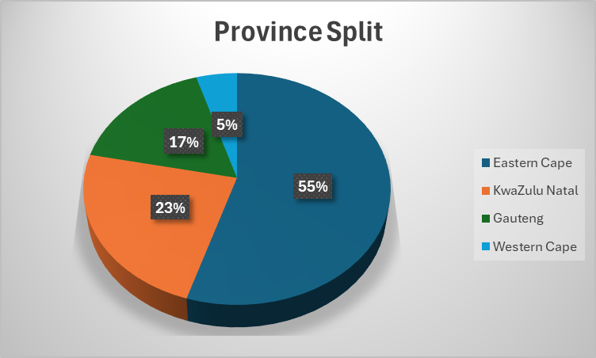

**Table C: Orders issued in the District- Chart A**

|  |  |  |  |  |
| --- | --- | --- | --- | --- |
| **LOCAL MUNICIPALITY** | **AMOUNT** | **%** | **NO. OF ORDERS** | **%** |
| Umzimvubu | R61 980.00 | 25.848672 | 5 | 15.1515152 |
| WMMLM | R13 857.50 | 5.779250923 | 2 | 6.06060606 |
| Ntabankulu | R26 770.91 | 11.16477044 | 2 | 6.06060606 |
| Matatiel | R0.00 | 0 | 0 | 0 |
| Outside Alfred Nzo | R137 171.80 | 57.20730664 | 24 | 72.7272727 |
| TOTAL | R239 780.21 | 100 | 33 | 100 |

**Pie Chart B: Orders issued in the District- Chart B**

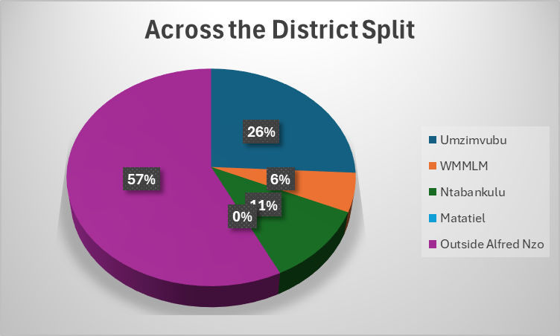

1. **Orders issued less than R200 000.00**

|  |  |  |  |  |  |
| --- | --- | --- | --- | --- | --- |
| **DATE** | **NAME OF SUPPLIER** | **DESCRIPTION** | **BID NUMBER** | **AMOUNT** | **REGION** |
| 2025/05/14 | SMELOKUHLE PROJECTS | Facilitation of ANDA Accreditation to be a Skills Development Provider | 30/2024/2025 | R105 000.00 | Johannesburg |
| 2025/05/14 | Ulie General Trading | Provision of supply and Installation of File cabinet | 31/2024/2025 | R95 000.00 | EmaXesibeni |
| 2025/05/14 | Mbewu Consultants and Maintenance | Supply and Delivery of Laptops | 33/2024/2025 | R145 000.00 | Ntabankulu |
| 2025/05/14 | Mbewu Consultants and Maintenance | Enterprise Development Incubation for ULM | 34/2024/2025 | R195 000.00 | Ntabankulu |
| 2025/05/14 | Mbewu Consultants and Maintenance | Enterprise Development Incubation for WMMLM | 35/2024/2025 | R195 000.00 | Ntabankulu |
| 2025/06/03 | Masinyane and Son | Supply and Delivery of one Laptop | 36/2024/2025 | R46 500.00 | Bizana |
| 2025/06/25 | Gell Management Solutions | Supply and installations of Air conditioners | 37/2024/2025 | R159 390.00 | Port Edward |

1. **Bids awarded above R 200 000.00**

There were no bids appointed for this financial year

1. **Bid Committee Sittings**

|  |  |  |  |
| --- | --- | --- | --- |
| **BID COMMITTEE SITTING 2024/25 QUARTER 4** | | | |
|  |  |  |  |
| **BID NO.** | **DESCRIPTION** | **BID COMMITTEE** | **DATE OF SITTING** |
| 32/2024/2025 | Provision of cellphone contracts for 2 years | Bid Specification Committee | 15-Apr-25 |
| 34/2024/2025 | Enterprise Development Incubation for ULM | Bid Specification Committee | 15-Apr-25 |
| 35/2024/2025 | Enterprise Development Incubation for WMMLM | Bid Specification Committee | 15-Apr-25 |
| 30/2024/2025 | Facilitation of ANDA Accreditation to be a Skills Development Provider | Bid Specification Committee | 15-Apr-25 |
| 33/2024/2025 | Supply and Deliver of Laptops | Bid Specification Committee | 15-Apr-25 |
|  |  |  |  |
| 32/2024/2025 | Provision of cellphone contracts for 2 years | Bid Evaluation Committee | 04-Jun-25 |
| 29/2024/2025 | Panel of Service providers for handling Legal matters | Bid Evaluation Committee | 05-Jun-25 |
| 32/2024/2025 | Provision of cellphone contracts for 2 years | Bid Adjudication Committee | 26-Jun-25 |
| 29/2024/2025 | Panel of Service providers for handling Legal matters | Bid Adjudication Committee | 26-Jun-25 |

1. **Updated Supplier Database**

The updated database is attached

1. **Procurement Plan**

ANDA developed a procurement plan in line with the SDBIP and the procurement plan that is as follows:

|  |  |  |  |  |  |  |  |  |  |  |  |  |  |  |
| --- | --- | --- | --- | --- | --- | --- | --- | --- | --- | --- | --- | --- | --- | --- |
| **No.** | **Directorate / Unit** | **Vote** | **Bid Description** | **Date of Submission of Specification / TOR's** | **Budgeted Amount** | **Source of Funding** | **Envisaged Date of Bid Specification Committee** | **Envisaged Date of Advert** | **Envisaged Date of Bid Evaluation Committee** | **Envisaged Date of Bid Adjudication Committee** | **Envisaged Date of objection period** | **Envisaged Date of Award** | **Actual date of award** | **Comments** |
| **1** | Finance and Admin | Administrative and Corporate Support:Admin & Corporate Services | Leasing and maintenance of printing machines | 8/8/2024 | R600 000 | ANDM | 2024/08/12 | 2024/08/16 | 2024/09/13 | 2024/09/26 | 2024/10/03 | 2024/10/18 |  | The appointment is currently being requested through the transversal contract that is with the National Treasury. |
| 2 | Programme | Corporate Wide Strategic Planning (IDPs, LEDs): LED | Appointment of Service provider for Construction of 1x shearing sheds at Winnie Madikizela Mandela LM | 8/8/2024 | R500 000.00 | ANDM | 2024/08/12 | 2024/08/16 | 2024/09/13 | 2024/09/26 | 2024/10/03 | 2024/10/18 | 18-Oct-24 | Service Provider has been appointed |
| 3 | Programme | Corporate Wide Strategic Planning (IDPs, LEDs): LED | Appointment of Service provider for Construction of 1x shearing sheds in Umzimvubu LM | 8/8/2024 | R500 000.00 | ANDM | 2024/08/12 | 2024/08/16 | 2024/09/13 | 2024/09/26 | 2024/10/03 | 2024/10/18 | 18-Oct-24 | Service Provider has been appointed |
| 4 | Programme | Corporate Wide Strategic Planning (IDPs, LEDs): LED | Supply and Delivery of Sewing Material | 8/8/2024 | R70,000 | ANDM | 2024/08/12 | 2024/08/16 | N/A | N/A | N/A | 2024/08/30 | 15-Oct-24 | Project Completed |
| 5 | Programme | Corporate Wide Strategic Planning (IDPs, LEDs): LED | Appointment of Service provider for refurbishment of 1 Shearing shed at Matatiele LM. | 8/8/2024 | R500 000.00 | ANDM | 2024/08/12 | 2024/08/16 | 2024/09/13 | 2024/09/26 | 2024/10/03 | 2024/10/18 | 30-Dec-2024 | Service Provider has been appointed |
| 6 | Programme | Corporate Wide Strategic Planning (IDPs, LEDs): LED | Appointment of service provider for development of Cannabis and Hemp Master Plan | 2024/09/18 | R1 500 00.00 | ANDM | 2025/01/12 | 2025/01/25 | 2025/02/25 | 2025/03/06 | 2025/03/11 | 2025/03/25 |  | Project on hold |
| 7 | Programme | Corporate Wide Strategic Planning (IDPs, LEDs): LED | Appointmnent of service provider for development of 1x Business Plan for Macadamia Nuts | 2024/09/18 | R500 000.00 | ANDM | 2025/01/12 | 2025/01/25 | 2025/02/25 | 2025/03/06 | 2025/03/11 | 2025/03/25 |  | Project on hold |
| 8 | Programme | Corporate Wide Strategic Planning (IDPs, LEDs): LED | Appointment of panel of training providers | 8/8/2024 | R0.00 | N/A | 2024/08/12 | 2024/08/16 | 2024/09/13 | 2024/10/11 | 2024/10/03 | 2024/10/18 | 07-Jan-25 | Service Provider has been appointed |
| 9 | Finance and Admin | Administrative and Corporate Support:Admin & Corporate Services | Provision of Cleaning Services | 8/8/2024 | R400 000.00 | ANDM | 2024/08/12 | 2024/08/16 | N/A | N/A | N/A | 2024/08/30 | 2024/08/28 | Service Provider has been appointed |
| 10 | Finance and Admin | Administrative and Corporate Support:Admin & Corporate Services | Appointment of Service Provider for Cellphone Contract | 1/17/2024 | R600 000.00 | ANDM | 2025/01/24 | 2025/01/31 | 2025/02/06 | 2025/02/13 | 2025/02/18 | 2025/03/13 |  | Project being recommended for appointment |
| 11 | Programme | Corporate Wide Strategic Planning (IDPs, LEDs): LED | Development of of Business Plans for Fresh Produce Pack Houses at WMMLM and MLM | 02/17/2025 | R500 000 | ANDM |  | 2025/01/15 | 2/24/2025 | 2025/03/04 | 2025/03/10 | 2025/12/20 | 2025/03/31 | Service Provider has been appointed |
| 12 | Programme | Corporate Wide Strategic Planning (IDPs, LEDs): LED | Appointment of a Social Facilitator for Emfundisweni Skills Development Centre Project | 2025/01/10 | R300 000 | ANDM | 2025/01/24 | 2025/01/31 | 2025/03/11 | 2025/03/19 | 2025/03/24 | 2025/03/13 | 2025/05/14 | Service Provider has been appointed |
| 13 | Finance and Admin |  | Panel of service providers for Maintenance & Repairs | 2025/01/10 | N/A | ANDM | 2025/01/24 | 2025/01/31 | 2025/02/06 | 2025/02/13 | 2025/02/18 | 2025/03/13 | 2025/03/31 | Service Provider has been appointed |
| 14 | Programme | Corporate Wide Strategic Planning (IDPs, LEDs): LED | Expression of Interest for Strategic Partnerships | 2025/01/10 | N/A | ANDM | 2025/01/24 | 2025/01/31 | 2025/02/06 | 2025/02/13 | 2025/02/18 | 2025/03/13 |  | Project recommended for re-advertisement |
| 15 | Programme | Corporate Wide Strategic Planning (IDPs, LEDs): LED | Identification, packaging and sourcing for high impact projects | 2025/01/10 | N/A | ANDM | 2025/01/24 | 2025/01/31 | 2025/02/06 | 2025/02/13 | 2025/02/18 | 2025/03/13 |  | Project recommended for re-advertisement |
| 16 | Finance and Admin | Administrative and Corporate Support:Admin & Corporate Services | Handling of Legal Matters for ANDA | 2025/01/11 | R500 000 | ANDM | 2025/02/11 | 2025/02/14 | 2025/03/06 | 2025/03/13 | 2025/03/18 | 2025/03/13 |  | Project is being evaluated |

# PART 5: UNAUTHORISED, IRREGULAR, FRUITLESS AND WASTEFUL EXPENDITURE

The Irregular Expenditure report is prepared according to MFMA circular number 68, the Irregular, Fruitless and Wasteful Expenditure Register is attached.

Irregular expenditure from prior years amounts to **R37 193 360.00,** and there has been no irregular expenditure recorded for the current financial year.

Irregular expenditure totaling **R37 193 360** was certified as irrecoverable by the Board and was written off by the Council.

Fruitless and wasteful expenditure from prior years and to date totals to **R5 842 773.61.** The investigations are still underway.

|  |  |
| --- | --- |
|  | **2024 - 2025** |
| **Fruitless & wasteful expenditure** |  |
| Opening Balance | 5 842 773.61 |
| Add Current year fruitless & wasteful expenditure | 15 668.56 |
| Less Fruitless & wasteful expenditure written off | - |
| Less Fruitless & wasteful expenditure recovered | - 15 668.56 |
|  | **5 842 773.71** |

Consequences for responsible officials have been implemented, and a formal report was submitted to both the Board and the Municipal Public Accounts Committee (MPAC). The entity is waiting for MPAC findings on the report.

# PART 6: TAX COMPLIANCE REPORT

This report serves as a summary of the Entity's tax obligations and compliance schedule. It is essential for the entity to maintain accurate records and ensure timely submissions to avoid penalties or interest.

With the recent appointment of a new **Chief Executive Officer**, SARS must be formally notified, and records must be updated to reflect this change in representation to enable the CEO to assume this statutory role as a Public Officer to further strengthen compliance and improve tax governance.

**1. Types of Taxes Applicable to the Entity:** The Entity is required to comply with the following types of taxes:

* **Provisional Tax**: This tax is applicable to the Entity and must be paid twice a year. It serves as a method of pre-paying the annual tax liability in advance to avoid a large lump sum at year-end.
* **Value-Added Tax (VAT)**: The Entity is registered for VAT and submits VAT returns every two months. This tax is applicable on the sale of goods and services, and the entity is eligible to claim input VAT on expenses incurred in the course of its business.
* **Annual Income Tax**: The Entity is required to file an annual income tax return based on the taxable income derived during the financial year.
* **Employees’ Tax (PAYE)**: The Entity deducts employees' tax (PAYE) from salaries and submits these payments monthly to the tax authority. This tax is withheld as part of the employees' remuneration process.

**2. Tax Submission Frequency:**

* **VAT**: Every two months.
* **Employees’ Tax (PAYE)**: Monthly.
* **Provisional Tax**: Twice a year.
* **Annual Income Tax**: Once a year.

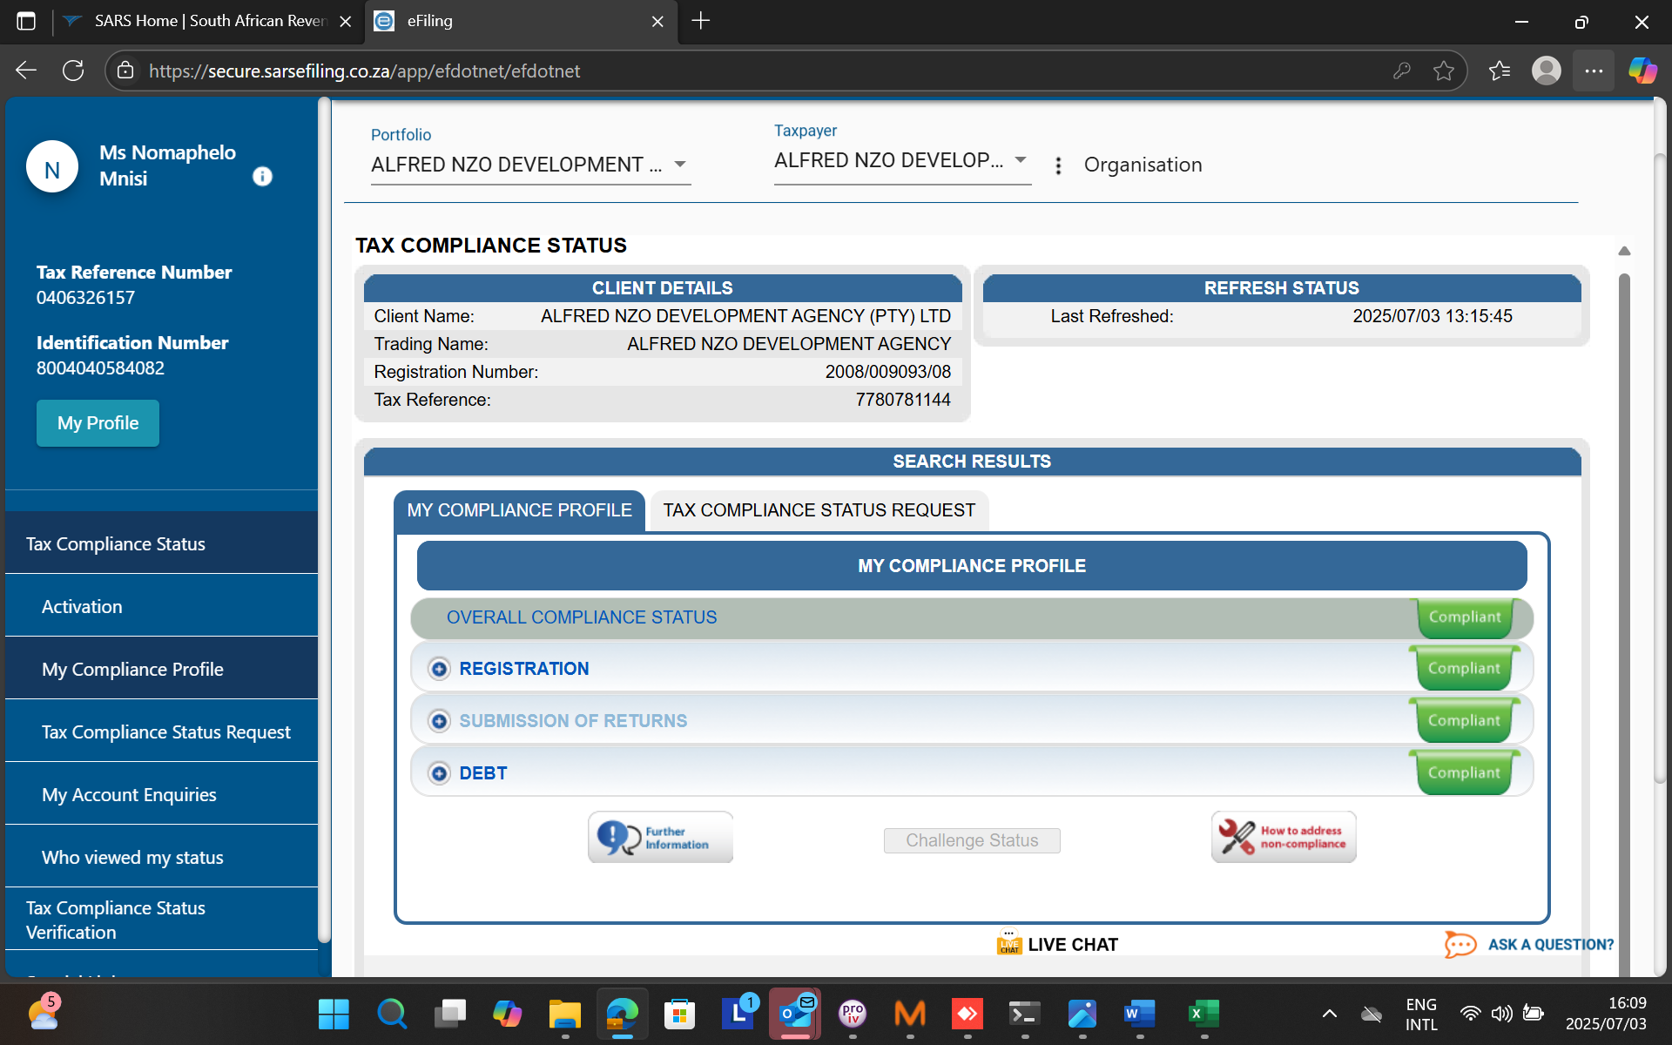

**3. Tax Audit Communication:**

No tax audits have been communicated to the Entity to date.

# PART 7: STATUS ON IMPLEMENTATION OF RISK MITIGATING PLANS

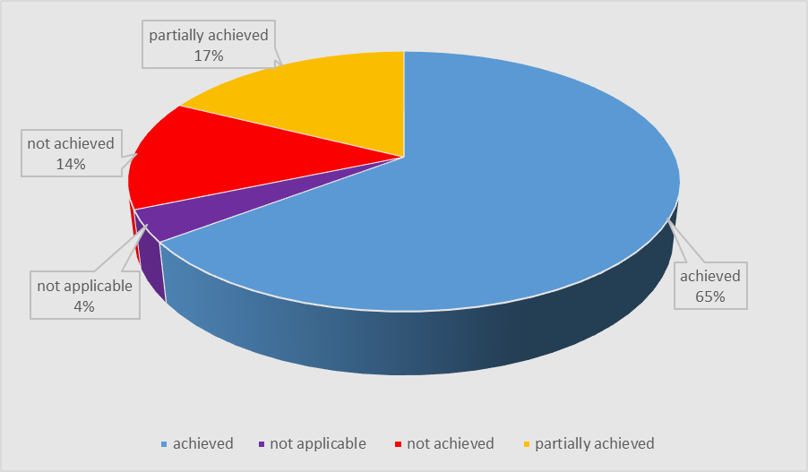

## **Chief Executive Officer’s Quality Certification**

|  |
| --- |
| **QUALITY CERTIFICATE** |

I, _____________________________________ (Full Names), the Acting Chief Executive Officer at Alfred Nzo Development Agency hereby certify that the **Quarterly Report** for the period ended 30 June 2025 has been prepared in accordance with the Local Government: Municipal Finance Management Act 2003 (Act 56 of 2003) and regulations made under the Act.

______________________ ___________________

**L. Mtimde Date**

**Chief Executive Officer**

|  |
| --- |
| **RECEIPT BY THE ACCOUNTING OFFICER** |

I, ______________________________________ (Full Names), the Municipal Manager of **Alfred Nzo District Municipality**, hereby accept the **Quarterly Report** of the municipal entity for the period ended 30 June 2025 as presented by the Chief Executive Officer in terms of the Local Government: Municipal Finance Management Act 2003 (Act 56 of 2003) and regulations made under the Act.

_________________________ ___________________

**Mr O. Diko Date**

**Acting Municipal Manager**