**IN-YEAR PERFORMANCE AND FINANCIAL REPORT (QUARTER TWO)**

**Author : N. Boti**

**Designation : Acting Chief Executive Officer**

**Date : 10 January 2025**

**Attachment : In-year financial and non-financial report**

□ For noting 1st Level : Senior Management

□ For information 2nd Level : Audit Committee

□ For consideration 3rd Level : Board

□ For recommendation 4th Level : Mayoral Committee

□ For approval 5th Level : Council

1. **PURPOSE**

The purpose of this document is to present the state of the Entity’s performance, budget versus actual income collected and actual expenditure incurred for the quarter ended of 31 December 2024.

1. **LEGISLATIVE PROVISIONS**

Municipal Finance Management Act No. 56 of 2003

Municipal Planning & Performance Management Regulations

1. **BACKGROUND**

The report is prepared in compliance with Section 52 (d) of the Municipal Finance Management Act No. 56 of 2003, which provides that:

The Mayor of a municipality must, within 30 days of the end of each quarter, submit a report to the Council on the implementation of the budget and the financial state of affairs of the municipality.

In preparation of the Quarterly Performance Assessment Report, the Chief Executive Officer must take into account the Section 87 Reports and ensure that reported performance is in line with the Service Delivery and Budget Implementation Plan as approved by the Board in line with Section 53 of the MFMA.

The Report encapsulates performance of respective departments for the Period: 1st October 2024 to 31 December 2024. In instances where quarterly targets have not been met, reasons for variance are stated and corrective measures are captured. Documentation of areas with positive variances is also a requirement in reporting of performance.

**4. OVERALL INSTITUTIONAL PERFORMANCE**

The organization is responsible for a total of 51 KPIs for Quarter two, of which all were assessed with 43 achieved and 8 not achieved. All the assessed KPIs contribute to the overall performance level of the combined Multi-year Business Plan and SDBIP Scorecards as reflected in this report. Institutional statistics were as follows:

**COLOUR CODING**

|  |  |
| --- | --- |
|  | **Targets Not Achieved** |
|  | **Targets Achieved** |

**Table 4.1**

|  |  |  |  |  |  |
| --- | --- | --- | --- | --- | --- |
| **ACHIEVED TARGETS VS NOT ACHIEVED BY DEPARTMENT** | | | | | |
| **Department** | **Total No. of targets** | **Achieved** | **Not Achieved** | **Achieved%** | **% Not Achieved** |
|  |
| Programmes | 18 | 16 | 2 | 89% | 11% |  |
| Trade & Investment Promotion | 6 | 5 | 1 | 83% | 17% |  |
| Finance and Administration | 21 | 21 | 0 | 100% | 0% |  |
| Office of the Chief Executive Officer | 6 | 1 | 5 | 17% | 83% |  |
| **TOTAL** | **51** | **43** | **8** | **84%** | **16%** |  |

Detailed **Quarter 2** Institutional Performance for the period 2024/25 is presented in **APPENDIX “A”**

**5. COMPARISON OF THE QUARTER 2 WITH THE PREVIOUS FINANCIAL YEAR**

**Table 5.1**

|  |  |  |  |  |  |  |  |
| --- | --- | --- | --- | --- | --- | --- | --- |
| **Department** | **2023/2024 Quarter two Performance** | | | **2024/2025 Quarter two Performance** | | | **Improved, Maintained or Declined** |
| Total No. of Targets | % Achieved | % Not Achieved | Total No. of targets | % Achieved | % Not Achieved | **Outcome** |
| Chief Executive Officer | **7** | 100% | 0% | **6** | 17% | 83% |  |
| Programmes | **19** | 66% | 34% | **18** | 89% | 11% |  |
| Trade and Investment | **7** | 86% | 14% | **6** | 83% | 17% |  |
| Finance and Administration | **17** | 94% | 6% | **21** | 100% | 0% |  |
| **Overall Percentage** | **50** | **82%** | **18%** | **51** | **84%** | **16%** |  |

**Bar Graph 5.2**

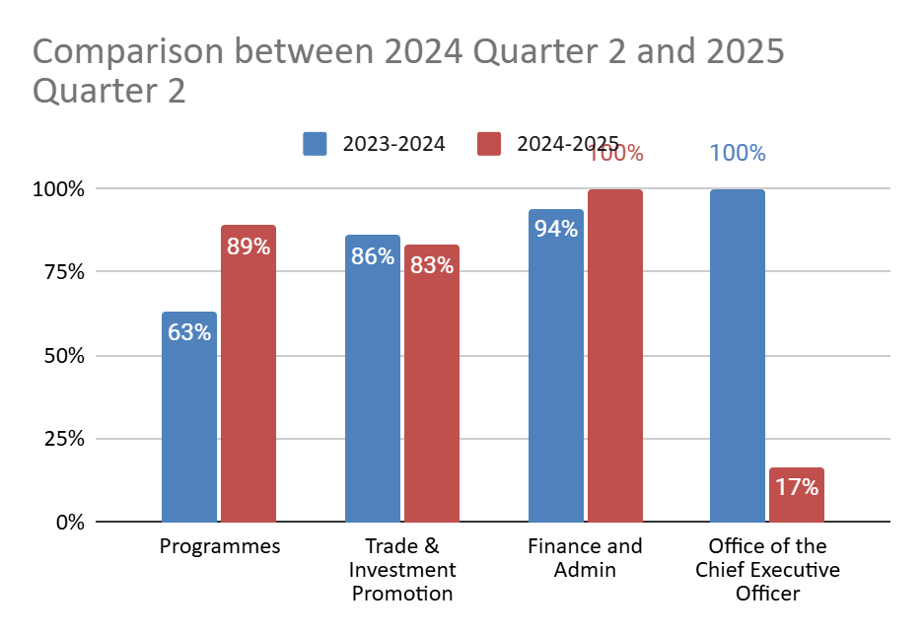

**6. INSTITUTIONAL FINANCIAL PERFORMANCE AND POSITION**

In the statement of financial performance, revenue accrued is R17,1-million out of the projected R20,9-million giving rise to an unfavorable variance of R3,8-million. The variance-contributing factor is LGSETA and Services SETA transfers that were not fully received because of the late commencement of the programmes.

On operating expenditure, R15,3-million was spent against the estimated budget of R20,8-million giving rise to a positive variance of more than R5,5-million.

The statement of financial position indicates that the entity's current assets exceed its current liabilities, suggesting a favourable liquidity position. This means the entity has sufficient short-term resources to meet its short-term obligations, demonstrating its ability to manage immediate financial commitments effectively.

The municipal entity ended the quarter with a positive cash and cash equivalents balance of R6,3 million, this however is inclusive of the R3.4-million of the unspent grants portion.

**7. FINANCIAL IMPLICATIONS**

None

**8. HR IMPLICATIONS**

None

**9. LEGAL IMPLICATIONS**

The report is prepared in compliance with section 88 of the MFMA. Non-submission of the report to Council may lead to an audit query: Non-compliance with applicable legislation.

**10. COMMUNICATION IMPLICATION**

The report has to be uploaded on the Entity’s website.

**11. SERVICE DELIVERY IMPLICATIONS**

The Mid Term Budget and Performance Assessment Report is a yardstick to measure achievement of indicators and targets as pre-determined in the SDBIP. It gives a reflection of whether or not the Entity is likely to achieve its annual targets and which may trigger revisions to the SDBIP and business re-engineering to achieve targets as set in the SDBIP.

**12. RECOMMENDATIONS**

1. That the Quarter 2 Budget and Performance Assessment Report for 2024-2025 FY be **NOTED** and **APPROVED**.
2. That the Quarter 2 Budget and Performance Assessment report for 2024-2025 FY be further submitted to Council for **NOTING** and **ADOPTION**.
3. That the Quarter 2 Budget and Performance Assessment report for 2024-2025 FY be further submitted to the Municipal Public Accounts Committee (MPAC) for further scrutiny in line with its oversight responsibility
4. That irregular expenditure incurred totalling R67- thousand be investigated.
5. That fruitless and wasteful expenditure as reported in the investigation report be written off.

**SUBMITTED BY:**

|  |
| --- |
| Report Generator : Ms N. Boti  Contact No. : 039 492 0011  Email address : botin@andm.gov.za  Designation : Acting - Chief Executive Officer  Date : 20 January 2025 |



**ANDA IN-YEAR PERFORMANCE REPORT-**

**QUARTER TWO 2024/2025**

**Table of Contents**

**PART 01: CHAIRPERSON REPORT 7**

**1.1** **Link between the budget and service delivery agreement 7**

**1.2** **Skills Development, Revenue enhancement strategies and partnerships 8**

**1.3** **Overview of the Financial Performance 8**

**1.4** **Financial risks faced by the agency 9**

**1.5** **Interventions to mitigate the challenges 9**

**1.6** **Legal framework 10**

**1.7** **Executive summary 10**

**1.8** **Progress on resolving problems identified in the 2023/2024 Annual Report 11**

**PART 2: OVERALL PERFORMANCE 11**

**2.1** **Achieved Targets vs. Not Achieved 12**

**2.2. SUMMARY OF PERFORMANCE ACHIEVEMENTS PER DIRECTORATE 13**

**PART 3: QUARTERLY BUDGET STATEMENT 19**

**3.1 Operating Revenue 19**

**3.2 Operating Expenditure 20**

**3.3 Capital Expenditure 22**

**3.4 Financial Position 22**

**3.5 Cash Flows 22**

**Table F1: Monthly Budget Statement Summary 22**

**Table F2: Monthly Financial Performance (Revenue and Expenditure) 23**

**Table F3: Capital Expenditure 24**

**Table F4: Statement of Financial Position 25**

**Table F5: Cash flows 25**

**Table SF3: Aged Debtors 26**

**Table SF4: Aged Creditors 26**

**Table SF5: Investment Portfolio Analysis 27**

**Table SF6: Board member allowances and staff benefits 27**

**Table SF7: Grants receipts and expenditure 27**

**PART 4: IMPLEMENTATION OF SCM POLICY 28**

**PART 5: UNAUTHORISED, IRREGULAR, FRUITLESS AND WASTEFUL EXPENDITURE 45**

**PART 6: TAX COMPLIANCE REPORT 45**

# PART 01: CHAIRPERSON REPORT

## Link between the budget and service delivery agreement

In conforming to the mandate of the organization as defined in the shareholder agreement between the ANDM and ANDA, the Board is committed to working with management and the municipality to promote economic development initiatives that aim to better the district and to better the lives of its inhabitants. As defined in the SDA the Board has further translated the ANDA mandate into the MYBP 2024/2025 whilst also keeping in mind goals of the shareholder expressed in the IDP.

The Service Delivery and Budget Implementation Plan 2024/2025 (SDBIP) is developed from the Multi – Year Business Plan and is essentially management and implementation tool which sets in-year information, such as quarterly service delivery and monthly budget targets, and links each service delivery output to the budget of the Agency, thus providing credible management information and a detailed plan for how the Agency will provide such services and the inputs and financial resources to be used.

The Annual Budget in line with the SDBIP 2024/2025 sets the yearly service delivery and budget targets (revenue and expenditure), it is imperative that in-year mechanisms are able to measure performance and progress on a continuous basis. Hence, the end-of-year targets must be based on quarterly and monthly targets, and the CEO must ensure that the budget is built around quarterly and monthly information. Being a start- of-year planning and target tool, the SDBIP 2024/2025 gives meaning to both in-year reporting in terms of section 87 (monthly reporting), section 52d (in-year report) and end-of-year annual reports. The in-year reporting is an illustration of the implementation of the budget.

## Skills Development, Revenue enhancement strategies and partnerships

The entity has made significant progress in revenue enhancement and skills development. By securing R23 million from Construction SETA and partnering with the Department of Public Works and Infrastructure, the entity aims to revitalize the Emfundisweni Skills Development Centre. Additionally, the R17.5 million secured from various SETAs will support youth training programs, enhancing their employability and entrepreneurial skills.

The partnership with Sunfarming and the establishment of the Agri-voltec project at Umzimvubu marks a strategic move for the district. This initiative combines solar energy generation with agricultural activities, supporting both energy independence and sustainable farming practices.

The Entity has partnered with the Eastern Cape Development Corporation and the local municipalities in the hosting of trade fairs which gives market opportunity for the SMMEs. The trade fair was successfully hosted at Matatiele Municipality due the period under review.

## Overview of the Financial Performance

The financial viability of the institution has been identified as organizational and strategic risk. It is worth highlighting that although efforts are underway to forge relations with strategic stakeholders that should ideally yield revenue enhancement through new investment and through ANDA’s existing property profile.

Financial sustainability and clean governance remain one of the critical areas in steering the Entity towards achieving its objectives. A revenue shortfall was experienced during the period under review because of SETA grant transfers that were not realized as planned due to continuous learner dropouts and delays in receipt of tranche payments.

As at the end of quarter two, the Entity had not spent R5,5-million of its projected year-to-date budget. The underspending is a result of the LG SETA trench payment delays; Services SETA learner dropouts and challenges experienced in constituting a quorum for the bid adjudication committee meetings. Despite the shortfalls, the Board is committed to ensuring that it works with Management to continue to explore strategies to increase value creation for the benefit of the Alfred Nzo District community.

The board notes that there are strategic programmes that the entity needs to gain attraction in the short to midterm, to turn around the state of the Entity. This would require mobilization of financial resources and securing land parcels with specific focus in unlocking investment attraction opportunities.

## Financial risks faced by the agency

The Alfred Nzo Development Agency operates under financial constraints that limit its capacity to fully implement its mandate, with the budget mainly covering operational expenses and leaving little for capital expenditure. It is recognized that there are strides internally to mobilize more funds in the form of grants and related funding models. Critical financial challenges facing the Development Agency include the following:

* Non availability of land parcels that are ready for development
* There are challenges in leveraging the LED opportunities due to limited financial resources to attract investors which leads to a limited ability to implement and sustain the entity's programmes and projects effectively.
* The packaging and sourcing of funding to implement high impact projects.
* Inability to attract investors.
* The incompleteness of TFC processes has adversely affected our planning. It must be noted that processes to transfer Fort Donald and Emfundisweni properties from O.R Tambo Ntinga Development Agency to Alfred Nzo Development Agency have been initiated. An attorney has been instructed to deal with the transfers.

These challenges expose the Agency to the following Strategic Risks:

* Non – Achievement of strategic objectives like financial viability of the Agency.
* Non–Achievement of annual performance targets translates to non–achievement of strategic objectives.
* Failure to effectively implement the Development Agency’s mandate as outlined in the service delivery agreement (SDA) with the parent municipality.

## Interventions to mitigate the challenges

* SETAs including LG & FoodBev SETA have made trench payments for the projects being implemented and this demonstrates that the cash inflow of the entity is slowly beginning to improve.
* ANDA is intensifying its resource mobilization efforts, it is anticipated that this will assist to attract prospective funders to the Development Agency. A Memorandum of Understanding has been entered into between ANDA and the Department of Labour. Funding proposals have been submitted to Construction SETA and WR SETA.
* The Entity through its attorneys is in the process of registering two properties under ANDA assets.

## Legal framework

This report is in line with the statutes governing local government.

a) Constitution of the Republic of South Africa (1996), Chapter 7 Section 152, Chapter 10 Section 195 (1) Public administration must be governed by the democratic values and principles including (b) Efficient, economic and effective use of resources musty be promoted and (f) Public administration must be development-oriented.

b) Section 52d of Local Government: Municipal Finance Management Act 53 of 2003, provides that the Mayor of a municipality must, within 30 days of the end of each quarter, submit a report to Council on the implementation of the budget and the financial state of the municipality. Additionally, whilst it also provides a monitoring tool for Council on the non-financial indicators which is part of the Service Delivery and Budget Implementation Plan (SDBIP).

c) Local Government: Municipal Planning and Performance Regulations (2001), prescribe that a municipality must development a performance management system and determine continuous review of performance based on the predetermined objectives. This process encompasses review of Indicators as per set targets in the SDBIP.

d) Alfred Nzo Development Agency is in compliance with the Performance Regulations developed and adopted its Performance Management System Policy Framework which gives an indication of the approach by the Municipality towards performance management.

## Executive summary

This report serves to report the **Quarter Two Entity’s Performance** for the **2024/2025** financial year **ending 30 June 2025**. This report details the actual performance and variances of the Agency’s Key Performance Areas in adjusted SDBIP. In the case of under-performance, this report demonstrates mitigations and solutions that will address the challenges that led to under-performance.

The overall Institutional performance score achieved for the **Quarter two of 2024/2025, ending 30 June 2025** is **84%**, which is an increase when compared to the previous Quarter two performance of **2023/2024 financial year which stood at 82%.**

# PART 2: OVERALL PERFORMANCE

This section provides an outline in terms of the Entity’s Quarter two performance for 2024/2025 in line with the SDBIP 2024/2025 targets and in relation to the various directorates of the Entity:

* Office Of the Chief Executive Officer (OCEO)
* Programmes Department (PD)
* Trade and Investment Promotion
* Finance and Admin

## Table 2.1:Achieved Targets vs. Not Achieved

|  |  |  |  |  |  |
| --- | --- | --- | --- | --- | --- |
| **ACHIEVED TARGETS VS NOT ACHIEVED BY DEPARTMENT** | | | | | |
| **Department** | **Total No. of targets** | **Achieved** | **Not Achieved** | **Achieved%** | **% Not Achieved** |
|
| Programmes | 18 | 17 | 1 | 94% | 6% |
| Trade & Investment Promotion | 6 | 5 | 1 | 83% | 17% |
| Finance and Administration | 21 | 21 | 0 | 100% | 0% |
| Office of the Chief Executive Officer | 6 | 1 | 5 | 17% | 83% |
| **TOTAL** | **51** | **43** | **8** | **84%** | **16%** |

**2.1 Bar Graph: representation of performance**

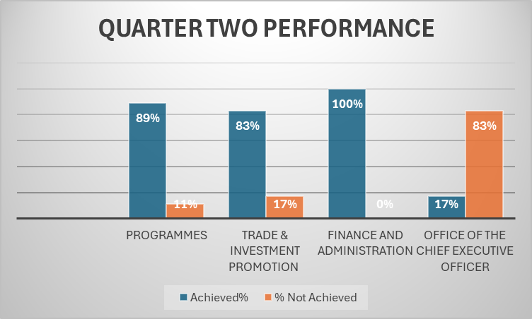

**2.2 COMPARISON OF QUARTER 2 WITH THE PREVIOUS FINANCIAL YEAR**

This section graphically presents a comparison of the Mid-Year performance from the previous financial year and the year under review.

Table 2.2

?????



## 2.3 SUMMARY OF PERFORMANCE ACHIEVEMENTS PER DIRECTORATE

**Table :2.3 Directorate: Programmes**

|  |  |  |  |  |  |
| --- | --- | --- | --- | --- | --- |
| **PROGRAMMES DEPARTMENT** | | | | | |
| **ACHIEVED TARGETS VS NOT ACHIEVED BY PROJECT** | | | | | |
| **Project Name** | **Total No. of targets** | **Achieved** | **Not Achieved** | **% Achieved** | **% Not Achieved** |
| Sheep Farming Programme | 1 | 1 | 0 | 100 | 0 |
| Emfundisweni Skills Development Centre: Business Support | 1 | 1 | 0 | 100 | 0 |
| Enterprise Development | 1 | 1 | 0 | 100 | 0 |
| Fresh Produce Industry Development | 1 | 1 | 0 | 100 | 0 |
| SETA Accreditation | 1 | 0 | 1 | 0 | 100 |
| FoodBev Learnership | 1 | 1 | 0 | 100 | 0 |
| LG SETA Learnership (LED) | 1 | 1 | 0 | 100 | 0 |
| LG SETA Learnership (Environmental Practice) | 1 | 1 | 0 | 100 | 0 |
| LG SETA ARPL (Plumbing) | 1 | 1 | 0 | 100 | 0 |
| LG SETA ARPL (Bricklaying) | 1 | 1 | 0 | 100 | 0 |
| LG SETA Apprenticeship (Plumbing - Employed) | 1 | 1 | 0 | 100 | 0 |
| LG SETA Apprenticeship (Plumbing- Unemployed) | 1 | 1 | 0 | 100 | 0 |
| Services SETA: Learnership Programme (Clothing Manufacturing) | 1 | 1 | 0 | 100 | 0 |
| Services SETA: Learnership (Generic Management) | 1 | 1 | 0 | 100 | 0 |
| Services SETA: Learnership Programme (Business Administration) | 1 | 1 | 0 | 100 | 0 |
| Services SETA: Learnership Programme (Sewing) | 1 | 1 | 0 | 100 | 0 |
| Services SETA: Vocational Internship Programme | 1 | 1 | 0 | 100 | 0 |
| Services SETA: NATED Internship Programme | 1 | 1 | 0 | 100 | 0 |
| Services SETA: Vocational Internship | 1 | 1 | 0 | 100 | 0 |
| **Total** | **18** | **17** | **1** | **89%** | **11%** |

**2.3.1 Directorate Overview, Challenges and Successes**

* Programmes Department is a very crucial but under-resourced department in terms of the staff complement as it has only 3 Employees including the Executive Manager whose contract will expire soon. However, the recruitment process is at its final state.
* During the period under review, the Programmes Department had a total of 18 targets, 17 of the total targets were achieved successfully and 1 target not achieved.
* Challenges facing the department relate to insufficient financial and human resource capacity in the department to deliver in terms of key projects with great socio-economic impact.

**Table 2.4 The reasons for not achieving 100% in Quarter two are as follows:**

|  |  |  |  |
| --- | --- | --- | --- |
| **Project Name** | **Challenges/Reason for Variance** | **Service Delivery implications** | **Corrective Action** |
| SETA Accreditation | The project has been discontinued due to budget constraints | Continuous outsourcing of all skills programme | The project will be taken out of the SDBIP in the Midterm Budget adjustment |

**Table 2.5 Directorate: Trade and Investment**

|  |  |  |  |  |  |
| --- | --- | --- | --- | --- | --- |
| **TRADE & INVESTMENT** | | | | | |
| **ACHIEVED TARGETS VS NOT ACHIEVED BY PROJECT** | | | | | |
| **Project Name** | **Total No. of targets** | **Achieved** | **Not Achieved** | **% Achieved** | **% Not Achieved** |
| Cannabis and Hemp production | 1 | 0 | 1 | 0 | 100 |
| Macadamia Nuts Plantation | 1 | 0 | 1 | 0 | 100 |
| Agri-Voltaic - Sun farming | 1 | 1 | 0 | 100 | 0 |
| Alfred Nzo Industrial Park | 1 | 1 | 0 | 100 | 0 |
| Resource Mobilization | 1 | 1 | 0 | 100 | 0 |
| Partnerships | 1 | 1 | 0 | 100 | 0 |
| **Total** | **6** | **4** | **2** | **67%** | **33%** |

**2.5.1 Departmental Overview and Challenges**

* Department operates with one personnel
* During the period under review, the Trade and Investment Promotion Department had a total of 6 targets and only 4 were achieved successfully whilst 2 were left not achieved.

**Table 2.6 The reasons for not achieving 100% in the Quarter two are as follows:**

|  |  |  |  |
| --- | --- | --- | --- |
| **Project Name** | **Challenges/Reason for Variance** | **Service Delivery implications** | **Corrective Action** |
| Cannabis and Hemp production | The project has been discontinued due to budget constraints | The procurement of service provider had to be discontinued due to the current financial pressure faced by the entity. | The Agency will explore the possibilities of collaboration with other entities to undertake the study. |
| Macadamia Nuts Plantation | Delays in receipt of first tranche payment form LGSETA | The entity could not proceed with the Business Plan due to insufficient hectarage identified by the Feasibility study | The scope of the project has been extended to partner with ECDC. Targets will be adjusted in the mid-year. |

**Table 2.7 Directorate: Finance and Admin**

|  |  |  |  |  |  |
| --- | --- | --- | --- | --- | --- |
| **FINANCE AND ADMIN** | | | | | |
| **ACHIEVED TARGETS VS NOT ACHIEVED BY PROJECT** | | | | | |
| **Project Name** | **Total No. of targets** | **Achieved** | **Not Achieved** | **% Achieved** | **% Not Achieved** |
| Procurement Projects | 1 | 1 | 0 | 100% | 0% |
| Asset Management | 1 | 1 | 0 | 100% | 0% |
| Fleet Management | 1 | 1 | 0 | 100% | 0% |
| Budget & Reporting | 1 | 1 | 0 | 100% | 0% |
| Financial Information Systems | 1 | 1 | 0 | 100% | 0% |
| Improved Audit Opinion | 1 | 1 | 0 | 100% | 0% |
| Irregular Expenditure | 1 | 1 | 0 | 100% | 0% |
| Policy Development | 1 | 1 | 0 | 100% | 0% |
| VIP Payroll | 1 | 1 | 0 | 100% | 0% |
| Staff Establishment Review | 1 | 1 | 0 | 100% | 0% |
| Skills Development | 1 | 1 | 0 | 100% | 0% |
| ICT Management | 1 | 1 | 0 | 100% | 0% |
| Records Management | 1 | 1 | 0 | 100% | 0% |
| Individual Performance Management | 1 | 1 | 0 | 100% | 0% |
| Cleaning Goods & Services | 1 | 1 | 0 | 100% | 0% |
| Recruitment and selection | 1 | 1 | 0 | 100% | 0% |
| Occupational Health and Safety | 1 | 1 | 0 | 100% | 0% |
| **Total** | **21** | **21** | **0** | **100%** | **0%** |

**2.7.1 Directorate Overview, Challenges and Successes**

* Finance and Admin Department had an overall of 21 targets at Quarter two for the 2024/25 financial year
* 21 targets were achieved successfully.
* The financial management system used by the entity consumes 10% of the total budget, which is a significant expense. Additionally, the system has experienced reporting errors, such as an incorrect reflection of an additional amount that was not actually received. The reporting error of R5-million on grants received will be corrected in the second quarter.
* The Entity is currently unable to provide skills development for its employees due to financial constraints. The LGSETA mandatory grant is unable to fund the programme, and the entity has applied for alternative funding.
* The entity is struggling to retain employees due to concerns about job security and the lack of employee benefits. Management is applying the prudence principle in budget implementation, acknowledging the constraints and uncertainties regarding potential increases in operational funding allocations.

**Table 2.8 Directorate: Office of the CEO**

|  |  |  |  |  |  |
| --- | --- | --- | --- | --- | --- |
| **OFFICE OF THE CEO** | | | | | |
| **ACHIEVED VS NOT ACHIEVED** | | | | | |
| **Project name** | **Total No. of Targets** | **Achieved** | **Not Achieved** | **% Achieved** | **% Not achieved** |
| Sitting of Board Meetings | 1 | 0 | 1 | 0% | 100% |
| Communications Project | 1 | 1 | 0 | 100% | 0% |
| Institutional Performance Management | 1 | 0 | 1 | 0% | 100% |
| Internal Audit | 1 | 0 | 1 | 0% | 100% |
| Risk Management | 1 | 0 | 1 | 0% | 100% |
| Legal Services | 1 | 0 | 1 | 0% | 100% |
| **TOTAL** | **6** | **1** | **5** | **17%** | **83%** |

**2.8.1 Directorate Overview, Challenges and Successes**

* The OCEO had an overall of 06 targets in Quarter two for the 2024/25 financial year.
* Out of the 06 targets, only 01 targets were achieved successfully.
* The following targets for Quarter two Implementation were not achieved due to the expiry of the Audit and Performance (APC) Shared Services:
  + Sitting of Board Meeting
  + Internal Audit
  + Risk Management
  + Legal Service
  + Institutional Performance Management System
* The entity was not able to send the reports to the Internal Audit and Audit and Performance Committee (APC) for quality assurance due to the expiry of the Shared Services with the Parent Municipality which has adversely affected the performance of the Office of the CEO.
* The Department is without a permanently employed CEO, which causes instability.

# PART 3: QUARTERLY BUDGET STATEMENT

## 3.1 Operating Revenue

**Operating Revenue**

In the statement of financial performance, revenue accrued is R17,1-million out of the projected R20,9-million giving rise to an unfavorable variance of R3,8-million. The variance-contributing factor is LGSETA and Services SETA transfers that were not fully received because of the late commencement of the programmes.

**Investment Revenue17**

This relates to interests received on the call account deposits. Interest received since July amounts to R311-thousand out of the expected R120-thousand.

**Other Revenue**

Tender fees –R37-thousand accrued compared to the estimated R26-thousand.

Operational revenue – The Agency estimated an annual budget of R4,2-million that would be realized on the following: -

* Project management fees
* Savings on unfilled posts
* Savings on projects

However, R764-thousand accrued compared to the Quarter two estimate of R2,1-million has been realized because the budget estimate was not based on monies to be actually received, but on savings from last financial year.

Project management fees received to date have not been all been recognized as yet.

**Table 3.1Transfers and subsidies**

An amount of R5.0-million was received from the parent municipality, and not all qualifying revenues have been recognized for conditional grants as per the table below.

|  |  |  |  |  |  |
| --- | --- | --- | --- | --- | --- |
| **No.** | **Description** | **Opening balance** | **Bank receipts** | **Qualifying revenue/ expenditure** | **Unspent portion** |
| 1 | BANKSETA | 891 600.00 | - | 17 250.00 | 874 350.00 |
| 2 | LG SETA | - 1 290.00 | 980 160.00 | 563 499.36 | 415 370.64 |
| 3 | SERVICES SETA | 391 880.68 | 2 621 534.84 | 4 186 720.00 | - 1 173 304.48 |
| 4 | NSF | 824 138.85 | - | 824 138.85 | - |
| 5 | Food and Bev | - | 2 223 060.00 | 1 830 325.00 | 392 735.00 |
|  |  | **2 106 329.53** | **5 824 754.84** | **7 421 933.21** | **509 151.16** |

## 3.2 Operating Expenditure

On operating expenditure, R6,2-million was spent against the estimated budget of R10,4-million giving rise to a positive variance of more than R4,2-million.

**Employee Costs**

R4,2-million has been spent to date on employee-related costs against the estimated budget of R5,8-million as projected, giving rise to a variance of R1,5 - million. This has been due to the vacancy of the CEO, Executive Manager Trade and investment and Manager Budget, and Reporting posts that have not been filled together with employees’ salary increment that has not been paid out.

**Board Member Allowance**

Amount spent since July totals to R289-thousand, when the expected expenditure to date was estimated at R305-thousand, giving rise to an unfavorable variance of R16-thousand.

Operational costs– This line item includes all the other operating expenses like accommodation, telephone, electricity, audit fees, and software licenses.

Included in the operational costs’ budget are learnership and internship programmes aimed at assisting the unemployed youth of the District to acquire workplace experiential training and skills. Total expenditure since July totals to R9,7million against the projected R11,2-milion. Variance contributing factors are as follows:

* The delays in receipt of trench payments from LG SETA affected the projected budget because the Learnership in Environmental Practice had to start later than the anticipated date.
* Services SETA Internship programme, the project has been closed, and the Entity is waiting for the payment of retention fees.
* Dropouts of learners in various programmes include the following:

**Table 3.2: Dropouts From Various Programmes**

|  |  |  |  |
| --- | --- | --- | --- |
| **Project** | **Initial No. of learners** | **Current No. of learners** | **Reason for Dropouts** |
| Learnership (Generic Management) | 40 | 29 | 8 learners obtained full time employment. |
| Learnership (Project Management) | 31 | 26 | Only 2 learners obtained full time employment, the rest just absconded |
| Learnership (Clothing manufacturing processes) | 15 | 14 | The 1 Learner that dropped out relocated from where the training took place |
| Vocational Internship | 100 | 84 | 10 Interns confirmed to have obtained full time employment; others relocated due to other opportunities |
| Internship – NATED | 70 | 60 | 04 Interns confirmed to have obtained full time employment; others relocated due to other opportunities, and 2 learners passed on. |
| Business Administration Service | 70 | 46 | 7 learners confirmed to have obtained full time employment; 11 learners went back to school in January, and 6 learners relocated for other opportunities |

Contracted Services - Expenditure is R740-thousand against the expected budget of R3,1-million.

Operational Costs - This line item includes all the other operating expenses like accommodation, telephone, electricity, audit fees, and software licenses. Total expenditure is R4,1-million against the estimated R5,0-million giving rise to variance of R886-thousand.

## 3.3 Capital Expenditure

No capital acquisitions for the quarter.

## 3.4 Financial Position

The municipality’s current assets exceed the current liabilities. The municipality’s ability to pay its short-term liabilities is tested by taking the total current assets and dividing them by current liabilities. This test is mainly used to give an idea of the entity’s ability to pay back its short-term liabilities using the current assets.

## 3.5 Cash Flows

The municipality ended the month with a positive cash and cash equivalents balance of R3,3 million.

# Table F1: Monthly Budget Statement Summary

The table below reflects on the summary of the total municipality’s budget against year-to-date collections or expenditures.

# Table F2: Quarter Two Financial Performance (Revenue and Expenditure)

# Table F3: Capital Expenditure

There has been no capital expenditure since July 2024.

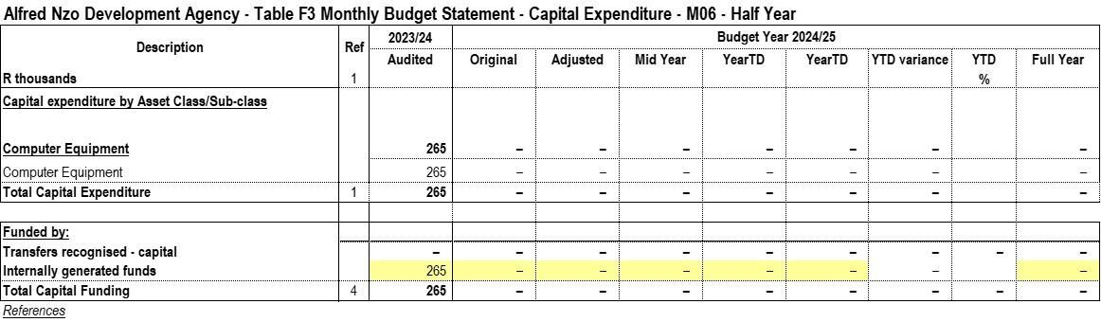

# Table F4: Statement of Financial Position

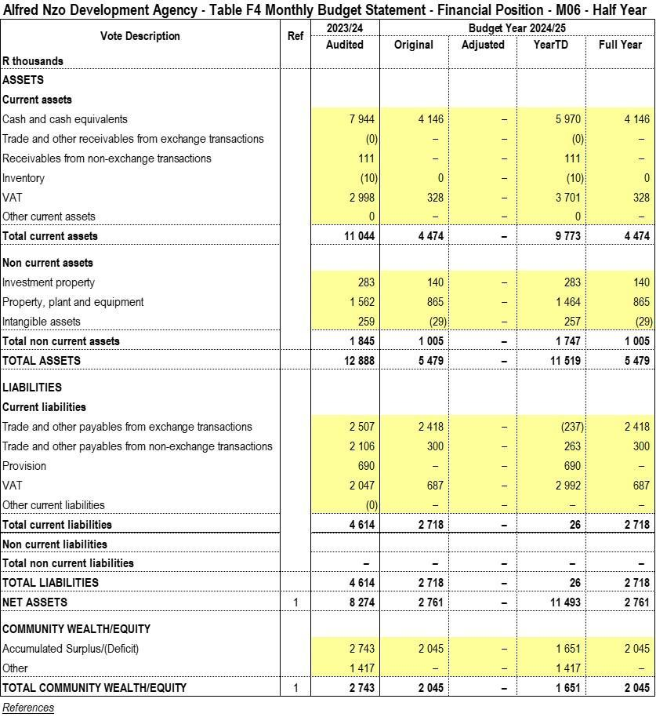

# Table F5: Cash flows

The table below reflects on cash flows of the institution.

**PART 2 – SUPPORTING DOCUMENTATION**

**Table SF1: Material variances and explanations**

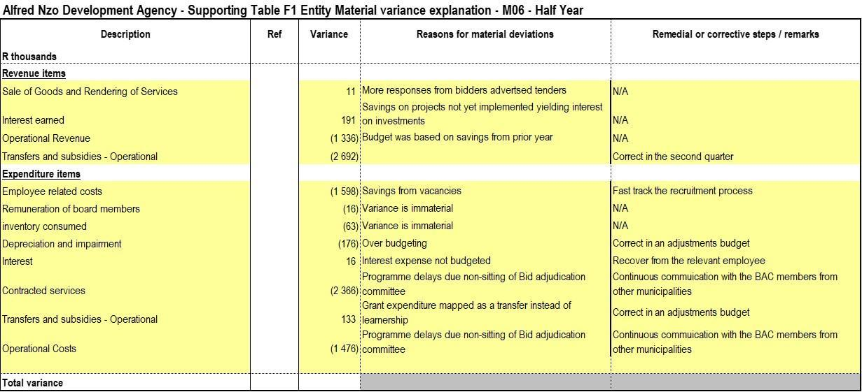

# Table SF3: Aged Debtors

The agency is owed a total amount of R50-thousand resulting from under payment from the parent in January 2024.

# Table SF4: Aged Creditors

The table below reflects the outstanding creditors totaling R3,5 million on grants and R1,2 million on trade creditors.

# Table SF5: Investment Portfolio Analysis

All the call deposits are highly liquid short-term investments and are held for the purpose of meeting short-term commitments rather than the purpose of earning a return (interest).

|  |  |  |  |  |  |  |
| --- | --- | --- | --- | --- | --- | --- |
| **Description** | **Account No** | **Opening balance** | **Transfers in** | **Transfers out** | **Interest Income** | **Closing balance** |
| **01-Jul-24** | **30-Jun-25** |
| Main Account | 62215290355 |  |  |  |  |  |
| Livestock Call Account | 62238128351 | 1 056 377.11 | - | - | 43 047.71 | 1 099 424.82 |
| SMME Call Account | 62238128517 | 56 445.43 | - | - | 2 300.17 | 58 745.60 |
| ANDA Reserve Fund | 62238130231 | 5 868 694.79 | 10 000 000.00 | (11 500 000.00) | 219 772.42 | 4 588 467.21 |
| Capacity Building | 62723833621 | 45 977.64 | - | (47 232.05) | 1 528.49 | 274.08 |
| Commercial NFS Account | 62822669620 | 306 864.05 | - | (315 236.21) | 8 372.16 | 0.00 |
|  |  | **7 334 359.02** | **10 000 000.00** | **(11 862 468.26)** | **275 020.95** | **5 746 911.71** |

Out of the R 5,7 million in call account deposits as reflected in the table below, R392-thousand relates to unspent grants and the balance of R5,3 million is the entity’s investment.

# Table SF6: Board member allowances and staff benefits

# 

# Table SF7: Grants receipts and expenditure

Unspent conditional grants’ total is R392 – thousand.

* **BANKSETA -** The project has been completed, however awaiting certification and the Service Delivery Provider (SDP) has not yet been fully paid hence the unspent amount. Once the certification has been received, this amount will recognized as project management fees as there are no outstanding payments for this project.
* **LGSETA –** The project has been completed however the Entity is facilitating the finalization of the addendum with LG SETA to enable the entity to recognize the balance as project management fees.
* **SERVICES SETA –** The entity utilized the funds from savings to fund the payments totalling to R1 411 916.60 as the entity awaits payment for invoices submitted.
* **FOOD AND BEV -**

|  |  |  |  |  |  |
| --- | --- | --- | --- | --- | --- |
| **No.** | **Description** | **Opening balance** | **Bank receipts** | **Qualifying revenue/ expenditure** | **Unspent portion** |
| 1 | BANKSETA | 891 600.00 | - | 17 250.00 | 874 350.00 |
| 2 | LG SETA | - 1 290.00 | 980 160.00 | 563 499.36 | 415 370.64 |
| 3 | SERVICES SETA | 391 880.68 | 2 621 534.84 | 4 186 720.00 | - 1 173 304.48 |
| 4 | NSF | 824 138.85 | - | 824 138.85 | - |
| 5 | FOOD & BEV | - | 2 223 060.00 | 1 830 325.00 | 392 735.00 |
|  |  | **2 106 329.53** | **5 824 754.84** | **7 421 933.21** | **509 151.16** |

# PART 4: IMPLEMENTATION OF SCM POLICY

In terms of Municipal Finance Management Act SCM Regulations Section 6 (3) states that the accounting officer must, within 10 days of the end of each quarter, submit a report on the implementation of the supply chain management policy to the board of directors of the municipal entity.

In terms of Section (111) of the MFMA, the Municipal Entity must have and implement a supply chain management policy that:

1. gives effect to:
2. section 217 of the Constitution; and
3. Part 1 of chapter 11 and other applicable provisions of the Act;
4. Is fair, equitable, transparent, competitive, and cost effective
5. Complies with;
6. The regulatory framework prescribed in Chapter 2 of these Regulations and
7. Any minimum norms and standards that may be prescribed in terms of section 168 of the Act
8. Is consistent with other applicable legislation;
9. Does not undermine the objective for uniformity in supply chain management system between organs of state in all spheres; and
10. It is consistent with national economic policy concerning the promotion of investments and doing business with the public sector.

ANDA SCM Policy required that the conditions for the procurement of goods or services through formal written price quotations are followed:

* At least 1 Quotation for procurement of a transaction value of between R300 to R2 000 (VAT Included)
* Formal written quotations for procurement of a transaction value over R2 000.00 up to R30 000.00 (VAT included)
* At least 3 Formal written price quotations for procurements of a transaction value over R30 000.00 up to R200 000.00 VAT included and shall be advertised for at least 7 days on the website.
* Competitive bidding process to be followed for procurements above a transaction value of R200 000 (VAT Included)

Legislative provisions

* Municipal Finance Management Act 56 of 2003
* Supply Chain Management Regulations
* Preferential Procurement Policy Framework Act and its Regulations
* 2023/2024 Supply Chain Management Policy

Deviations Report

**a)** **Annexure A**: **Deviations Report**

The Deviations report is prepared according to MFMA circular 68 and is as follows:

No Deviations were incurred this quarter.

Contracts Register

The Contracts Register has been developed according to the Contract Management Guide and is attached as an annexure.

Performance of External Suppliers

| **LEGEND:**  **1 – Not meeting the standards (0-30%)**  **2 – Meet some of the standards (30-50%)**  **3 – Meet most of the standards (50-70%)**  **4 – Meet all the standards (70-100%)** | | | | | |
| --- | --- | --- | --- | --- | --- |
| **NAME OF SERVICE PROVIDER** | **SERVICE RENDERED** | **SET TARGET OF PERFORMANCE (2024/2025)** | **PERFORMANCE** | **RATING FOR CURRENT FINANCIAL YEAR** | **COMMENTS /RECOMMENDATIONS** |
| MUNSOFT | Financial System | Provision of municipal financial system for transacting | Good | 3 | The interaction with Munsoft has improved after an email was sent to management. No challenges so far |
| Vodacom | Business Contract Phones and Internet | Phones and internet are provided as specified. | Poor | 2 | Contract is in place and monitored monthly but overall service is poor. |
| Umzimvubu Leather Craft | Provision of cleaning services | Cleaning services | Good | 3 | Service provider is performing as expected. |
| MTN | Provision of Cellphone contracts for 24 months | Cellphone Contracts | Poor | 2 | Service Provider performance is fair though the MTN network coverage is a problem. |
| Bonakude Consulting | Provision of Annual Financial Statements (AFS). | Provision of 20225/23 Annual Financial Statements | Fair | 2 | Contract ongoing with no challenges. |
| Taleni Godi Attorneys | Provision of Legal Services | Provision of Legal Services | Good | 3 | Contract ongoing with no challenges. |
| Silale Skills Academy | Silalele appointed to conduct learnership on Generic management L04 | Learnership on Generic Management NQF L4 | Good | 3 | Contract ongoing with no challenges. |
| Silale Skills Academy | Silalele appointed to conduct learnership on Sewing General Education Training (GET) Certificate Clothing Manufacturing Processes | Learnership on Clothing Manufacturing Processes NQF L1 | Good | 3 | Contract ongoing with no challenges. |
| Reflections Development Institute | Reflections appointed to conduct learnership programme on General Education Training Certificate: Business Administration NQF L4 | Learnership programme on Business Administration | Good | 3 | Contract ongoing with no challenges. |
| Kunene Makopo Risk Solutions | Provision of Insurance Services | Provision of Insurance Services | Good | 3 | Contract ongoing |
| Silalele Skills Solutions | Silalele appointed to conduct learnership on Bread and Confectionary baking for 12 months | Learnership on Bread and Confectionary Baking for 12 months | Good | 3 | Contract ongoing with no challenges |
| Artisan Development Academy | ADA appointed to conduct an apprenticeship and ARPL Programme on Plumbing and Bricklaying for 36 months | Apprenticeship and ARPL Programme on Plumbing and Bricklaying | Good | 3 | Contract ongoing with no challenges |

Orders issued less than R30 000.00

Orders issued for Quarter two (2) amounted to R 232 449.05 including VAT for VAT vendors and are as follows:

**Table A: Orders issued in Q2 of 2024/2025**

|  |  |  |  |  |
| --- | --- | --- | --- | --- |
| **Creditor Name** | **Order No.** | **Order Date** | **Value** | **Specifications** |
| Lint Foods (Pty) Ltd | 28687 | 12/10/2024 | R5,200.00 | Catering for ANDA Employees attending Wellness Programme on the 11/12/2024 40x 500ml Water; Lunch with soft drinks/Juice |
| DZAMA TRADING | 28660 | 10/29/2024 | R10,380.00 | Candidate screening of 6 candidates for the EM: Programmes; and EM: Tr Matric verification; Post matric qualification verification and Crimin check |
| DZAMA TRADING | 28657 | 10/28/2024 | R5,190.00 | Matric verification; post matric qualification verification and crimin record check of 3 candidates for the Trade & Investment Coordinator po |
| Animeds (Pty) Ltd | 28680 | 11/27/2024 | R6,080.00 | REPAIRS AND MAINTENANCE this is to request a service provider to suppl delivery and installation of 19 light bulb at Alfred Nzo Development A |
| LYMAGE CONSULTING AND TRADING | 28678 | 11/27/2024 | R10,100.00 | Request of cleaning material 1. toilet paper 2ply(48) 1x2; 2 mult-pur h 750ml ( 6 per pack) 1x4 pack; furniture polish 300ml (6 per pack) 1x shing liquid 750ml (6 per pack) 1x4 pack;toilets detergent 1600x1600 j |
| ZODIAC TRADING | 28679 | 11/27/2024 | R2,190.00 | Accommodation and meals for Ms Majola and Ms Jijana attending trade fair at Matatiele |
| Garden Court East London | 28676 | 11/25/2024 | R3,060.00 | Accommodation and meals for Ms Makhatha attending workshop on transversal contracts |
| Garden Court East London | 28675 | 11/25/2024 | R3,060.00 | Accommodation and meals for Ms Sompa attending workshop on transversal contracts |
| Garden Court East London | 28656 | 10/25/2024 | R1,530.00 | Accommodation extension; Ms Sokhanyile Attending Munsoft working session |
| Garden Court East London | 28655 | 10/25/2024 | R1,530.00 | accommodation extension; Ms Makhatha attending Munsoft working session |
| Garden Court East London | 28652 | 10/22/2024 | R3,060.00 | Accommodation and meals for Ms S. Sokhanyile attending Munsoft workshop in EL |
| Garden Court East London | 28651 | 10/22/2024 | R3,060.00 | Accommodation and meals for Ms Makhatha attending Munsoft workshop at East London |
| Pondoland Times | 28649 | 10/3/2024 | R600.00 | Advertising an erratum for leasing and maintenance of printer |
| DZAMA TRADING | 28689 | 12/18/2024 | R5,190.00 | matric verification x3; post matric qualification x3 Criminal record check x3 Accountant post candidates |
| GIJIMA HOLDINGS | 28688 | 12/13/2024 | R28,800.00 | Competency Assessments for 4 candisates of the Executive Manager: Programmes Position |
| DZAMA TRADING | 28685 | 12/9/2024 | R5,190.00 | Candidate screening for 3x candidates for SCM post (matric verification; post matric qualifications & criminal record che |
| DZAMA TRADING | 28670 | 11/15/2024 | R5,190.00 | Matric verification x3; Post matric qualifications x3; Criminal Record Check x3 |
| PONDO NEWS | 28668 | 11/14/2024 | R1,955.00 | Advert for Accountant: Budget; Expenditure and Reporting |
| Pondoland Times | 28654 | 10/24/2024 | R390.00 | Advert for SCM Manager position |
| ARENA HOLDINGS | 28653 | 10/23/2024 | R3,622.50 | Advert for SCM Manager Position |
| PONDO NEWS | 28648 | 10/3/2024 | R1,955.00 | Re-advert for Chief Executive Officer position |
| MAIL AND GUARDIAN ONLINE | 28647 | 10/3/2024 | R2,990.00 | Re-advert for Chief Executive Officer position |
| ARENA HOLDINGS | 28646 | 10/3/2024 | R3,622.50 | Re-advert for Chief Executive Officer |
| Vincent Valley Lodge | 28683 | 12/3/2024 | R1,500.00 | Accommodation and meals for Mr Tshonga attending RED Hubs Review and Redesign Project Workshop |
| Vincent Valley Lodge | 28682 | 11/28/2024 | R3,000.00 | Accommodation for Mr Tshonga attending multi-sectoral engagement meeting with ECSSEC |
| FUNDIE AND SONS HOLDINGS | 28681 | 11/27/2024 | R12,999.90 | Hiring of 3 taxis for the transportation of trade fair exhibitors |
| RALAKE CONSTRUCTION AND SERVIC | 28677 | 11/26/2024 | R8,970.00 | Hiring of 2x VIP Toilets and 1x mobile toilet for the Food and Agricultural trade fair |
| KATS MOHOU TRADING ENTERPRISE | 28674 | 11/22/2024 | R14,490.00 | Hiring of x70 folding tables; x70 tablecloths and x70 plastic chairs for the Agriculture and Food Trade Fair |
| ALFRED NZO COMMUNITY RADIO | 28673 | 11/21/2024 | R20,000.00 | Recorded adverts to be flighted 2 times per day for 5 days 3 hour live broadcast Agriculture and Food Trade Fair (Matatiele LM) |
| Southern Sun Hemmingways | 28686 | 12/9/2024 | R3,060.00 | Accommodation for Ms Maloi; attending a Mt Ayliff Agricultural Hub meeting with ECDC at East London |
| PONDO NEWS | 28672 | 11/21/2024 | R4,140.00 | request the publication of ANDA trade fair for local advertising |
| Southern Sun Hemmingways | 28671 | 11/19/2024 | R1,530.00 | Accommodation for Ms Maloi attending a meeting with ECDC |
| ARENA HOLDINGS | 28650 | 10/15/2024 | R4,381.50 | Advertisement |
| Allenio Travel | 28669 | 11/14/2024 | R13,200.00 | Car hire for Mrs Mabude attending Public Entities Collaboration Forum |
| Allenio Travel | 28667 | 11/13/2024 | R8,064.00 | Car hire for Ms Mabudeattending the Public Entities Collaboration Foru |
| Garden Court East London | 28666 | 11/13/2024 | R3,060.00 | Accommodation & meals for Ms Mabude attending the Public Entities Coll Forum in East London |
| Southern Sun Hemmingways | 28665 | 11/13/2024 | R3,060.00 | Accommodation and meals for Ms Maloi attending the Public Entities Col Forum at East London |
| Allenio Travel | 28664 | 11/4/2024 | R2,860.00 | Car hire for Mr Vimba attending meeting with Executive Mayor at Wild C |
| Allenio Travel | 28663 | 11/4/2024 | R3,620.30 | Return flight for Mr Vimba; attending the ANDA Board members X Executi Mayor meeting |
| Garden Court East London | 28662 | 10/30/2024 | R3,060.00 | Accommodation and meals for Mr Gentse; attending the CIPC beneficial o & ANDA annual returns; and the EC legal advisors forum |
| PREMIER HOTEL ELICC | 28661 | 10/30/2024 | R3,400.00 | Accommodation and meals for Ms Maloi attending the Inaugural meeting o in EL |
| Allenio Travel | 28659 | 10/29/2024 | R4,108.35 | Flight for Ms Maloi attending the Inaugural meeting at EL |

**Table B: Orders issued Across the Province**

|  |  |  |  |  |
| --- | --- | --- | --- | --- |
| **PROVINCE** | **AMOUNT** | **%** | **NO. OF ORDERS** | **%** |
| Eastern Cape | 268207.4 | 55.9 | 50 | 64.1 |
| KwaZulu Natal | 139660 | 29.1 | 15 | 19.2 |
| Cape Town | 14906.49 | 3.1 | 4 | 5.1 |
| Gauteng | 56710.5 | 11.8 | 9 | 11.5 |
| **TOTAL** | **479484.39** | **100.0** | **78** | **100** |

**Table C: Orders issued across the province**

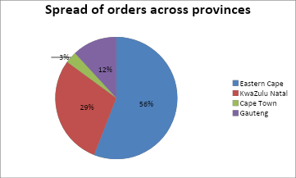

**Table D: Orders issued in the District**

|  |  |  |  |  |
| --- | --- | --- | --- | --- |
| **LOCAL MUNICIPALITY** | **AMOUNT** | **%** | **NO. OF ORDERS** | **%** |
| Umzimvubu | R99 290.00 | 20.7 | 12 | 15.4 |
| Bizana | R31 596.70 | 6.6 | 6 | 7.7 |
| Matatiele | R38 649.90 | 8.1 | 4 | 5.1 |
| Ntabankulu | R0.00 | 0.0 | 0 | 0.0 |
| Outside Alfred Nzo | R309 947.79 | 64.6 | 56 | 71.8 |
| **TOTAL** | **479 484.39** | **100** | **78** | 100 |

**Table E: Orders issued in the District- Chart B**

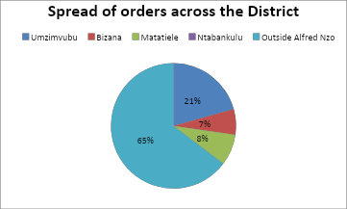

1. **Orders issued less than R200 000.00**

Appointment letters issued for quarter (one) 1 amounted to R 316 080.00 and is as follows

|  |  |  |  |  |
| --- | --- | --- | --- | --- |
| **LOCAL MUNICIPALITY** | **AMOUNT** | **%** | **NO. OF ORDERS** | **%** |
| Umzimvubu | R276,500.00 | 87.478 | 2 | 66.67 |
| Bizana | R39,580.00 | 12.522 | 1 | 33.33 |
| Matatiele | 0 | 0 | 0 | 0 |
| Ntabankulu | 0 | 0 | **0** | 0 |
| Outside Alfred Nzo | 0 | 0 | 0 | 0 |
| Total | **R316,080.00** | 100 | 3 | 100 |

**Table F.1: Distribution Across the District**

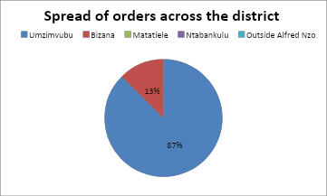

1. **Bids awarded above R 200 000.00**

The following bids were awarded in Q1 and Q2 at a total amount of R 1 452 889.80

|  |  |  |  |  |
| --- | --- | --- | --- | --- |
| **DATE** | **NAME OF SUPPLIER** | **DESCRIPTION** | **AMOUNT** | **REGION** |
| 18-Oct-24 | Silalele Skills Academy | Provision of Learnership Programme on National Certificate: Environmental Practice for a period of 12 months | R391,000.00 | EL |
| 18-Oct-24 | Silalele Skills Academy | Provision of Learnership Programme on National Certificate: Local Economic Development for a period of 12 months | R273,700.00 | EL |
| 18-Oct-24 | Ooketshe Trading & Transport | Construction of a Shearing Shed at ULM | R368,189.80 | Umzimvubu |
| 18-Oct-24 | Extreme Auto Wash & Chillaz | Construction of a Shearing Shed at WMMLM | R420,000.00 | Bizana |
| 30-Dec-24 | Xolweni Trading | Refurbishment and fencing of Ephifane Shearing Shed | R365,230.80 | Umzimvubu |
|  |  |  | **R1,818 120.60** |  |

1. **Bid Committee Sittings**

|  |  |  |  |
| --- | --- | --- | --- |
| **BID NO.** | **DESCRIPTION** | **BID COMMITTEE** | **DATE OF SITTING** |
| ANDA 02/2024/2025 | Supply and delivery of Sewing Material | Bid Specification Committee | 6-Aug-24 |
| ANDA 03/2024/2025 | Provision of Plumbing Services at ESDRC |
| ANDA 04/2024/2025 | Provision of Electrical Services at ESDRC |
| ANDA 05/2024/2025 | Refurbishment and fencing of Ephifane Sheep Shearing Shed |
| ANDA 06/2024/2025 | Construction of a Shearing Shed at ULM |
| ANDA 07/2024/2025 | Construction of a Shearing Shed at WMMLM |
| ANDA 08/2024/2025 | Provision of Cleaning Services |
| ANDA 09/2024/2025 | Panel of accredited training providers for 3 years |
| Panel Proposal | Provision of learnership on NC: Environmental Practice for 12 months | Bid Specification Committee | 6-Aug-24 |
| Panel Proposal | Provision of learnership on NC: Local Economic Development for 12 months |
| Panel Proposal | Provision of learnership on NC: Environmental Practice for 12 months | Bid Evaluation Committee | 28-Aug-24 |
| Panel Proposal | Provision of learnership on NC: Local Economic Development for 12 months |
| ANDA 13/2024/2025 | Leasing and maintenance of printing machines | Bid Specification Committee | 18-Sep-24 |
| ANDA 10/2024/2025 | Refurbishment and fencing of Ephifane Sheep Shearing Shed | Bid Evaluation Committee | 8-Oct-24 |
| ANDA 11/2024/2025 | Construction of a Shearing Shed at WMMLM |
| ANDA 12/2024/2025 | Construction of a Shearing Shed at ULM |
| ANDA 15/2024/2025 | Development of Business Plans for Frsh Produce Pack Houses at WMMLM and MLM | Bid Specification Committee | 9-Oct-24 |
| Panel Proposal | Provision of learnership on NC: Environmental Practice for 12 months | Bid Adjudication Committee | 18-Oct-24 |
| Panel Proposal | Provision of learnership on NC: Local Economic Development for 12 months |
| ANDA 10/2024/2025 | Refurbishment and fencing of Ephifane Sheep Shearing Shed |
| ANDA 11/2024/2025 | Construction of a Shearing Shed at WMMLM |
| ANDA 12/2024/2025 | Construction of a Shearing Shed at ULM |
| ANDA 14/2024/2025 | Leasing and Maintenance of two Printing Machines | Bid Evaluation Committee | 29-Oct-24 |
| ANDA 09/2024/2025 | Panel of Accredited Training Providers for a period of 36 months |
| ANDA 10/2024/2025 | Refurbishment and fencing of Ephifane Sheep Shearing Shed |
| ANDA 16/2024/2025 | Provision of Electrical Services at ESDRC | Bid Specification Committee | 12-Nov-24 |
| ANDA 15/2024/2025 | Development of Business Plans for Frsh Produce Pack Houses at WMMLM and MLM | Bid Evaluation Committee | 6-Dec-24 |
| ANDA 10/2024/2025 | Refurbishment and fencing of Ephifane Sheep Shearing Shed | Bid Adjudication Committee | 10-Dec-24 |
| ANDA 13/2024/2025 | Leasing and Maintenance of two Printing Machines |
| ANDA 09/2024/2025 | Panel of Accredited Training Providers for a period of 36 months |
| ANDA 15/2024/2025 | Development of Business Plans for Frsh Produce Pack Houses at WMMLM and MLM |

Procurement Plan Implementation

ANDA developed a procurement plan in line with the SDBIP. Below is the status of implementation:

|  |  |  |  |  |  |  |  |  |  |  |  |  |  |  |
| --- | --- | --- | --- | --- | --- | --- | --- | --- | --- | --- | --- | --- | --- | --- |
| **ANNUAL PROCUREMENT PLAN 2024/2025** | | | | | | | | | | | | | | |
|  |
|  | **Directorate / Unit** | **Vote** | **Bid Description** | **Date of Submission of Specification / TOR's** | **Budgeted Amount** | **Source of Funding** | **Envisaged Date of Bid Specification Committee** | **Envisaged Date of Advert** | **Envisaged Date of Bid Evaluation Committee** | **Envisaged Date of Bid Adjudication Committee** | **Envisaged Date of objection period** | **Envisaged Date of Award** | **Actual date of award** | **Comments** |  |
| 1 | Programme | Corporate Wide Strategic Planning (IDPs, LEDs): LED | Appointment of Service provider for Construction of 1x shearing sheds at Winnie Madikizela Mandela LM | 2024/08/08 | R500 000.00 | ANDM | 12-Aug-24 | 16-Aug-24 | 13-Sept-24 | 2024/09/26 | 2024/10/03 | 2024/10/18 | 2024/10/18 |  |  |
| 2 | Programme | Corporate Wide Strategic Planning (IDPs, LEDs): LED | Appointment of Service provider for Construction of 1x shearing sheds in Umzimvubu LM | 2024/08/08 | R500 000.00 | ANDM | 12-Aug-24 | 16-Aug-24 | 13-Sept-24 | 2024/09/26 | 2024/10/03 | 2024/10/18 | 2024/10/18 |  |  |
|  |  |  | Supply and Delivery of Sewing Material | 2024/08/08 | R70 000 | ANDM | 12-Aug-24 | 16-Aug-24 | N/A | N/A | N/A | 2024/08/30 | 2024/10/15 |  |  |
| 3 | Programme | Corporate Wide Strategic Planning (IDPs, LEDs): LED | Appointment of Service provider for refurbishment of 1 Shearing shed at Matatiele LM. | 2024/08/08 | R500 000.00 | ANDM | 12-Aug-24 | 16-Aug-24 | 13-Sept-24 | 2024/09/26 | 2024/10/03 | 2024/10/18 | 2024/12/30 |  |  |
| 4 | Programme | Corporate Wide Strategic Planning (IDPs, LEDs): LED | Appointment of service provider for development of Cannabis and Hemp Master Plan | 18-Sept-24 | R1 500 00.00 | ANDM | 12-Aug-24 | 16-Aug-24 | 20-Sept-24 | 2024/09/27 | 2024/10/03 | 2024/10/18 |  | Waiting for adjustment budget. |  |
| 5 | Programme | Corporate Wide Strategic Planning (IDPs, LEDs): LED | Appointmnent of service provider for development of 1x Business Plan for Macadamia Nuts | 18-Sept-24 | R500 000.00 | ANDM | 13-Aug-24 | 16-Aug-24 | 20-Sept-24 | 2024/09/27 | 2024/10/03 | 2024/10/18 |  | This business plan was replaced by Pack Houses Business Plan , project is being re-advertised |  |
| 6 | Programme | Corporate Wide Strategic Planning (IDPs, LEDs): LED | Appointment of panel of training providers | 2024/08/08 | R0.00 | N/A | 12-Aug-24 | 16-Aug-24 | 13-Sept-24 | 2024/10/11 | 2024/10/03 | 2024/10/18 |  | Waiting for objection period to lapse, service providers will be appointed in January. |  |
| 8 | Finance and Admin | Administrative and Corporate Support:Admin & Corporate Services | Provision of Cleaning Services | 2024/08/08 | R400 000.00 | ANDM | 12-Aug-24 | 16-Aug-24 | N/A | N/A | N/A | 2024/08/30 | 2024/08/30 |  |  |
| 7 | Finance and Admin | Administrative and Corporate Support:Admin & Corporate Services | Appointment of Service Provider for Cellphone Contract | 2024/01/17 | R600 000.00 | ANDM | 24-Jan-25 | 31-Jan | 06-Feb | 2025/02/13 | Feb-25 | Mar-25 |  |  |  |

# PART 5: UNAUTHORISED, IRREGULAR, FRUITLESS AND WASTEFUL EXPENDITURE

The Irregular Expenditure report is prepared according to MFMA circular number 68, the Irregular, Fruitless and Wasteful Expenditure Register is attached.

Irregular expenditure from prior years amounts to **R37 193 360.00,** and there has been no irregular expenditure recorded for the current financial year.

Irregular expenditure totaling **R27 650 951.96** was certified as irrecoverable by the Board and was written off by the Council. The balance of R9 543 184.18 is under investigation made up of the following:

• Opening balance R3 100 000.00

• 2014 financial year R3 962 029.52

• 2015 financial year R652 902.32

• 2022 financial year R991 769.35

• 2023 financial year R463 529.82

During the 2024 audit, **R67 283.11** was discovered as irregular expenditure as one contract on legal services was awarded without confirming municipal clearance.

Fruitless and wasteful expenditure from prior years and to date totals to **R5 826 529.72.** The investigations are still underway.

|  |  |  |
| --- | --- | --- |
|  | **2025** | **2024** |
| **Fruitless & wasteful expenditure** |  |  |
| Opening Balance | 5 842 773.61 | 3 374 551.00 |
| Add Current year fruitless & wasteful expenditure | 15 668.56 | 2 482 986.79 |
| Less Fruitless & wasteful expenditure written off |  |  |
| Less Fruitless & wasteful expenditure recovered | - 2 000.00 | - 14 764.18 |
|  | **5 856 442.17** | **5 842 773.61** |

PART 6: TAX COMPLIANCE REPORT

This report serves as a summary of the entity's tax obligations and compliance schedule. It is essential for the entity to maintain accurate records and ensure timely submissions to avoid penalties or interest.

**1. Types of Taxes Applicable to the Entity:** The entity is required to comply with the following types of taxes:

* **Provisional Tax**: This tax is applicable to the entity and must be paid twice a year. It serves as a method of pre-paying the annual tax liability in advance to avoid a large lump sum at year-end.
* **Value-Added Tax (VAT)**: The entity is registered for VAT and submits VAT returns every two months. This tax is applicable on the sale of goods and services, and the entity is eligible to claim input VAT on expenses incurred in the course of its business.
* **Annual Income Tax**: The entity is required to file an annual income tax return based on the taxable income derived during the financial year.
* **Employees’ Tax (PAYE)**: The entity deducts employees' tax (PAYE) from salaries and submits these payments monthly to the tax authority. This tax is withheld as part of the employees' remuneration process.

**2. Tax Submission Frequency:**

* **VAT**: Every two months.
* **Employees’ Tax (PAYE)**: Monthly.
* **Provisional Tax**: Twice a year.
* **Annual Income Tax**: Once a year.

**3. Tax Audit Communication:**

No tax audits have been communicated to the entity to date.

## 

## **Chief Executive Officer’s quality certification**

|  |
| --- |
| **QUALITY CERTIFICATE** |

I, _____________________________________ (Full Names), the Acting Chief Executive Officer at Alfred Nzo Development Agency hereby certify that the **Section 52 Report** for the period ended 31 December 2024 has been prepared in accordance with the Local Government: Municipal Finance Management Act 2003 (Act 56 of 2003) and regulations made under the Act.

______________________ ___________________

**N. Boti Date**

**Acting Chief Executive Officer**

|  |
| --- |
| **RECEIPT BY THE ACCOUNTING OFFICER** |

I, ______________________________________ (Full Names), the Municipal Manager of **Alfred Nzo District Municipality**, hereby accept the **Section 52 report** of the municipal entity for the period ended 31 December 2024 as presented by the Chief Executive Officer in terms of the Local Government: Municipal Finance Management Act 2003 (Act 56 of 2003) and regulations made under the Act.

_________________________ ___________________

**T. Mopeloa Date**

**Acting Municipal Manager**